Water
Author: Elizabeth Simmermeyer
Unit Overview
Target Audience: 3rd Grade | Est. Time: Three 60 minute lessons to be taught 3 consecutive days | Content Area(s): Science, Engineering
Abstract:
In this mini unit, Water, third grade students will have the opportunity to participate in three 60-minute lessons over three consecutive days. In lesson 1, students will make connections between water and life. Through discussion, students will learn about the steps of the water cycle. They will then create their own artificial water cycle in a bottle. Students will have a worksheet to go along with this lesson in order to reflect on what they have learned and get excited for the next lesson. In lesson 2, students will dive into learning about water pollution. They will use tongs to try and “de-pollute” water. After a discussion on water pollution, they will then work together to create their own water filtration system. The class will compare systems and discuss what went well and what did not go well. Students will have a worksheet to fill out to expand on the activity and record what they did and why. The last lesson students will participate in will be focused on water conservation. After being informed on water waste and how we can be environmentally responsible, students will work in teams to create ways that businesses can conserve water. They will record their plan on a worksheet. To end the mini unit, students will complete a summative assessment that measures their knowledge on the water cycle, water pollution, and water conservation.
Unit Goals/Objectives:
Students will be able to:
- Explain the water cycle
- Construct a water filtration system to purify polluted water
- Formulate a plan to conserve water
Lesson Summaries:
Lesson 1: What is the Water Cycle?
- Students will be able to discuss the impact water pollution has on all life.
- Students will be able to construct their own water filtration system.
- Students will be able to identify limitations for water purification.
Lesson 2: Water Pollution and Filtration
- Students will be able to discuss the impact water pollution has on all life.
- Students will be able to construct their own water filtration system.
- Students will be able to identify limitations for water purification
Lesson 3: Water Usage
- Students will be able to justify the importance of water conservation.
- Students will be able to formulate plans for businesses to conserve water by using evidence from previous practices.
- Students will be able to execute water conservation practices in their own life.
Lesson Timeline:
Lesson 1 (60 minutes instruction + 60 minute wait time)
- Interest Approach Activity: 10 minutes
- Identifying parts of the water cycle: 10 minutes
- Water Cycle in a Bottle Activity: 15 minutes
- Formative Assessment: 10 minutes
- Wait Period: 60 minutes
- Formative assessment: 15 minutes
Lesson 2 (60 minutes)
- Review: 5 minutes
- Interest Approach Activity: 10 minutes
- Water Filtration System Activity: 30 minutes
- Discussion: 15 minutes
Lesson 3 (60 minutes)
- Review: 2 minutes
- Interest Approach Activity: 8 minutes
- How you can save water at home activity: 10 minutes
- Scenarios Activity: 30 minutes
- Summative Assessment: 10 minutes
Standards:
Indiana State Standards
- Science
- Engineering
- Math
NGSS Stand
STEM Integration within the Unit:
For my Integrated STEM through AFNR Mini Unit, I decided to create lessons for third grade students that focus on the water cycle. Each lesson builds off of one another in order to encourage more STEM integration. My first lesson focuses on the water cycle, the second lesson focuses on water pollution and filtration, and the third lesson focuses on water usage. For lesson plan 1, my STEM component is mostly focused on science. Students learn about the water cycle and how it occurs in nature. They then use some basic math skills to measure water and create their own water cycle in a bottle. The students discuss what a hypothesis is and are required to make their own based on the water cycle in a bottle activity. Lesson 2 includes more STEM integration because students continue to learn about water as a natural resource that is required for all life. The lesson focuses on the impact of water pollution. Engineering is incorporated because students work together to create a filtration system. They use math skills to determine the water loss to visually see how pollution slows down the water filtration process. Lesson 3’s STEM component builds off of lesson 1 and 2 because now students work together to design ways to conserve water and reduce usage. Before doing this, students solve math problems to get them thinking about how big of an impact one person can have on the environment. I chose to integrate the STEM and AFNR components in my mini unit by creating activities and having discussions that relate to real life problems that make sense to third grade students. This was difficult because at such a young grade level, students might not have the background knowledge or skills to solve some issues that are relevant to the real world. By having students create the water cycle in a bottle, they were able to identify the components needed for the water cycle to occur. We discussed how water plays a role in agriculture and all forms of life. In lesson 2, science, engineering, and math were all used for students to create a filtration system. This was a good activity because then students were able to connect how water treatment plants provide fresh water for us to drink. In lesson 3, I wanted students to use critical thinking skills and apply what they know about water pollution, filtration, and the importance of conservation to real world scenarios. Students were assigned to create a water conservation plan for a group (i.e. a school). This encouraged the students to think about real life experiences and allowed them to connect it with the lesson.

Lesson 1: What is the Water Cycle?
Est. Time: 60 minutes (+ 60 minutes for the bottles to sit)
Lesson Learning Goals/Objectives:  - Students will be able to describe steps that water goes through in the water cycle process.  - Students will be able to design an artificial water cycle.  - Students will be able to defend the importance of the water cycle for all life. |  | Indiana State Academic Standards (2016):  - Science: 3.LS.1: Analyze evidence that plants and animals have traits inherited from parents and that variation of these traits exists in a group of similar organisms.
Assessments
Pre-Assessment:
Interest approach activity
Formative:
Worksheet of predictions and observations
Summative:

Concept Prerequisites or Background Knowledge Needed:
None
Vocabulary:
Cycle, evaporation, precipitation, condensation, transpiration
Materials & Technology Needed:
Pictures (https://cdn.agclassroom.org/media/uploads/lp225/Water_in_Agriculture_Pictures.pdf)
White Board & marker, pencils, paper
Empty, plastic water bottle, Plastic cup, Ice cubes, Blue food coloring, Permanent marker, Liquid measuring cup, Water
Lesson Component | Instructions |  | Materials
Introduction  10 minutes | Interest Approach Activity: Students will connect water, a natural resource, to agriculture.  - Divide students into groups of 4.  - Give each group of students a set of pictures  - Have students compare the pictures and create a list of what they have in common.  - After five minutes, have students gather back as a class.  - Ask the class what they found the pictures to have in common.  - Answers should center around agriculture.  - Lead into a discussion about water…  - What does all life require?  - Where does water come from?  - Where does water go? |  | Pictures: (https://cdn.agclassroom.org/media/uploads/lp225/Water_in_Agriculture_Pictures.pdf)
Instructional Activities  Time | Identify the Parts of the Water Cycle (10 minutes)  - Draw the water cycle on the board.  - Scaffolding: ask students questions in order to get them to tell you what to draw.  - Where do we get water, where does water go, etc.?  - At the end, the drawing should look like Figure 1: https://cdn.agclassroom.org/media/uploads/lp225/watercycleinacup.png |  | White Board & marker
 | Activity – Water Cycle in a Bottle (15 minutes)  - Provide students with the needed items for the activity.  - Empty, plastic water bottle  - Plastic cup  - Ice cubes  - Blue food coloring  - Permanent marker  - Liquid measuring cup  - Water  - Explain to students that they will be making their own water cycle in a bottle.  - Provide step by step instructions to students, and go through steps together.  - First, add a drop of blue food coloring to the bottle.  - Second, fill the water bottle with 2/3 cups of water.  - Third, tighten the cap on the bottle and flip upside down.  - Fourth, use the permanent marker to decorate the water bottle with clouds.  - Fifth, place the bottle upside down in the plastic cup.  - Sixth, place two ice cubes on the top of the water bottle and place the cup in a sunny location.  - Leave the water bottle sit for an hour. |  | Empty, plastic water bottle  Plastic cup  Ice cubes  Blue food coloring  Permanent marker  Liquid measuring cup  Water
Wrap Up,  Synthesis/Closure  25 minutes  (+ 60 minute break for the bottles to sit) | Formative assessment - worksheet  - Have the students write down their predictions about what will happen in their water cycle in a bottle  - Discuss the reasoning behind their predictions  - Ask students if they have any questions about the worksheet.  --- Since this is for a 3rd grade classroom, students should be able to go to another lesson and come back in an hour to make observations---  Formative assessment – worksheet  Have students revisit their predictions  - As a class, discuss what students observed, what happened, and why it happened. |  | Pencil  Paper
Resources:
Water Cycle Image: https://cdn.agclassroom.org/media/uploads/lp225/watercycleinacup.png
Images: https://cdn.agclassroom.org/media/uploads/lp225/Water_in_Agriculture_Pictures.pdf

Lesson 2: Water Pollution and Filtration
Est. Time: 60 minutes
Lesson Learning Goals/Objectives:  - Students will be able to discuss the impact water pollution has on all life.  - Students will be able to construct their own water filtration system.  - Students will be able to identify limitations for water purification. |  | Indiana State Academic Standards:  Engineering  - 3-5.E.1: Identify a simple problem with the design of an object that reflects a need or a want. Include criteria for success and constraints on materials, time, or cost.  - 3-5.E.2: Construct and compare multiple plausible solutions to a problem based on how well each is likely to meet the criteria and constraints of the problem  Math  - 3.C.1: Fluently add and subtract whole numbers within 1000 using strategies and algorithms based on place value, properties of operations, and relationships between addition and subtraction.
Assessments
Pre-Assessment:
Formative:
Review Lesson 1 content
Discussion
Summative:
Concept Prerequisites or Background Knowledge Needed:
Lesson 1 content: water cycle, importance of the water cycle for all life
Vocabulary:
Pollution, purify, filtration, filtration system, water treatment plant, limitations
Materials & Technology Needed:
3 large plastic bin filled 2/3 with water, Trash, Vegetable oil, Spices, Tongs, Strainer
Mason Jar, Measuring cup , Empty plastic cup with a hole in the bottom, Dirty water cup (1 cup of water), Dirt, oil, trash, Variety of filtration items, Coffee filters, Sand, Charcoal, Rocks
Lesson Component | Instructions |  | Materials
Introduction  15 minutes | Review (5 minutes)  - Return Lesson 1 worksheet and review answers and answer questions  Interest Approach Activity (10 minutes)  - Divide students into three large groups.  - Provide each group with the needed materials:  - Three polluted water bins  - Large plastic bin filled 2/3 with water  - Trash  - Vegetable oil  - Spices  - Tongs  - Strainer  - Have each group try to “unpollute” (purify) the water bin using tongs and a strainer.  - After five minutes, have students share with class how hard or easy it was to clean their water.  - Discuss what water pollution is and how it can harm the environment and living species.  - Discuss what can be done to prevent water pollution. |  | 3 large plastic bin filled 2/3 with water  Trash  Vegetable oil  Spices  tongs  strainer
Instructional Activities  30 minutes | Water Filtration System Activity  - Explain directions to students.  - Split students into groups of three.  - Provide each group with the following items:  - Mason Jar  - Measuring cup  - Empty plastic cup with a hole in the bottom  - Dirty water cup (1 cup of water)  - Dirt, oil, trash  - Variety of filtration items  - Coffee filters  - Sand  - Charcoal  - Rocks  - Groups will each get a cup of dirty water that they have to create a filtration system for.  - Groups must create a filtration system by placing items in the empty plastic cup with the hole in the bottom.  - They place the cup in the Mason Jar and gradually pour the dirty water in their filtration cup.  - They then observe how clean their water is in the Mason Jar.  - Students can reuse the water in the bottom of the Mason Jar and continue filtering it until they can get it as clean as possible.  - Students will measure the amount of water in the Mason Jar when finished.  - Students will individually fill out the worksheet (formative assessment) as they go through the activity and turn it in at the end of class. |  | Mason Jar  Measuring cup  Empty plastic cup with a hole in the bottom  Dirty water cup (1 cup of water)  Dirt, oil, trash  Variety of filtration items  Coffee filters  Sand  Charcoal  Rocks
Wrap Up,  Synthesis/Closure  15 minutes | Discussion  - Ask students to share what they used in their filtration systems.  - Compare Mason Jars; who has the cleanest water?  - What happens each time the water goes through the filtration system?  - What might water treatment plants do to clean the water?  - What technology, chemicals, etc. do they use?
Resources:

Lesson 3: Water Usage
Est. Time: 60 minutes
Lesson Learning Goals/Objectives:  - Students will be able to justify the importance of water conservation.  - Students will be able to formulate plans for businesses to conserve water by using evidence from previous practices.  - Students will be able to execute water conservation practices in their own life. |  | Indiana State Academic Standards:  Science  - 3.ESS.2: Develop solutions that could be implemented to reduce the impact of weather related hazards.  Engineering  - 3-5.E.1: Identify a simple problem with the design of an object that reflects a need or a want. Include criteria for success and constraints on materials, time, or cost.  - 3-5.E.2: Construct and compare multiple plausible solutions to a problem based on how well each is likely to meet the criteria and constraints of the problem  Math  - 3.C.4: Interpret whole-number quotients of whole numbers.
Assessments
Pre-Assessment:
Formative:
Review Lesson 2 content, activity discussions, student presentations
Summative:
Mini unit test
Concept Prerequisites or Background Knowledge Needed:
Lesson 1 & 2 content: water cycle, importance of water, water pollution, water filtration
Vocabulary:
facility, environmental
Materials & Technology Needed:
“One Well: The Story of Water on Earth” by Rochelle Strauss: https://www.kidscanpress.com/products/one-well
white board, marker, and eraser for each student, math problems from: https://www.desertmuseum.org/center/edu/docs/desertwaters_post_grade4.pdf
white boards, markers, and erasers
Math Problems from: https://www.desertmuseum.org/center/edu/docs/desertwaters_post_grade4.pdf
Lesson Component | Instructions |  | Materials
Introduction  10 minutes | Review (2 minutes)  Return Lesson 2 worksheet and answer questions  Interest Approach Activity (8 minutes)  - Review questions from Lesson 2’s formative assessment  - Read “One Well: The Story of Water on Earth” by Rochelle Strauss |  | Book: “One Well: The Story of Water on Earth” by Rochelle Strauss  https://www.kidscanpress.com/products/one-well
Instructional Activities  40 minutes | How You Can Save Water at Home (10 minutes)  - Provide each student with a white board, marker, and eraser.  - Begin discussion on how each person can work together to save water.  - Read math problems (page 3) out loud and show on overhead screen.  - https://www.desertmuseum.org/center/edu/docs/desertwaters_post_grade4.pdf  - Have students answer each question on a whiteboard and hold it above their head when done.  - Go over each answer.  - Lead this into a discussion on how we can save water at home and businesses can save water too. |  | white boards, markers, and erasers  Math Problems from: https://www.desertmuseum.org/center/edu/docs/desertwaters_post_grade4.pdf
 | Scenarios Activity (30 minutes)  - Divide class into four groups and explain directions.  - Assign each group one of the four facilities.  - Elementary school  - Chicken farm  - Strawberry farm  - City park  - Each group is on the environmental committee for their assigned facility.  - They must create a plan to reduce water usage.  - They may use the internet and other resources to gather information for their plan.  - The group must fill out a worksheet to explain their plan.  - After 20 minutes, each group will share their plan with the class and get feedback from others |  | Worksheet to guide student research
Wrap Up,  Synthesis/Closure  10 minutes | Students will complete a summative assessment for the mini-unit.
Resources:
WATER SAVERS MATH: https://www.desertmuseum.org/center/edu/docs/desertwaters_post_grade4.pdf

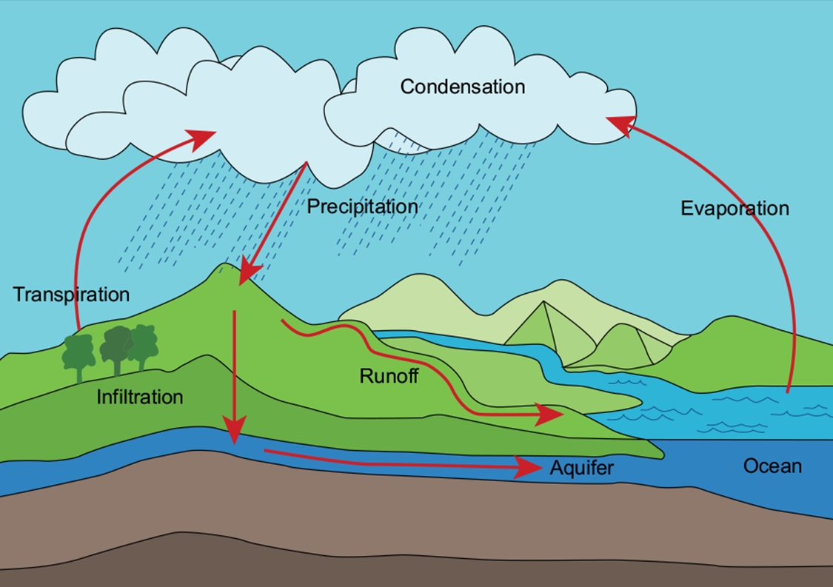
Figure 1: Water Cycle
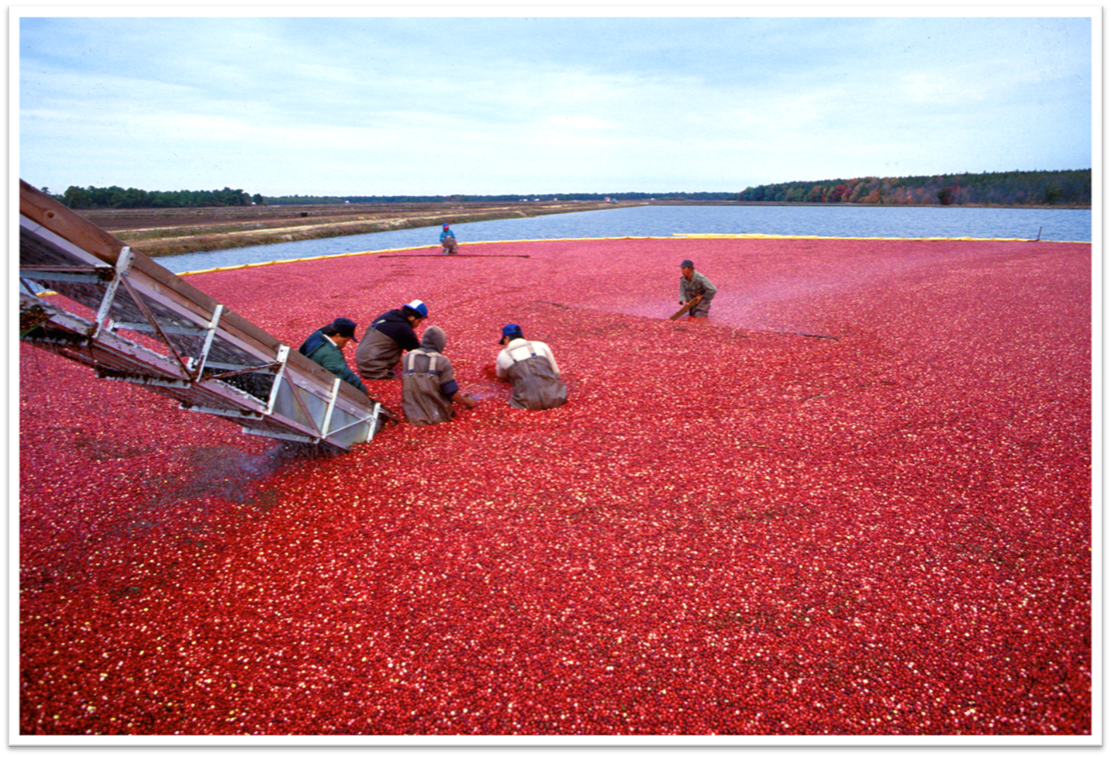
Cranberry Harvest
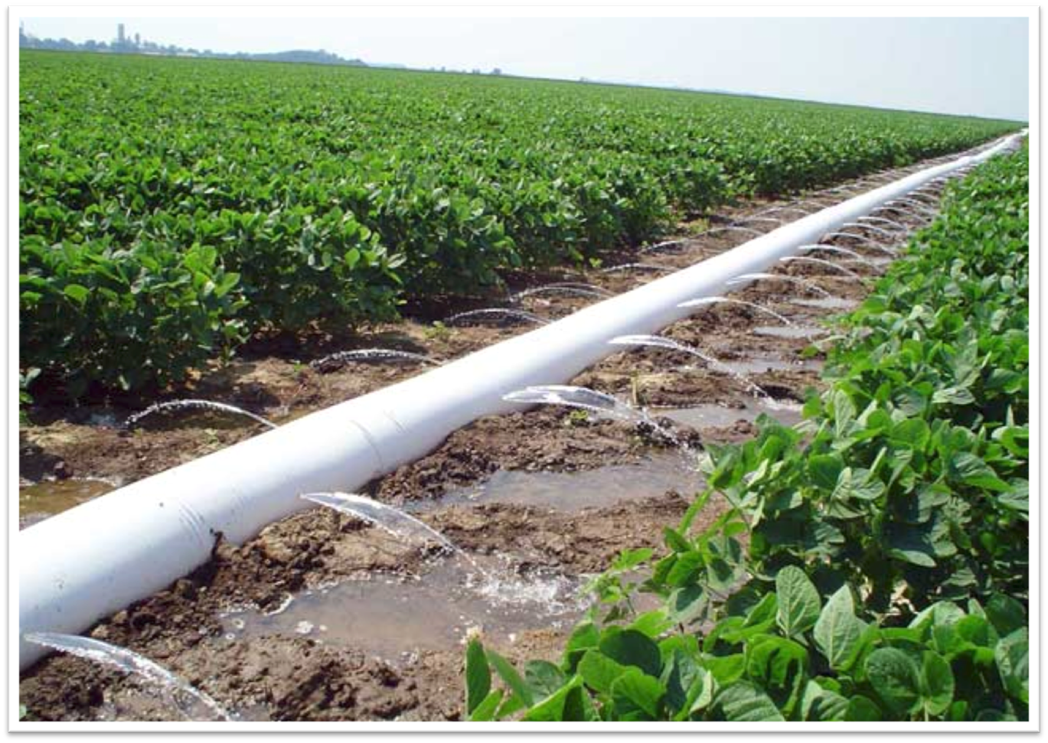
Soybean Field
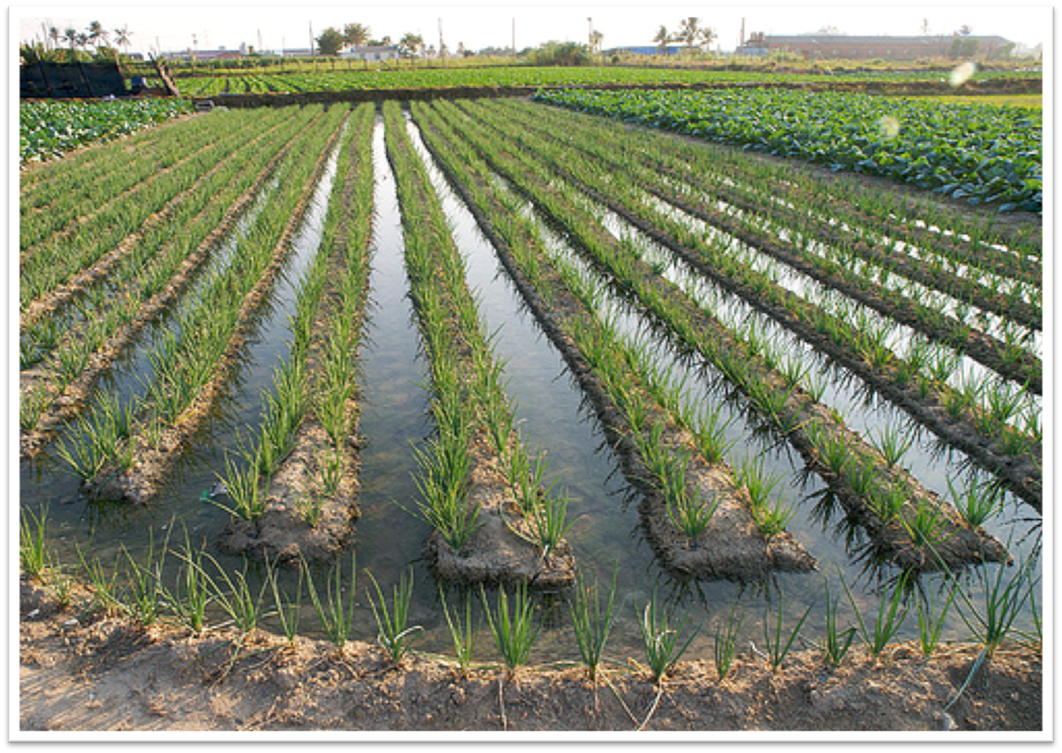
Onion Field
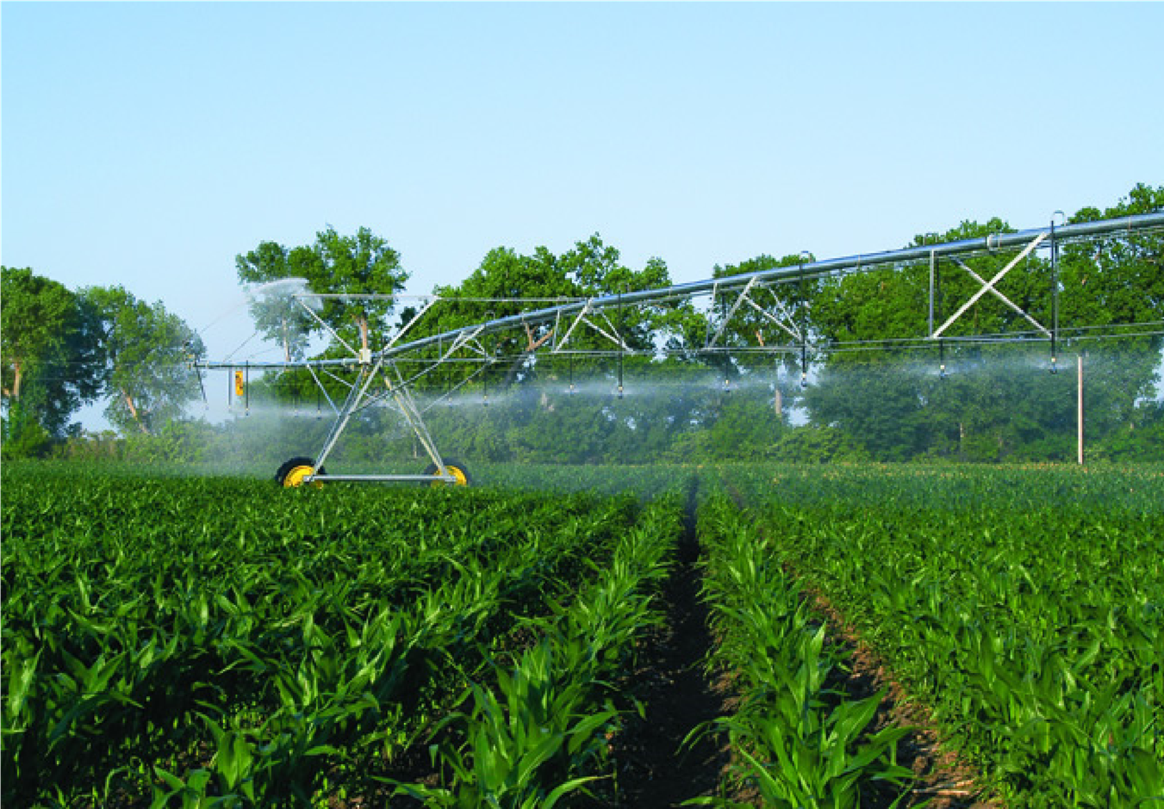
Corn Field
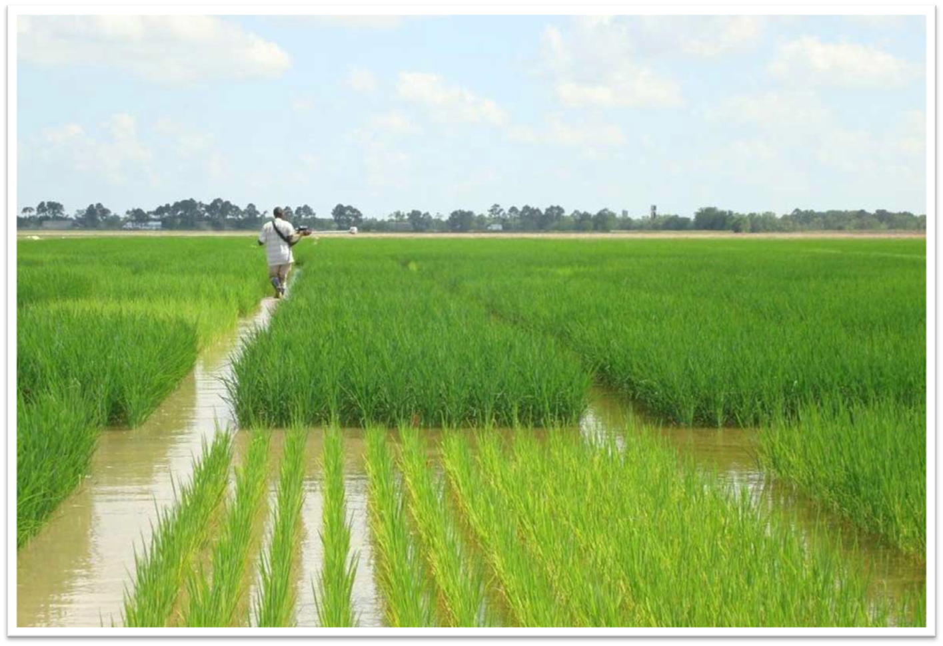
Rice Field
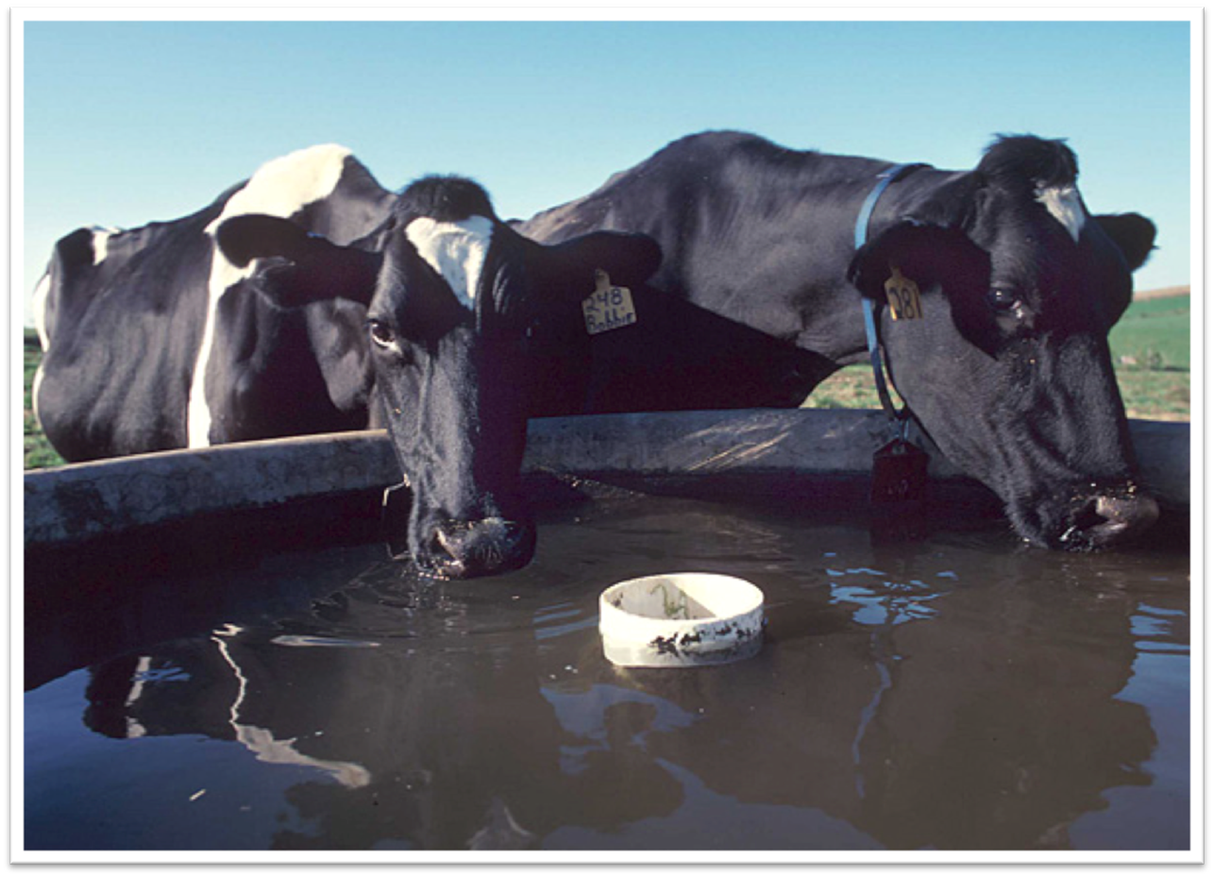
Cattle
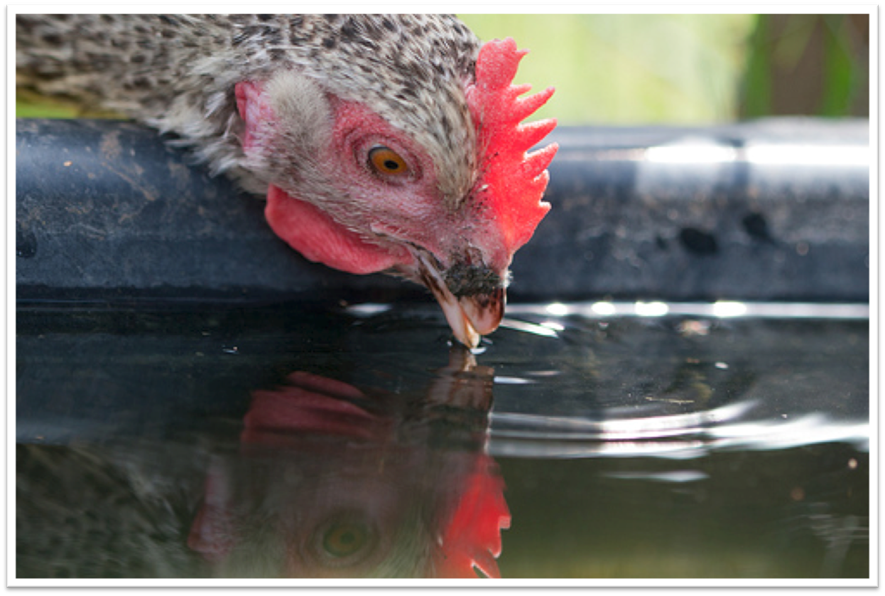
Chicken

