Monitoring goat and sheep milk somatic cell counts☆
Author links open overlay panelM.J.PaapeªG.R.Wiggans^{b}D.D.BannermanªD.L.Thomas^{c}A.H.Sanders^{b}A.Contreras^{d}P.Moroni^{e}R.H.Miller^{b}
Show more
https://doi.org/10.1016/j.smallrumres.2006.09.014Get rights and content

Abstract
The milk somatic cell count (MSCC) forms the basis of abnormal milk control programs world wide for goats, cows and sheep. To better understand factors that contribute to elevations in MSCC, the effects of stage of lactation, parity, breed and state/area in the United States (US) on MSCC were examined. Least squares means were calculated on composite milk somatic cell scores from 26,607 goats, 5,944,614 cows and 2197 sheep and the results converted back to MSCC. For goats and cows, MSCC increased with stage of lactation and parity. Counts for cows were lower than counts for goats. By the fifth parity, counts for goats increased to 1,150,000 ml⁻¹, exceeding the 1,000,000 ml⁻¹ legal limit for goat milk in the US, whereas maximum counts for cows averaged only 300,000 ml⁻¹, less than the 750,000 ml⁻¹ legal limit in the US and 400,000 in the European Union (EU). Currently, there is no legal limit for goat milk in the EU. For sheep, MSCC for first parity were higher than for later parities. For later parities, MSCC decreased with advanced lactation. Cell counts for sheep milk were similar to counts for cow milk. Breed and state/area contributed to variation in cell count for goats and cows. Data were not available for sheep. Studies in the US and EU examined non-infectious factors contributing to elevations in cell counts. Non-infectious factors such as parity and stage of lactation had minimal effects on MSCC for cows and sheep, but had a major impact on counts for goats, and need to be considered when establishing legal limits for goat milk.

1. Introduction
Control of abnormal milk is the most complex and expensive technical problem facing dairymen today. The objective of an abnormal milk control program is to prevent abnormal milk from entering channels of human consumption. The milk somatic cell count (MSCC) is the basis for abnormal milk control programs for cows, goats and sheep. In the United States (US) the legal MSCC limit established by the Food and Drug Administration for cows is 750,000 ml⁻¹ and for goats and sheep 1,000,000 ml⁻¹. In the European Union (EU) (Directive 92/46ECC Council, 1992) the legal limit for cows is 400,000 ml⁻¹ and there is no legal limit for goats and sheep. The MSCC has evolved into an accepted parameter for the evaluation of milk quality and as a management tool for dairymen worldwide. The direct MSCC was developed to meet the need for a standardized reference method of determining MSCC in the abnormal milk control programs being implemented in the US and EU. While MSCC is an accepted procedure for evaluating cow and sheep milk, it is not applicable to goat milk. MSCC for uninfected goats appear to be higher than counts for uninfected cows and sheep. Factors other than intramammary infection such as management practices, stage of lactation, parity and caprine arthritis-encephalitis virus (CAEV) infection contribute to an elevation of MSCC of goats.
The need for a rapid, accurate and economical method for large scale counting of somatic cells in both bulk tank milk and milk from individual animals has long been recognized. A method was needed that could be integrated into laboratories that evaluated large numbers of milk samples. Coulter, Technicon optical, Foss and Bentley electronic cell counters were developed to fill this need. Because counting with the Coulter and Technicon optical counters required dispersal of fat in the milk and failed to fit into laboratories that also evaluated milk composition, their use soon lost favor as a means of determining MSCC. Currently, the Foss and Bentley electronic cell counters are the industry standards for determining MSCC.

2. Materials and methods

2.1. Test-day somatic cell score (SCS)
Data for goats (years 2000–2004) and cows (years 2000–2005) on Dairy Herd Improvement test across the US were submitted to the USDA Animal Improvement Programs Laboratory in Beltsville, MD, USA, and a GLM analysis of the SCS (log₂[SCC/100,000] + 3) for composite milk samples was used to estimate SCS means by year, stage of lactation, parity, breed and state/region in the US. For sheep, composite MSCS was obtained during 1997–2004, from a flock maintained by the Department of Animal Sciences, University of Wisconsin, Madison. The entire data set included composite milk SCS from 16,041 goats, 3,416,731 cows and 1010 ewes. Least squares means from the SAS GLM procedure were calculated on SCS and the results converted back to SCC. Effects for year of testing and stage of lactation by parity were estimated for all data sets. For goats and cows, breed effects and state/region in the US also were estimated, and for cows, month of calving and month of testing effects also were estimated. All effects within species were estimated simultaneously. All effects were significant based on the F-statistic.

3. Results and discussion

3.1. Effect of parity and stage of lactation
Results from the above data set indicate that composite MSCC increased with increasing parity and stage of lactation for goats and cows but not for sheep (Fig. 1, Fig. 2, Fig. 3). For goats, counts were lowest at first parity, averaging approximately 200,000 ml⁻¹ at 15 days of lactation and reached maximum counts of around 500,000 ml⁻¹ at 285 days of lactation (Fig. 1). By the fifth parity, counts averaged approximately 250,000 ml⁻¹ at 15 days and increased to a maximum of approximately 1,150,000 ml⁻¹ at 285 days of lactation. While some of the increase in cell counts with increased parity and days in milk were probably attributable to increased intramammary infections, much of the increase was previously attributed to non-infectious factors (Paape and Contreras, 1997). Cell counts for uninfected mammary glands have been reported to increase with stage of lactation and parity (Dulin et al., 1983, Luengo et al., 2004). In the latter study, multiple births and short duration of lactation were also associated with elevated MSCC in healthy udders. In a recently published study (Moroni et al., 2005), a stage of lactation increase was observed for both infected and non-infected udders. By 170 days of lactation no difference in MSCC was observed between healthy and infected udders. The mean MSCC for udders free from intramammary infection (IMI) was log 3.9 (7943 ml⁻¹) and from infected udders it was log 5.6 (398,107 ml⁻¹).
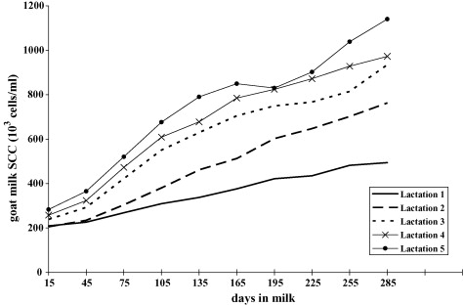
Fig. 1. Effect of days in milk and lactation number on goat composite milk somatic cell counts (MSCC). Lactation 1, n = 10,130 goats; lactation 2, n = 6989 goats; lactation 3, n = 4617 goats; lactation 4, n = 2990 goats; lactation 5, n = 1881 goats.
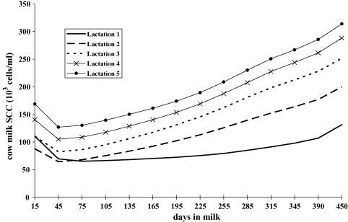
Fig. 2. Effect of stage of lactation and lactation number on composite MSCC for cows. Lactation 1, n = 2,173,447 cows; lactation 2, n = 1,683,535 cows; lactation 3, n = 1,103,768 cows; lactation 4, n = 643,404 cows; lactation 5, n = 341,460 cows.
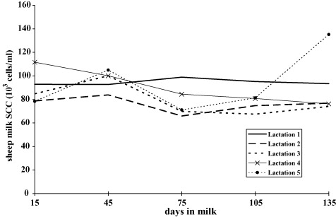
Fig. 3. Effect of stage of lactation and lactation number on composite MSCC for ewes. Lactation 1, n = 877 ewes; lactation 2, n = 722 ewes; lactation 3, n = 376 ewes; lactation 4, n = 173 ewes; lactation 5, n = 49 ewes.
In one study, it was determined that more than 90% of the variation in MSCC in goats was not due to IMI (Wilson et al., 1995). They reported that increasing days in milk and month of the year were among the most important factors contributing to increased cell count in the absence of IMI. To a lesser extent, parity and reduced milk production also contributed significantly to increased cell count. Interestingly, 75% of the variation was unexplained. The unexplained variation could be due to infections by Mycoplasma, anaerobic bacteria or even CAEV (Paape et al., 2001). Clinical intramammary infections by Mycoplasma is one of the most important causes of elevated MSCC in goat milk (Corrales et al., 2004), but the prevalence in the US is low (Wilson et al., 1995). On the other hand, the effect of CAEV on increased MSCC is low (Sánchez et al., 2001, Lerondelle et al., 1992), and similar to MSCC produced by coagulase-negative Staphylococci. In Murciano-Granadina goats free of CAEV and IMI, Sánchez et al. (1998) showed a progressive increase in geometric mean MSCC from first (140 × 10³ cell/ml) to fifth lactation (600 × 10³ cell/ml).
The increase in MSCC for stage of lactation, season and milk yield were associated with increasing parity. Most authors point out that the increase in MSCC throughout lactation could be explained by a dilution effect, because milk production decreases with increasing stage of lactation, and MSCC follows a linear increase throughout lactation. In addition, when date of parturition and stage of lactation are similar, the effect of season on MSCC was shown to be related to milk production (Sánchez et al., 1998). More recently, milking frequency (1× versus 2×) was shown to have no effect on MSCC over three parities (Salama et al., 2003). McDougall and Voermans (2002) reported that estrus resulted in increased MSCC, and was independent of infection status and milk yield. The influence of non-infectious factors on bulk tank MSCC for goats makes it difficult for goat dairymen to maintain MSCC below the US legal limit of 1,000,000 ml⁻¹ (Droke et al., 1993, Haenlein and Hinckley, 1995). These factors need to be considered when establishing the legal limit in the EU (Corrales et al., 2004, Luengo et al., 2004).
In the USDA data, composite MSCC for cows were considerably lower than counts for goats. In the first parity at 15 days after parturition, counts averaged approximately 110,000 ml⁻¹, decreased to approximately 70,000 ml⁻¹ at 45 days and then gradually increased throughout lactation to around 125,000 ml⁻¹ at 450 days (Fig. 2). By the fifth parity counts at day 15 increased to approximately 170,000 ml⁻¹ and reached maximum counts of around 300,000 ml⁻¹ at day 450 of lactation. For all five parities, lowest cell counts were observed at around 45 days of lactation. This was probably attributed in part to a dilution of the cells in milk with increased milk production as the cows approached peak lactation.
The high counts during early lactation could be attributed to a carry over of the high MSCC in colostrum, reported to be around 2000 × 10³ ml⁻¹ (McDonald and Anderson, 1981). The observed increase in cell counts after 45 days for all parities was probably attributed to the increased rate of intramammary infections. Regardless of intramammary infection status, MSCC are higher during the first few weeks after calving when compared to other stages of lactation (Sheldrake et al., 1983, McDonald and Anderson, 1981, Miller et al., 1986). The MSCC for cows has been reported to increase with stage of lactation and lactation number for infected mammary quarters but not for uninfected quarters (Paape et al., 1979, Eberhart et al., 1979, Jaartsveld et al., 1983, Sheldrake et al., 1983, Östensson, 1993). Within a given lactation, cell counts for uninfected quarters increased only 20 × 10³ to 80 × 10³ cells/ml (Sheldrake et al., 1983, Östensson, 1993). The stable MSCC during the large decrease in milk yield in late lactation suggests that the cell content of milk from uninfected quarters is unrelated to milk yield. This is further supported by the observation that the MSCC for morning and evening milkings rarely differed despite large fluctuations in milk yield (Natzke et al., 1972, Paape et al., 1979).
Interestingly, for the sheep flock studied, with the exception of ewes in their fifth parity where counts suddenly increased at 135 days of lactation, counts did not increase with parity (Fig. 3). This increase may be due to the small number (n = 49) of ewes in this parity group, where a sudden increase in MSCC for some ewes would less likely get diluted out with low cell count milk. The increase with stage of lactation was less in first lactation ewes. In later parities, composite MSCC decreased slightly in the second month and then increased. Similar results were also reported by Othmane et al. (2002). They reported non-significant effects of stage of lactation and parity on MSCC. They attributed this to the strict mastitis control procedures used in that study. The geometric mean of composite MSCC of sheep uninfected mammary glands reported by others averaged <100 × 10³ ml⁻¹ and was very similar to that of dairy cows (Marco, 1994, Gonzalez-Rodriguez et al., 1995, Romeo et al., 1996). Pengov (2001) reported that 64% of samples from 366 uninfected udder halves had MSCC less that 50 × 10³ ml⁻¹, 81.9% had counts less than 250 × 10³ ml⁻¹ and 91.1% had counts less that 500 × 10³ ml⁻¹. With the exception of 1-year-old ewes, Suarez et al. (2002) reported no effect of age or parity on MSCC. Rupp et al. (2003), however, reported no difference in MSCC in the first (log 3.13 [1349 ml⁻¹]) and second lactations (log 3.15 [1413 ml⁻¹]).
Various non-infectious factors have been associated with increased cell counts in sheep milk. The most significant are parity, stage of lactation, time of year, herd, handling of ewes and diurnal variation (Gonzalo et al., 1994a, Gonzalo et al., 1994b, Gonzalo and San Primitivo, 1998). For uninfected mammary glands, MSCC are highest on the day of parturition (596 × 10³ cells/ml) and decrease during the transition from colostrum to true milk, averaging 239 × 10³ and 186 × 10³ ml⁻¹ at 5 and 12 days of lactation. Counts continue to decrease with increasing milk production and reach minimum values of approximately 30 × 10³ ml⁻¹ at the fifth week of lactation, which coincides with maximum milk production. Counts remained unchanged for the remainder of the lactation. The change in MSCC throughout lactation was studied by Romeo et al. (1996) at monthly intervals on 799 ewes of the Latxa breed. Uninfected mammary halves (n = 579) had mean MSCC of 185 × 10³ ml⁻¹ and never exceeded 477 × 10³ ml⁻¹. Infected mammary halves (n = 92) averaged 1.5 × 10⁶ ml⁻¹, and never fell below 1 × 10⁶ ml⁻¹. Ewes (n = 128) with mammary halves that were intermittently infected averaged 576 × 10³ ml⁻¹. The number of lambs delivered at lambing does not influence the MSCC count (Gonzalo et al., 1994b). For the majority of milk producing breeds, there is seasonal breeding with most ewes lambing in the winter months. Thus, the seasonal increase in sheep MSCC reported by others appears to be linked to the normal lactation curve, where milk production is lowest during summer and winter months. In that study, a 4–11% increase in MSCC occurred between the first and fourth lactation. The diurnal and daily variations between milkings are similar to those observed in dairy cows. Gonzalo et al., 1994a, Gonzalo et al., 1994b reported a 70% increase in the MSCC one hour immediately after milking. Other non-systematic factors contributing to variation in MSCC of ewes, such as changes in feeding, have not been studied.

3.2. Yearly trends
In the USDA data, interesting yearly trends were observed (Fig. 4, Fig. 5, Fig. 6). For goats, composite MSCC showed a modest increase over time (Fig. 4). Counts increased from 525,000 ml⁻¹ in the year 2000 to 570,000 ml⁻¹ in 2004. This was surprising because of the recent emphasis to lower the legal limit for goat MSCC in the US from 1,000,000 ml⁻¹ to 750,000 ml⁻¹. Thus, one would expect a tendency for the cell count to decrease, not increase, over time. There is no set limit in the EU. For cow milk, composite MSCC averaged 142,000 ml⁻¹ in the year 2000 and decreased to 120,000 in 2005 (Fig. 5). The legal limit for cell counts for bulk tank cow milk in the US is 750,000 and 400,000 ml⁻¹ in the EU. A recent proposal made by the National Mastitis Council in the US to lower the MSCC regulatory limit to 400,000 by the year 2012 was rejected by delegates to the National Conference on Interstate Milk Shipments. For sheep milk, composite MSCC tended to be more variable, and increased slightly from 85,000 ml⁻¹ in 1997 to 105,000 ml⁻¹ in 2004 (Fig. 6).
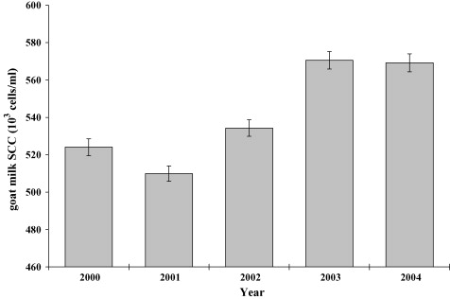
Fig. 4. Effect of year of Dairy Herd Improvement test date on composite MSCC for goats. Year 2000, n = 5923 goats; year 2001, n = 5720 goats; year 2002, n = 5298 goats; year 2003, n = 5139 goats; year 2004, n = 4527 goats. Mean (±standard error) MSCC are shown.
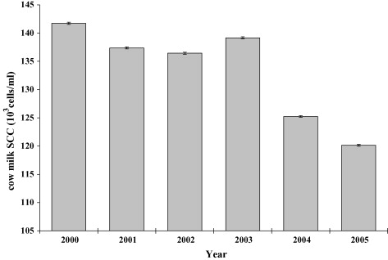
Fig. 5. Effect of year of Dairy Herd Improvement test date on composite MSCC for cows. Year 2000, n = 1,111,956 cows; year 2001, n = 1,137,603 cows; year 2002, n = 1,143,085 cows; year 2004, n = 1,162,478 cows; year 2005, n = 242,375 cows. Mean (±standard error) MSCC are shown.
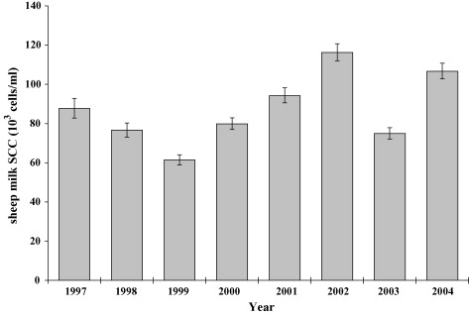
Fig. 6. Effect of year of Dairy Herd Improvement test date on composite MSCC for ewes. Year 1997, n = 201 ewes; year 1998, n = 237 ewes; year 1999, n = 242 ewes; year 2000, n = 277 ewes; year 2001, n = 282 ewes; year 2002, n = 353 ewes; year 2003, n = 308 ewes, year 2004, n = 297 ewes. Mean (±standard error) MSCC are shown.

3.3. Effect of breed
Breed differences were also observed in the USDA data for goats and cows (Fig. 7, Fig. 8). Among the goat breeds, Oberhasli had the lowest cell counts (400,000 ml⁻¹) and Toggenburg the highest (650,000 ml⁻¹) (Fig. 7). For cows, smaller differences existed among breeds when compared to goats (Fig. 8). Milking Shorthorns had the lowest cell counts (125,000 ml⁻¹) and Guernseys the highest (145,000 ml⁻¹). Breed differences for goats and cows could be attributed to differences in intramammary infection, milk yield or genetics. Data were not available for the sheep breeds. However, in other studies (Gonzalo et al., 2005), breed differences on log bulk tank MSCC were observed. Counts ranged from log 5.84 (691,831 ml⁻¹) (Castellana breed) to log 6.09 (1,230,269 ml⁻¹) (Awassi and Spanish Assaf), and supported results reported earlier by Gonzalez-Rodriguez et al. (1995).
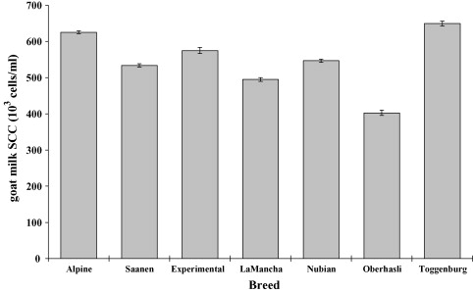
Fig. 7. Effect of breed on composite MSCC for goats. Alpine, n = 9653 goats; Saanen, n = 4619 goats; Experimental, n = 1165 goats; LaMancha, n = 2851 goats; Nubian, n = 4819 goats; Oberhasli, n = 859 goats; Toggenburg, n = 2641 goats. Mean (±standard error) MSCC are shown.
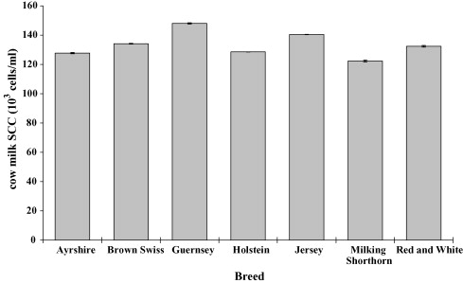
Fig. 8. Effect of breed on composite MSCC for cows. Ayrshire, n = 139,243 cows; Brown Swiss, n = 315,895 cows; Guernsey, n = 227,794 cows; Holstein, n = 50,149,035 cows; Jersey, n = 3,164,043 cows; Milking Shorthorn, n = 56,640 cows; Red and White, n = 110,125 cows. Mean (±standard error) MSCC are shown.

3.4. State and regional differences
In the USDA data, significant state/regional differences were observed for goat and cow MSCC (Fig. 9, Fig. 10). For goats, counts were greater than 600,000 ml⁻¹ for Wisconsin, MN, USA, and the Southwest region, between 500,000 and 600,000 ml⁻¹ for Pennsylvania and Ohio, and between 400,000 and 500,000 ml⁻¹ for New York, Iowa, Maryland, Oregon and California (Fig. 9). It would appear that heat stress did not contribute to elevated MSCC in goat milk, because the Southwest region had counts comparable to Wisconsin and Minnesota. For California, most of the goat herds were located in Northern California, where the temperature is more moderate compared to Southern California (personal communication, Bill VerBoort, General Manager, California DHIA, Clovis, CA 93612, USA). These data suggest that environmental temperature had little effect on goat MSCC, and that other factors contributed to the state and regional differences. Results from other studies also reported no effect of environmental temperature on goat MSCC (Sánchez et al., 1998).
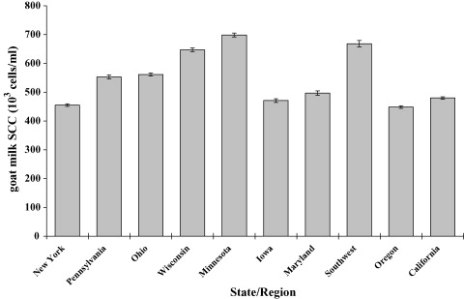
Fig. 9. Herd test-day composite MSCC for goats by state and region of the United States during 2000–2004. NY, n = 3465 goats; PA, n = 1582 goats; OH, n = 2929 goats; WI, n = 3092 goats; MN, n = 3602 goats; IA, n = 1414; MD, n = 1173; Southwest, n = 1148 goats; OR, n = 3494 goats; CA, n = 4708 goats. Mean (±standard error) MSCC are shown.
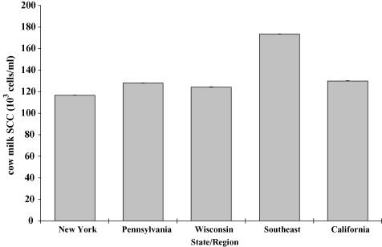
Fig. 10. Herd test-day composite MSCC for cows by state and region of the United States during 2000–2005. NY, n = 853,103 cows; PA, n = 964,539; WI, n = 1,446,846 cows; Southeast, n = 317,174 cows; CA, n = 2,362,952 cows. Mean (±standard error) MSCC are shown.
An environmental effect was observed for cow MSCC (Fig. 10). Counts for the Southeast that included states like Florida, Georgia, Mississippi and Louisiana were greater than counts for New York, Pennsylvania, Wisconsin and California. Interestingly, most of the large dairy herds are located in Southern California where environmental temperatures are comparable to states in the Southeast (personal communication, Bill VerBoort, General Manager, California DHIA, Clovis). This would suggest that perhaps humidity may have contributed to the increased counts. Also, mastitis control programs tend to be less vigorous for small herds when compared to large herds (Norman et al., 2000).

3.5. Differential MSCC
Unlike cow milk where macrophages are the predominant cell type (Östensson et al., 1988, Östensson, 1993, Miller et al., 1986), polymorphonuclear neutrophils (PMN) comprise the major cell type in milk from infected and uninfected mammary glands of goats (Dulin et al., 1983). For animals free of intramammary infection, PMN constitute 45–74% of the somatic cells in goat milk and 71–86% for infected mammary halves. Macrophages comprise 15–41% of the somatic cells in uninfected halves and 8–18% in infected halves. Lymphocytes comprise 9–20% of the somatic cells in uninfected halves and 5–11% in infected halves. Epithelial cells are low in goat milk, but identification by light microscopy is difficult because of the presence of cytoplasmic particles in goat milk. An early study reported that epithelial cells comprised less than 1% of the total cells. More recent studies reported that 6% of the cells in uninfected mammary halves were epithelial in origin (Contreras, 1998). Because milk secretion in the goat is apocrine (Wooding et al., 1970), cytoplasmic particles are shed into milk from the apical portion of mammary secretory cells. The numbers of cytoplasmic particles in milk of uninfected mammary halves range from 71 to 306 × 10³ ml⁻¹ and for infected mammary halves from 98 to 231 × 10³ ml⁻¹ (Dulin et al., 1983). Although the majority of these particles are generally anucleated, approximately 1% contain nuclear fragments (Dulin et al., 1982).
Limited data exist on changes in differential MSCC throughout lactation for ewes. Similar to dairy cows, the macrophage is the predominant cell type (46–84%) in milk from uninfected mammary glands of ewes (Cuccuru et al., 1997). The PMN comprise 2–28% of the cell population and lymphocytes (11–20%). Plasma cells are present in small numbers in colostrum (0–20%), as well as epithelial cells (1–2%). For infected mammary glands, the percentage of PMN increases to 50% at a MSCC of 200 × 10³ ml⁻¹ and to 90% at a MSCC over 3 × 10⁶ ml⁻¹. Cytoplasmic particles are normal constituents in ewe milk and colostrum. However, concentrations are 10 times less than counts in goat milk, averaging 15 × 10³ cells/ml (Martinez et al., 1997). A recent study by Albenzio (2004), reported no significant stage of lactation effect on differential MSCC.

3.6. Mechanisms responsible for increased MSCC during infection
Increases in MSCC during intramammary infection are an essential part of the mammary gland's defenses against an invading pathogen. The initial increases in milk somatic cells are primarily due to the recruitment of circulating PMN from the circulation to the inflamed tissue (Persson-Waller et al., 1997). Once PMN have migrated to the gland and become activated, they release a number of anti-bacterial components that are essential for successful host clearance of the infectious pathogen (Paape et al., 2002, Paape et al., 2003).
Recruitment of PMN to the gland occurs through a process referred to as chemotaxis (Wagner and Roth, 2000). Chemoattractants are soluble molecules secreted from inflamed tissue which enable directional migration of PMN to the site of infection. In addition to chemoattractants, PMN chemotaxis requires the expression and interaction of complementary adhesion molecules on PMN and endothelial cells, the latter of which line the luminal surface of the vascular wall and regulate leukocyte trafficking (Carlos and Harlan, 1994, Wagner and Roth, 2000).
Within the past decade, the mechanisms responsible for PMN recruitment, and thus increases in milk SCC, have been elucidated in small ruminants such as sheep. As mentioned previously, surface adhesion molecules play a requisite role in PMN adherence to and migration through the endothelial lining of the vascular wall (Carlos and Harlan, 1994, Wagner and Roth, 2000). Similar to other species, ovine PMN express l-selectin (CD62L) and CD18 (Persson-Waller and Colditz, 1998). l-Selectin is constitutively expressed on PMN surfaces and mediates rolling of PMN along the endothelium lining of post-capillary venules. CD18 mediates firm attachment of PMN to the endothelium and facilitates PMN transendothelial migration. The intensity of l-selectin staining is lower on ovine PMN in milk compared with those in blood (Persson-Waller and Colditz, 1998). In contrast, CD18 staining is higher on milk-derived ovine PMN than on those obtained from blood. The differential surface expression of these two ovine adhesion molecules between pre- and post-migrated PMN is consistent with the shedding of l-selectin and the upregulation of CD18 during transendothelial migration and is comparable to that seen in other species, including cattle (Riollet et al., 2000) and humans (Keeney et al., 1993).
Cytokines play a critical role in PMN recruitment to inflamed tissue (Wagner and Roth, 2000). These soluble, cell-derived molecules influence cell responses, such as adhesion molecule expression, by binding to cell surface receptors and activating intracellular signal transduction pathways leading to transcriptional activation. In humans, two well-described pro-inflammatory cytokines, TNF-α and IL-1β, induce vascular endothelial adhesion molecule expression, thereby, promoting PMN transendothelial migration to the site of infection (Carlos and Harlan, 1994, Wagner and Roth, 2000). Another cytokine involved in PMN recruitment is IL-8, which is directly chemotactic for PMN (Harada et al., 1994, Wagner and Roth, 2000).
There are data to suggest that the ovine orthologues of the aforementioned human cytokines have a similar role in mediating PMN recruitment to infected mammary glands. Experimental intramammary infection of sheep with Staphylococcus aureus or Escherichia coli has been shown to induce a significant increase in milk leukocytes within 24 h of infection (Persson-Waller et al., 1997). Similar to cattle (Bannerman et al., 2004), E. coli intramammary infection elicited a more rapid recruitment of PMN to the gland than S. aureus. Interestingly, this delay in PMN recruitment in response to S. aureus in both cattle and sheep correlated with impaired clearance of S. aureus relative to that of E. coli. Maximal increases in milk levels of ovine TNF-α and IL-8 preceded or were temporally coincident with maximal PMN recruitment to glands infected with either pathogen (Persson-Waller et al., 1997). Relative to E. coli-infected glands, a delay in induction of peak levels of these cytokines in S. aureus-infected quarters corresponded with a respective delay in maximal leukocyte recruitment (i.e., elevated milk SCC).
In contrast to the induction of comparable concentrations of TNF-α and IL-8 in glands infected with either pathogen, appreciable levels of IL-1β were only detected in S. aureus-infected glands. Elevations in milk IL-1β levels in S. aureus-infected glands paralleled increases in milk neutrophils. IL-1β production in sheep is not only elicited by S. aureus, as intramammary infection by another Gram-positive bacterium, Staphylococcus epidermidis, has similarly been reported to elicit its production (Winter and Colditz, 2002, Winter et al., 2003). The minimal induction of IL-1β in response to E. coli is consistent with another report demonstrating negligible production of ovine IL-1β in quarters infused with endotoxin (Waller et al., 1997), a highly immunostimulatory component of the cell wall of all Gram-negative bacteria, including E. coli. Similar to E. coli intramammary infection, increases in ovine TNF-α and IL-8 were detected in endotoxin-challenged quarters.
That increases in milk levels of TNF-α, IL-8 and IL-1β following intramammary infection are temporally coincident with increases in milk PMN suggests a role for these cytokines in ovine PMN recruitment. Direct evidence supporting this notion has been provided in studies investigating the direct effects of these cytokines on changes in PMN levels in lactating ovine glands (Persson et al., 1996). Infusion of ovine IL-1β or TNF-α into either the teat cisterns or udders of sheep induced an increase in leukocytes, the majority of which were PMN. Infusion of ovine IL-8 into the teat cistern, but not the udder, elicited an increase in PMN. Although IL-8 has been reported in vitro to be chemotactic for both caprine (Barber et al., 1999) and ovine PMN (Mulder and Colditz, 1993), the lack of an effect of IL-8 on PMN recruitment when infused into the ovine udder remains unexplained. One may speculate that a low potency of IL-8 combined with the dilutional effect of milk may have ablated its chemotactic activity. Together, the identification of cytokines and adhesion molecules responsible for PMN recruitment enhances our understanding of the mechanism by which elevations in MSCC occur during intramammary infection.

4. Conclusions
Intramammary infection is the major cause for elevated SCC in milk of dairy ruminants. The innate immune system calls into play a host of cytokines critical in the early recruitment of PMN to the mammary gland in response to invading mastitis pathogens. The increase in MSCC due to stage of lactation and parity for cows and sheep are mainly the result of intramammary infections. While intramammary infection increases MSCC for goats, other non-infectious factors such as estrus, season and milk yield will also increase counts in goat milk. For non-infected goat halves, a progressive increase in MSCC is also observed with parity and advanced lactation. North American goat dairymen have difficulties in maintaining bulk tank MSCC below the threshold of 1,000,000 ml⁻¹. There is currently no legal limit for goat milk in the EU. Non-infectious factors that contribute to elevations in MSCC for goats need to be considered when establishing legal cell count limits.

