Ecosystem: Plants, Animals, & Energy
Author: Elizabeth Ragland
Unit Overview
Target Audience: | Est. Time: Three 50 minute class periods | Content Area(s): Science
Abstract:
This lesson will draw connections with how energy passes through our ecosystem. The unit will explore how agricultural literacy can be improved using stem content knowledge and learning objectives. The scope of this unit will begin with examining energy as it passes through our ecosystem and energy’s relationship to nutrition. It all begins with the plant, the consumer, which agriculturalists around the world are working to improve and maximize to feed the growing populations. Then, we will branch out into different paths and different food webs and examine how this energy passes through livestock to humans, through the farm to fork process, or through an ecosystem to wildlife. We will then review how energy is recycled through the ecosystem, and how ecosystems evolve to meet the necessary energy requirements. We will discuss topics such as evolution, diversity, nutrition, energy transfer, and symbiosis. These topics will then be applied towards a summative overarching project which students will examine and construct a food web within an ecosystem.
Unit Goals/Objectives:
- Describe movement of energy through an ecosystem
- Define symbiotic and prey/predator relationships
- Describe different niches within an ecosystem
- Identify how natural selection occurs within an ecosystem, and its effect on diversity
- Discuss how plants and animals recycle energy through an ecosystem
- Explain the lifecycle of plants, wild animals, and animals used for agriculture
- Illustrate human’s involvement with the production of energy to fuel society
- Employ basic energy and nutrition principles to propose solutions to mitigate global hunger
- Classify animal’s diets and their relationships among one another
- Recognize different roles animals and plants have in the transfer of energy
- Organize how energy is transferred within an ecosystem between plants and animals
- Construct a food chain within an ecosystem to sustain diversity given set parameters
- Investigate how animal and plants interactions shape an ecosystem
Lesson Summaries:
Lesson 1: Movement of Matter & Energy, Role of Energy in our Diet
- Describe movement of energy through an ecosystem
- Discuss how plants and animals recycle energy through an ecosystem
- Classify animal’s diets and their relationships among one another
- Recognize different roles animal and plants have in the transfer of energy
Lesson 2: Lifecycle of Plants & Animals, Relationships within Ecosystems
- Define symbiotic and prey/predator relationships
- Describe different niches within an ecosystem
- Explain the relationship between biodiversity and the food chain
Lesson 3: Energy Transfer, Diversity & Evolution
- Identify how natural selection occurs within an ecosystem, and its effect on diversity
- Organize how energy is transferred within an ecosystem between plants and animals
- Construct a food chain within an ecosystem to sustain diversity given set parameters
- Investigate how animal and plants interactions shape an ecosystem
Lesson Timeline:
Lesson 1: Movement of Matter & Energy, Role of Energy in our Diet
- Entry Ticket (5 minutes)
- Think, Pair, Share (5 minutes)
- Define Terminology (10 minutes)
- Group Activity (20 minutes)
- Popcorn and Exit Ticket (10 minutes)
Lesson 2: Lifecycle of Plants & Animals, Relationships within Ecosystems
- Entry Ticket Brainstorm & Think, Pair, Share (5 minutes)
- Lecture & Group Activity (15 minutes)
- Hot Potato Activity (20 minutes)
- Exit Ticket (10 minutes)
Lesson 3: Energy Transfer, Diversity & Evolution
- Introduction and Game Directions (5 minutes)
- Play Game (35 minutes)
- Exit Ticket & Summative Assessment
Standards:
Indiana Academic Standards Science:
4.LS.1 Use evidence to support the explanation that a change in the environment may result in a plant or animal will survive and reproduce, move to a new location, or die
4.PS.4 Describe and investigate the different ways in which energy can be generated and/or converted from one form of energy to another form of energy.
5.LS.1 Develop a model to describe the movement of matter among plants, animals, decomposers, and the environment.
5.LS.2 Observe and classify common Indiana organisms as producers, consumers, decomposers, or predator and prey based on their relationships and interactions with other organisms in their ecosystem.
Indiana Academic Standards Agriculture:
Natural Resources EA-4.3 Understand the relationship between wildlife habitats and human population
STEM Integration within the Unit:
For the role of integration in learning objectives, learning objectives that used principles in STEM to solve AFNR problems were: “Construct a food chain within an ecosystem to sustain diversity given set parameters”, “Identify how natural selection occurs within an ecosystem, and its effect on diversity”, and “Investigate how animal and plant interactions shape an ecosystem”. All these required principles from STEM whether it is math, science, or engineering to understanding the relationship to natural resources and/or agriculture. For the role of STEM concepts, content knowledge, and skills presence I think the level 3 integration was prevalent in lesson 3 with the application-based game. Students were required to use their previous understanding of symbiotic relationships to create the food web, their understanding of energy transfer and energy within an ecosystem to attempt to sustain the ecosystem, and engineering/technology to propose a solution to keep the ecosystem rich in diversity. All of these requirements were blended into the game, and I don’t think students would see them separately. Looking at the role of the STEM concepts, content knowledge, and skills from a usage perspective, I also believe that lesson 3 reached a level 3 of integration in this category. This is because the final lesson showed how ecosystem interactions depend on each other and without one animal or diversity, ecosystems change, and species are affected. I think this breaches the larger idea of conservation and the importance of diversity. Students from this game should learn that ecosystems are delicate and can fall apart. Therefore, their STEM content knowledge should become a tool for them moving forward to have an opinion on conservation and understand it better.

Lesson 1: Movement of Matter & Energy, Role of Energy in Our Diet
Est. Time: 50 minutes
Lesson Learning Goals/Objectives:  - Describe movement of energy through an ecosystem  - Discuss how plants and animals recycle energy through an ecosystem  - Classify animal’s diets and their relationships among one another  - Recognize different roles animal and plants have in the transfer of energy |  | Standards:  4.PS.4 Describe and investigate the different ways in which energy can be generated and/or converted from one form of energy to another form of energy.  5.LS.1 Develop a model to describe the movement of matter among plants, animals, decomposers, and the environment.  5.LS.2 Observe and classify common Indiana organisms as producers, consumers, decomposers, or predator and prey based on their relationships and interactions with other organisms in their ecosystem.
Assessments
Pre-Assessment:
entry ticket
Formative:
Think, Pair, Share
Concept Prerequisites or Background Knowledge Needed:

Vocabulary:
primary, secondary, and tertiary consumers, ecosystem, producers, consumers,
Materials & Technology Needed:
Posters
Markers
Rulers
Paper Plates
Slideshow
Lesson Component | Instructions |  | Materials
Introduction  10 minutes | Entry Ticket (5 minutes)  Ask students to fill out worksheet with the following questions:  - What is your favorite food?  - What is a healthy food you eat?  - What does healthy mean?  - Where do you get your energy from?  - How do humans interact with the ecosystem?  Think Pair and Share (5 minutes)  Ask the students to find a buddy and compare their answers. Then ask a few of the pairs to share out with the class
Instructional Activities  30 minutes | Define the Terminology (10 minutes)  Give students the definitions of producers, consumers, and decomposers. Explain that energy travels from producers to consumers to decomposers and is then recycled.  Once explained and written definitions on the board, ask students to brainstorm and draw a photo of an example of each in the boxes provided
Group Activity (20 minutes)
- Introduce the idea of primary, secondary, and tertiary consumers
- Explain transfer of 1/10th energy as general rule
- Next introduction: “This is an ecosystem where the animals have forgotten their roles and who eats who. Tell the students they have 10 minutes to sort them out before the ecosystem fails! Ready, set, go!”
- Assign students to tables and have them as a group work together to create the pyramid by filling it in with the available printouts of animals. Do not let them talk while doing this activity, and each person can only sort one animal into one of the categories, until everyone has gone.
- “Now that the animals are sorted, they are confused on who should be eating how much of who. Can you help them out?”
- Once all the animals have been sorted, students should calculate the energy transfer (should be 10%, 1%, 0.1% and so on between levels).
- Now ask students to consider and discuss how many of each animal would be needed to feed the next, for instance how many ants would be needed to give a frog enough energy. Remind them to consider the amount of energy from each animal may be different. Ask them how they used the 10% rule of energy transfer in this process
- The first team to finish wins!
Wrap Up,  Synthesis/Closure  10 minutes | Popcorn & Exit Ticket  Ask students to each grab a plate & draw foods that they eat on the plate (have the plate sectioned out into the My Plate Design)  Ask what producers & consumers (if they eat meat) are on the plate --- where are they consuming their energy from  Share with the class before leaving & turn in plate
Resources:

Lesson 2: Plants & Animals Relationships within Ecosystems
Est. Time: 50 minutes
Lesson Learning Goals/Objectives:  - Define symbiotic and prey/predator relationships  - Describe differences in niches between species  - Explain the relationship between biodiversity and the food chain |  | Standards:  Natural Resources EA-4.3 Understand the relationship between wildlife habitats and human population
Assessments
Formative:
vocab quiz, discussion
Concept Prerequisites or Background Knowledge Needed:
Lesson 1 content
Vocabulary:
symbiosis, prey, predator, mutualism, commensalism, parasitism,
Materials & Technology Needed:
Printouts
Exit ticket
Lesson Component | Instructions |  | Materials
Introduction  5 minutes | Entry Ticket Brainstorm & Think Pair Share  - Given the definitions for prey versus predator, what are some real-life examples?  - What are positive, negative, and neutral interactions between animals?  - Ask students to partner up and compare responses, then share out with the class
Instructional Activities  25 minutes | Lecture & Group Activity (15 minutes)  Begin to familiarize students with what animal relationships are like using symbiosis & prey/predator relationships  - Review vocabulary: mutualism, commensalism, parasitism  Develop an understanding for animal’s purposes & roles in an ecosystem  - Define the term niche  - Ask students what roles different animals play in an environment.  - Ask students to sit in a circle and have one student go to the middle and pick an animal and close their eyes and point to another to explain what the animal does in the environment.
 | Activity: Hot Potato (20 minutes)  - Ask the classroom to sit in a circle  - Ask students to draw roles based out of an Indiana National Forest  - Possible Roles: squirrels, rabbits, grasshoppers, bees, flies, deer, coyote, foxes, possums, crows, hawks, quail, turkey, snake, beetle, bear earthworm, frog,  - Tell the students that yarn represents relationships, and they are going to play hot potato  - One student will begin by holding the beginning of the yarn string and they will remain holding it while throwing the yarn ball  - They will then play hot potato, and sing the song  - When the song ends, whichever student is left holding it must brainstorm a relationship between them and the person who passed them the yarn  - Once they have identified a possible relationship, they must then classify the relationships as one of the following:  - Mutualism  - Parasitism  - Commensalism  - Prey/Predator  - Have the students keep an end of the yarn, creating a map.  - Ask the students to see if anyone was left out, if so why is their species not included.  - Cut one student’s yarn in each group, representing an extinct species, ask them to reflect what this would do to the ecosystem.  - Ask them to include what the animal’s niche is in the environment, relationships with other animals, and how the ecosystem would change without them |  | Problem Based Learning Activity  Formative Assessment (Game)
Wrap Up,  Synthesis/Closure  10 minutes | Exit Ticket  Summative Assessment (Page 9) |  | Exit Ticket
Resources:

Lesson 3: Lifecycle of Plants & Animals, Relationships within Ecosystems
Est. Time: 50 minutes
Lesson Learning Goals/Objectives:  - Identify how natural selection and human selection occurs within and ecosystem, and its effect on diversity  - Organize how energy is transferred within an ecosystem between plants and animals  - Construct a food chain within an ecosystem to sustain diversity given set parameters  - Investigate how animal and plants interactions shape an ecosystem |  | Standards:  4.LS.1 Use evidence to support the explanation that a change in the environment may result in a plant or animal will survive and reproduce, move to a new location, or die
Assessments
Summative:
worksheet
Concept Prerequisites or Background Knowledge Needed:
Lesson 1 & 2 content
Vocabulary:
ecosystem, symbiotic relationships, niches, diversity
Materials & Technology Needed:
Tokens
Name Tags with roles
Summative Assessment Worksheet
Lesson Component | Instructions |  | Materials
Introduction  5 minutes | Game Directions  Each student will have a role in two mock ecosystems with a purpose (they are not allowed to talk among each other)  - They will be told options for them to consume  - They will be given point systems for tokens (representing energy) for eating an animal  - Once they are consumed they pass on that token  - They can only be consumed so many times each round, or they become extinct  - They need so many tokens at the end of each round to survive |  | Tokens  Name Tags with roles  Summative Assessment Worksheet
Instructional Activities  35 minutes | Play Game  Let the students play this until their roles die, once this happens ask if this was good or bad for diversity? Define what diversity is. Describe how this simulates natural selection  Now replay the game and give students the option to strategize with each other to control the ecosystem  - Students should communicate with each other to maintain optimal diversity |  | Tokens  Name Tags with roles  Summative Assessment Worksheet
Wrap Up,  Synthesis/Closure  Time | Exit Ticket & Summative Assessment  Ask students using a blank piece of paper to write and explain their strategy during the game. How did they contribute to the ecosystem surviving or failing? Ask them to include terminology such as symbiotic relationships, niches, and ecosystems.  Second, asking them to address conservation is important. And ask them to consider how humans interact with animals’ ecosystems, do humans change them, why or why not?
Resources:

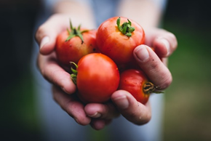
Energy In Our Diet: Entry Ticket

What is your favorite food?
_______________________________
_______________________________
What is a healthy food you eat?
_________________________________
_________________________________
What does healthy mean?
_________________________________
_________________________________

Where do you get your energy from?
______________________________________________________
How do humans interact with the ecosystem?
____________________________________________________________________________________________________________
Energy In Our Diet:
Write the definitions for the following terms and draw a photo in the box provided
Producer: __________________________
__________________________________
Consumer: _________________________
__________________________________
· Primary Consumer: _____________________
___________________________________________
___________________________________________
· Secondary Consumer: ____________________
___________________________________________
___________________________________________
Decomposer: _______________________
__________________________________
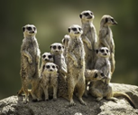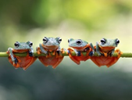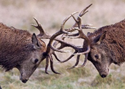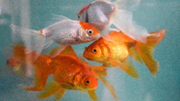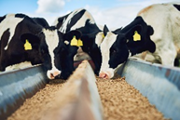
The Energy Pyramid: (Print on Poster Board for students to share)

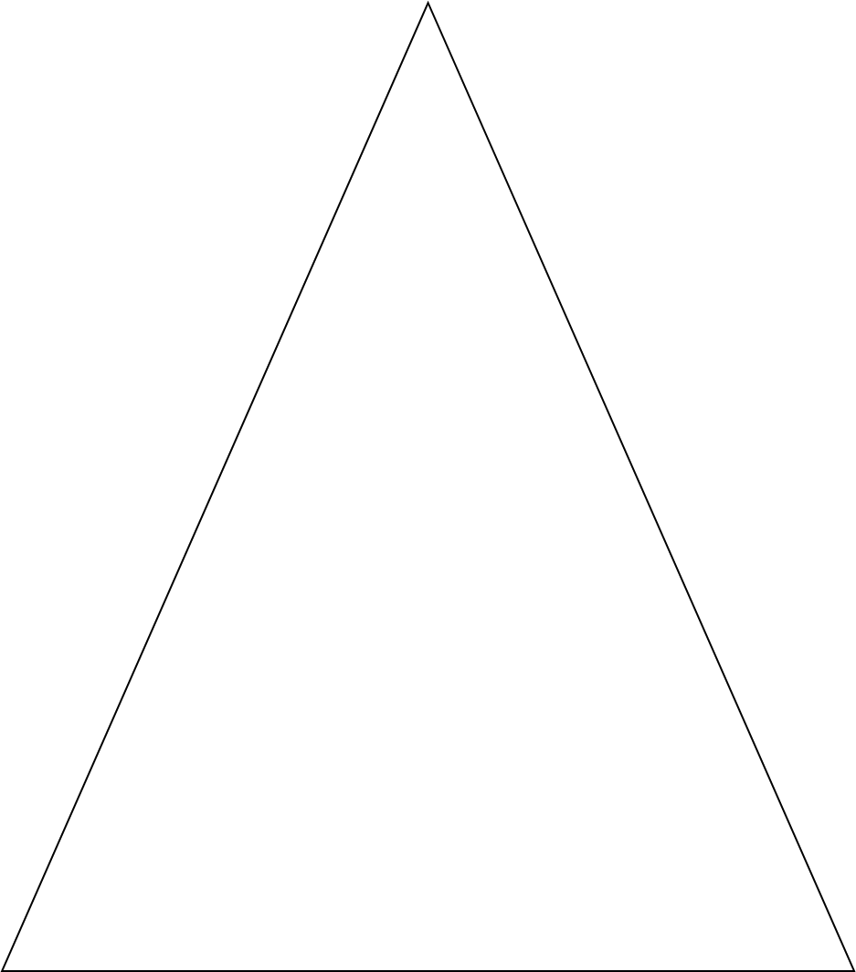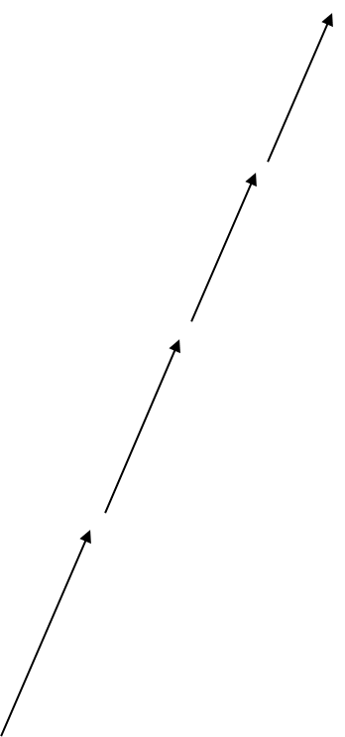

Animal Printouts
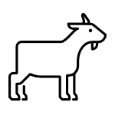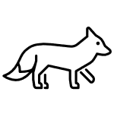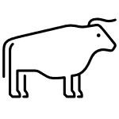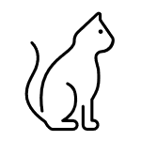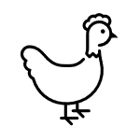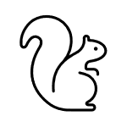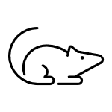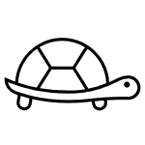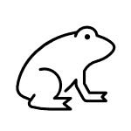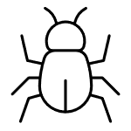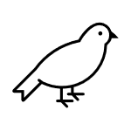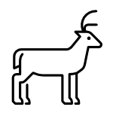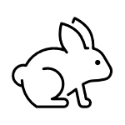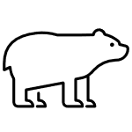

Exit Ticket: Using the plate below, draw what foods you typically eat for dinner.
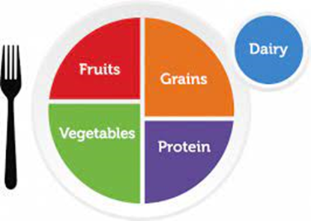
Photo credit: Myplate.gov
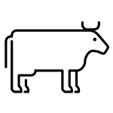
Animal Relationships: Entry Ticket
What is a prey predator reaction?
______________________________________
______________________________________
What is a positive interaction between animals?
______________________________________
______________________________________
What is a negative interaction between animals?
______________________________________
______________________________________
______________________________________
What is a neutral interaction between animals?
______________________________________
______________________________________
______________________________________

Animal Relationships: Symbiosis
Define the following terminology and give examples
Mutualism: _______________________
_________________________________
Example: _____________________

Parasitism: _______________________
________________________________
Example: ____________________

Commensalism: __________________
________________________________
Example: ____________________

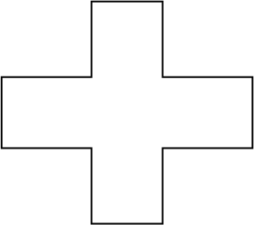
Hot Potato Game Roles (Cut and pass out roles)
Squirrel Crow

Rabbit Hawk

Grasshopper Quail

Bee Turkey

Fly Snake

Deer Beetle

Coyote Bear

Fox Earthworm

Possum Frog
Exit Ticket: Vocabulary Quiz, give definitions and examples
What does symbiosis mean?
____________________________________________________
What does mutualism mean?
____________________________________________________
What does commensalism mean?
____________________________________________________
What does parasitism mean?
____________________________________________________
What is a niche?
____________________________________________________
How do animals work together and against each other in an ecosystem?
____________________________________________________
Where does energy come from?
____________________________________________________
Using a few sentences describe an ecosystem which includes a producer, consumer, and decomposer.
____________________________________________________________________________________________________________________________________________________________________________________

Food Web Game
- Each person gets a certain population to begin the game with and a diet
- They need a set number of points to be extinct, hungry, full, or satisfied
- If they are extinct, the population is gone, if they are hungry they lose 1 member of the population, if they are full their population remains stagnant, if they are satisfied they can reproduce 1 for every 2 of their current population
- Finally, beware of natural disasters! Also, no speaking with other species and be careful as each round will only last 20 seconds.

Provide students with population tokens and energy tokens. Set out energy tokens in front of population tokens, so when someone eats the animal they take the energy token, that way the species can see which died (population without energy in front of them) at the end of the round and give their population token back to the bank. There is a set amount of energy required to sustain population, which is simplified for the sake of the game.

Producers:
1. Corn: eaten by grasshopper and deer *gives off 4 energy points each round*
- each energy points worth 1
2. Grass: eaten by rabbits, grasshopper, and deer *gives off 4 energy points each round*
- each energy points worth 1
3. Hay: eaten by rabbits

Members of Food Web (Assign one student to each, add more if needed or divide class)

Deer:
- Eats grass, hay, corn
- Eaten by hawks and coyote
- 0/1/2 Extinction, 3 lose 1 animal, 4 stable, 5 reproduce
- Starting population 3 each worth 4 pts

Grasshopper
- Eats corn, grass, hay
- Eaten by mice, crows, and foxes
- 0 extinction, 1 lose 1 animal, 2 stable, 3 reproduce
- Starting population 5 each worth 1 pts

Mice
- Eat grasshoppers and corn
- Eaten by hawks and coyotes
- 0/1 extinction, 2 lose 1 animal, 3 stable, 4 reproduce
- Starting population 3 worth 2 pts

Crows
- Eat grasshoppers and rabbits
- Eaten by coyotes and hawks
- 0 extinction, 1 lose 1 animal, 2 stable, 3 reproduce
- Starting population 3 worth 2 pts

Foxes
- Eat rabbits and grasshoppers
- Eaten by coyotes and hawks
- 0/1/2 extinction, 3 lose 1 animal, 4 stable, 5 reproduce
- Starting population 3 worth 3 pts

Rabbits
- Eat grass and hay
- Eaten by crows and foxes
- 0 extinction, 1 lose 1 animal, 2 stable, 3 reproduce
- Starting population 6 worth 2 pts

Coyotes
- Eat mouse, deer, crows, and foxes
- Eaten by hawks
- 0/1/2 extinction, 3 lose 1 animal, 4 stable, 5 reproduce
- Starting population 3 worth 4 pts

Hawks
- Eats mice, crows, coyotes, deer, foxes
- Eaten by nothing
- 0/1/2/3/4 extinction, 5 lose 1 animal, 6 stable, 7 reproduce
- Starting population 1 worth 5 points

Decomposer: Worms
- must collect 3 points each round from any species to simulate natural disaster or random death

Possible other animals to add frogs, possums, bears, quail, turkey, earthworm, beetle, fly etc.

Final Summative Assessment
Write and explain your strategy during the game. How did you contribute to the ecosystem surviving or failing? Include terminology such as symbiotic relationships, niches, conservation, human interaction, and ecosystem.
Second, address is conservation important. Consider how humans interact with animals’ ecosystems, do humans change them, why or why not? ____________________________________________________________________________________________________________________________________________________________________________________________________________________________________________________________________________________________________________________________________________________________________________________________________________________________________________________________________________________________________________
Answer Key
Energy In Our Diet: Entry Ticket

What is your favorite food?
Pancakes, salads, hamburgers, cookies__
_________________________________

What is a healthy food you eat?
Salads, fruit, vegetables, grains, proteins_
_________________________________

What does healthy mean?
Provides nutrients and energy to our body,
promotes health ___________________

Where do you get your energy from?
Foods, liquids, sun, vitamins, minerals
How do humans interact with the ecosystem?
Harvesting fruits and vegetables, hunting or eating meat, living within ecosystems __________________________
Animal Relationships: Entry Ticket (Examples May vary)
What is a prey predator reaction? Give an example
Where one animal hunts another for food
_________________________________
What is a positive interaction between animals?
Give an example
Where one animal benefits, for instance sharing a
habitat or cuddling to stay warm
What is a negative interaction between animals?
Give an example
Where the animal is hurt by the interaction,
for instance, prey-predator reactions or loss of
habitat or competition for food
What is a neutral interaction between animals?
Give an example
Where the animal is unaffected by the interaction,
for instance, a bug riding on a horse’s saddle
Exit Ticket: Using the plate below, draw what foods you typically eat for dinner.
Photo credit: Myplate.gov
Answers can vary, students should use Myplate to explain their dinner and compare to see if it accurately matches their plate, why or why not?

Entry Tickets & Exit Ticket Rubric
Formative Assessment Pair and Share
 | Needs work (3 points) | Proficient  (7 points) | Advanced  (10 points)
Effort & Creativity | The students did not address the questions or gave one-word answers | The students put in effort to answer the questions  The student’s brainstormed what the questions meant and responded | The students gave detailed responses and really thought about humans interact with the ecosystem to survive
Accuracy | The students did not think of what the questions meant | Students responded in a way that showed that they understood the main concept. Maybe give wrong examples, but this could be attributed to not understanding individual species interactions. | Students provided adequate definitions and examples that corresponded.
Pair & Share | Students did not engage in pairing and sharing | Students compared answers with classmates, but did not have in depth discussions | Students had in depth discussions on their responses
Overall & Comments

Formative Assessment Rubric
Project and Problem Based Learning
 | Needs work (3 points) | Proficient  (7 points) | Advanced  (10 points)
Engagement | Students were not paying attention or participating in the activity | Students were participating in the activity, but not contributing any more than necessary | Students were actively engaged and participating an appropriate amount
Effort | Students did not contribute to the final result | Students contributed some thought to the final result | Students contributed much thought and shared deep reflections
Collaboration | Students did not talk with other students | Students talked minimally with other students or talked over other students | Students talked an appropriate amount and contributed to the conversation
Overall & Comments

Animal Relationships: Symbiosis (No Grading)
Define the following terminology and give examples
Mutualism: both species benefit _______
_________________________________
Example: Bee and Flower________

Parasitism: one species benefit, and one is harmed
________________________________
Example: Dogs and Ticks _______

Commensalism: one species benefit, and one is
unaffected _____________________________
Example: _Tree frogs and plants ________

Exit Ticket: Vocabulary Quiz
What does symbiosis mean?
Interactions between two species living together in an ecosystem
What does mutualism mean?
Both species benefit ___________________________________
What does commensalism mean?
One species benefits and one is unaffected _________________
What does parasitism mean?
One species benefits and the other is harmed _______________
What is a niche?
Animal’s role in an environment in response to conditions and interactions ________________________________________
How do animals work together and against each other in an ecosystem? (Examples are suitable and answers may vary)
Work together and against through symbiotic relationships. For instance, work against through prey predator interactions and together through mutualistic interactions. ________________
Where does energy come from?
Food, producers, consumers, light_______________________
Using a few sentences describe an ecosystem which includes a producer, consumer, and decomposer. (Answers may vary, use of examples are appropriate to illustrate)
Rubric
 | Needs work (3 points) | Proficient  (7 points) | Advanced  (10 points)
Effort & Creativity | The students did not address the questions or gave one-word answers | The students put in effort to answer the questions  The student’s brainstormed what the questions meant and responded | The students gave detailed responses and really thought about through interactions.
Accuracy | The students did not think of what the questions meant | Students responded in a way that showed that they understood the main concept. Maybe give wrong examples, but this could be attributed to not understanding individual species interactions. | Students provided adequate definitions and examples that corresponded.
Overall & Comments

Final Summative Assessment
Ask students using a blank piece of paper to write and explain their strategy during the game. How did they contribute to the ecosystem surviving or failing? Ask them to include terminology such as symbiotic relationships, niches, and ecosystems.
Second ask them to address is conservation important. And ask them to consider how humans interact with animals’ ecosystems, do humans change them, why or why not? ANSWERS MAY VARY ____________________________________________________________________________________________________________________________________________________________________________________________________________________________________________________________________________________________________________________________________________________________________________________________________________________________________________________________________________________________________________

Summative Assessment Rubric
 | Needs Work (3 points) | Proficient  (7 points) | Advanced  (10 points)
The larger picture | Students don’t use the terminology at all and make no connections to the larger picture | Students apply the terminology to narrate their response. Students make connections to the larger picture. | Students applied knowledge to larger concepts such as human interactions with the environment, conservation, evolution
Vocabulary | Students don’t include any vocabulary from the unit | Students include vocabulary from the unit, with some mistakes | Students weave vocabulary from the unit into their responses in meaningful and accurate ways
Reflection | Student don’t reflect and apply what they learned this unit | Students reflect and apply what they learned this unit, but don’t make any personal reflection or connections beyond course content | Students reflect and apply course content beyond the scope of the course, by introducing new ideas and proposing questions
Strategy | The students showed no strategy or collaboration during the game | The students showed strategy and collaboration during the game, and reflect upon it in their response | Students use strategy and collaboration to make connections to course content and describe how ecosystems work

