Taking Steps to Solve the Water Crisis
Author: Elizabeth Thiel
Unit Overview
Target Audience: Grades 1 - 3 | Est. Time: Four 45 minutes class periods | Content Area(s): Science and Engineering
Abstract:
Design challenges centered on identifying and solving real-world problems add relevance to the classroom by showing students science in their own world and guiding them to sense making of science concepts. This lesson will focus science instruction on the 21st century problem of access to clean water. Using children’s literature, Nya’s Long Walk, as a starting point this lesson will guide students through identifying the global challenge that not all people have easy access to clean water, figure out why and how it happens and brainstorm potential solutions for providing access to clean water. The session will engage students in an abbreviated STEM design challenge aligned with science and engineering practices (SEPs) as well as Indiana content standards. Participants will create blueprints for a solar cooker and explain how it can create clean water, justifying their response with scientific evidence and concepts.
Unit Goals/Objectives:
- Brainstorm solutions to solve a clean water crisis
- Investigate and record temperatures to determine the materials that absorb and reflect heat
- Design and construct a solar cooker
Lesson Summaries:
Lesson 1: Read Aloud, Problem Scoping, Blue Prints
Driving Question: What problems does Nya face on her long walk and what are possible solutions?
- Brainstorm 21st century problems
- Suggest solutions to the problems.
- Create “BluePrints” for a solar cooker
Lesson 2: What materials absorb heat?
Driving Question: What materials will make the best solar cooker?
- Conduct an investigation with four different materials
- Record data
- Make a claim based on evidence collected
Lesson 3: Design, Make, and Test Solar Cooker
Driving Question: Can you make a solar cooker that will cook a s’more?
- Design and construct a solar cooker with recycled materials
- Evaluate a design to determine if it meets criteria.
- Analyze data from tests and explain why some designs were more effective.
- Create new designs by looking at test results to improve solar cooker
Lesson Timeline:
Lesson 1 (45 minutes): Read Aloud, Problem Scoping, Blue Prints
- Read Nya’s Long walk: 10 minutes
- Brainstorm problems Nya faced: 5 minutes
- Water crisis video: 5 minutes https://youtu.be/LSqan1xmMpY
- Brainstorm solutions: 5 minutes
- Introduce solar cookers: 5 minutes
- Create solar cooker Blueprints and share: 10 minutes
- Wrap up: 5 minutes
Lesson 2 (45 minutes): What materials absorb heat?
- Introduction: 5 minutes
- Review: 5 minutes
- Fair test investigation for Properties of matter, white paper, black paper, foil (25)
- Wrap up : Scaffolded CER
Lesson 3 (2 x 45 minutes): Design, Make, and Test Solar Cooker
Day 1:
- Introduction: 5 minutes
- Review: 5 minutes
- Intro to design challenge: 5 minutes
- Design and make solar cookers: 20 minutes
- Accurately calculate budget: 10 minutes
Day 2:
- Test the cookers with S’mores: 20 minutes
- Students share/ communicate ideas/ give feedback: 20 minutes
- Discuss results: 5 minutes
Standards:
NGSS standards for K-2:
2-PS Analyze data obtained from testing different materials to determine which materials have the properties that are best suited for an intended purpose.
K-2 ETS1-1 Ask questions, make observations, and gather information about a situation people want to change and define a simple problem that can be solved through the development of a tool.
K-2-ETS1-2. Develop a simple sketch, drawing or physical model to illustrate how the shape of an object helps it function as needed to solve a given problem.
K-2-ETS1-3 Analyze data from tests of two objects designed to solve the same problem to compare strengths and weaknesses of how each performs
Science and Engineering Process Standards (SEPS)
SEPS.1 Posing questions (for science) and defining problems (for engineering)
SEPS.2 Developing and using models and tools
SEPS.3 Constructing and performing investigations
SEPS.4 Analyzing and interpreting data
SEPS.6 Constructing explanations (for science) and designing solutions (for engineering)
SEPS.7 Engaging in argument from evidence
SEPS.8 Obtaining, evaluating, and Communicating information
STEM Integration within the Unit:
In my Integrated STEM through AFNR, Taking Steps to solve the Clean Water Crisis, three of the STEM disciplines are deeply integrated; science, engineering, and mathematics. Technology is integrated at a minimal level with room for expanding in future iterations of the lesson. There is also literacy and social studies integration in this 21st century problem solving unit. For both science and engineering, students engage in multiple science and engineering practices SEPs; including asking questions and defining problems, constructing explanations and designing a solution, developing and using models, engaging in argument from evidence and obtaining evaluating and communicating information (chart outlining how these present in the classroom is attached). The specific science concepts students focus on are highlighted on day two 1) creating a fair investigation to test what materials will work best for the solar cooker 2) Energy: heat and light 3) using the tools of a scientist: thermometer, stop watch. For engineering, students complete an engineering design challenge and construct their own solar cooker. This process begins on day one and continues on days 3, 4, and 5. Math integration is implemented through the use of a budget. Students have to calculate how much money is spent on their solar cooker design. Simple technology, such as using a thermometer and a heat lamp to test the solar cooker are implemented during the testing phase of the unit.

Lesson 1: Read Aloud: Nya’s Long Walk
Est. Time: 45 minutes
Lesson Learning Goals/Objectives:  - Students will engage in problem scoping for the Nya’s long walk and define a problem  - Students will create a reasonable diagram model for a solar cooker.  - Students will use evidence based reasoning to explain their diagram |  | Standards:  K-2 ETS1-1 Ask questions, make observations, and gather information about a situation people want to change and define a simple problem that can be solved through the development of a tool.  K-2-ETS1-2. Develop a simple sketch, drawing or physical model to illustrate how the shape of an object helps it function as needed to solve a given problem
Assessments
Formative:
Student Log Book
Concept Prerequisites or Background Knowledge Needed:

Vocabulary:
blueprint, solar
Materials & Technology Needed:
Nya’s Long Walk
Student graphic organizer/ log book- This item is critical in guiding the unit and appears in lessons 1 & 3
Video: https://www.youtube.com/watch?v=teX2l_E40mw
Lesson guiding Slide Deck- This is critical in guiding the unit and appears in all three lessons
National Geographic Video: https://youtu.be/Ofn7jqPDTeY
Lesson Component | Instructions |  | Materials
Introduction  15 minutes | Read Aloud (10 minutes)  - Before reading have students look at the cover of the book and brainstorm predictions  - Ask students to listen for challenges that Nya faces in the story.  - Record them as they read the story.  Brainstorm Problems Nya Faced (5 minutes)  - Class shares out ideas  - Generate a list on the white board  Watch video: https://www.youtube.com/watch?v=teX2l_E40mw |  | Nya’s Long Walk  Student graphic organizer/ log book- This item is critical in guiding the unit and appears in lessons 1 & 3  Video: https://www.youtube.com/watch?v=teX2l_E40mw  Lesson guiding Slide Deck- This is critical in guiding the unit and appears in all three lessons
Instructional Activities  25 minutes | Introduce Solar Cookers (5 minutes)  - Begin with scaffolding questions guiding students to solar cookers (slide deck)  - National Geographic Video: https://youtu.be/Ofn7jqPDTeY |  | National Geographic Video: https://youtu.be/Ofn7jqPDTeY  Link in slide deck
 | Create Solar Cooker BluePrints (20 minutes)  - Brainstorm possible materials that could be used for a solar cooker  - Draw a detailed, labeled “blueprint”  - Define blueprint (Detailed, labeled drawing of solar cooker) |  | Student log book
Wrap Up,  Synthesis/Closure  5 minutes | Formative assessment: Complete a one minute quick write responding to “What did you do and why?” |  | Student log book
Resources:

Lesson 2: What materials make the best solar cooker? Absorb the most heat?
Est. Time: 45 minutes
Lesson Learning Goals/Objectives:  - Students will be able to record and communicate observations and measurements  - Students will make claims from evidence  - Students will demonstrate an understanding of a fair test |  | Standards:  2-PS Analyze data obtained from testing different materials to determine which materials have the properties that are best suited for an intended purpose.
Assessments
Formative:
Student Log Book, discussions
Concept Prerequisites or Background Knowledge Needed:
Awareness of global challenges and solar cookers
Vocabulary:
hypothesis, phenomena
Materials & Technology Needed:
Nya’s Long Walk
Solar cooker Materials Investigation sheet
Lesson guiding Slide Deck
Fair test investigation sheets
Thermometers
Black paper
White paper
foil
Graphic Organizer/ Investigation sheet
Lesson Component | Instructions |  | Materials
Introduction  10 minutes | (5 minutes) Begin with the story about my students in Hawaii practicing for a May Day performance on the black top and racing to the cement in between rounds.  - Ask students if they have even been outside on a hot day in a black T-shirt. What happens to the T-shirt? Is it different from a white T-shirt?  - As a group write a prediction on a white board explaining this phenomena.  Review Solar Cookers (5 minutes)  - Remember our lesson last time?  - Can you think of a connection to the scenario we just described and solar cooker materials. |  | Nya’s Long Walk  Solar cooker Materials Investigation sheet  Lesson guiding Slide Deck
Instructional Activities  25 minutes | Develop Fair test Investigation as a class (10 minutes)  Scaffold a fair test investigation with students for materials  - Black paper  - White paper  - foil  Write a hypothesis  Create a “fill in the blank” procedure as a class  Create a data table as a class |  | Fair test investigation sheets  Thermometers  Black paper  White paper  foil
 | Conduct Fair Test Investigation (15 minutes)  - Record Data  - Discuss Data  - What do the results tell us? |  | Graphic organizer/ Investigation sheet
Wrap Up,  Synthesis/Closure  10 minutes | Formative Assessment: Write a claim evidence reasoning statement to answer the driving question |  | Graphic Organizer/ Investigation sheet
Resources:

Lesson 3: Design, Make and Test Solar Cooker (2 x 45-50 minute lessons)
Est. Time: 45 minutes
Lesson Learning Goals/Objectives:  - Students will design, construct and test a solar cooker  - Students will determine how their design could be improved in the future.  - Students will communicate their ideas with classmates  - Students will give written feedback to peer engineers. |  | Standards:  K-2 ETS1-1 Ask questions, make observations, and gather information about a situation people want to change and define a simple problem that can be solved through the development of a tool.  K-2-ETS1-2. Develop a simple sketch, drawing or physical model to illustrate how the shape of an object helps it function as needed to solve a given problem.  K-2-ETS1-3 Analyze data from tests of two objects designed to solve the same problem to compare strengths and weaknesses of how each performs
Assessments
Formative:
Criteria Check:Restate the task (bottom of log book p. 2)
Summative:
Summative assessment: Complete the back page of the student log book
Concept Prerequisites or Background Knowledge Needed:
Lesson 1 - 2 content
Vocabulary:
solar, criterion, budget
Materials & Technology Needed:
Student log book (below)
Slides
Log books
Lesson guiding Slide Deck
Foil
Tape
Saran wrap
Cardboard
Black paper
Skewer
Paper bowl
Craft sticks
Box
Other recyclables
Heat lamps
Laundry baskets
Skewers
Marshmallows
Chocolate
Graham crackers
Stop watches
Solar cookers
Solar cooker feedback form
Lesson Component | Instructions |  | Materials
Day 1
Introduction  5 minutes | - We need to think of a way to test our solar cookers!  - Have you ever cooked anything outside of the kitchen?  - Think- Pair-Share  - S’mores article from scholastic science world (link in slide deck) |  | Student log book
Instructional Activities  35 minutes | Introduce Criteria and Constraints and how to test (5 minutes)  - Read aloud criteria and constraints  - Discuss what they mean  - Develop a test scale: gooeyness? Temp of marshmallow?  - Reference temperatures from Science World Article |  | Student Log book
 | Background Solar Cooker Info (5 minutes)  - Share background solar cooker info slides with class while calling on volunteers complete page two brainstorm/ background boxes  - Record responses in Student log book  - Formative Assessment: Criteria Check:Restate the task (bottom of log book p. 2) |  | Log books  Lesson guiding Slide Deck
 | Design and Budget (10 minutes)  - With your partner decide on the design you want to create  - Include a detailed Labeled drawing of your cooker.  - Determine the budget based on the supplies used.  - Work through an example together to make sure students understand how to calculate budget. |  | Log book
 | Construct (15 minutes)  - When students can share a completed budget and labeled design they may collect their materials to begin constructing their solar cooker with a partner. |  | Foil  Tape  Saran wrap  Cardboard  Black paper  Skewer  Paper bowl  Craft sticks  Box  Other recyclables
Wrap Up,  Synthesis/Closure  5 minutes | Formative assessment: Complete Criteria Check before storing solar cooker in a safe place until testing day. |  | Log Book
Day 2: Testing Solar Cookers
Instructional Activities  40 minutes | Test Solar Cookers (15 minutes)  - Test and record data  - Follow slide deck procedure for testing,  - Set up test areas with heat lamps and laundry baskets.  - If it is a sunny day- set the test up outside! |  | Heat lamps  Laundry baskets  Skewers  Marshmallows  Chocolate  Graham crackers  Stop watches
 | Share Designs (15 minutes)  - Partners present their solar cookers to the class  - Explain design  - Share budget and data  Engineer Feedback Complete during design share  - Write about another classmates design  - What did they do well and why?  - Complete feedback form for one or more other teams |  | Solar cookers  Solar cooker feedback forms
 | Analysis (10 minutes)  - Summative assessment: Complete the back page of the student log book |  | Log book  slides
Wrap Up,  Synthesis/Closure  5 minutes | Revisit essential question: Can a solar cooker help solve the clean water crisis? How?
Resources:

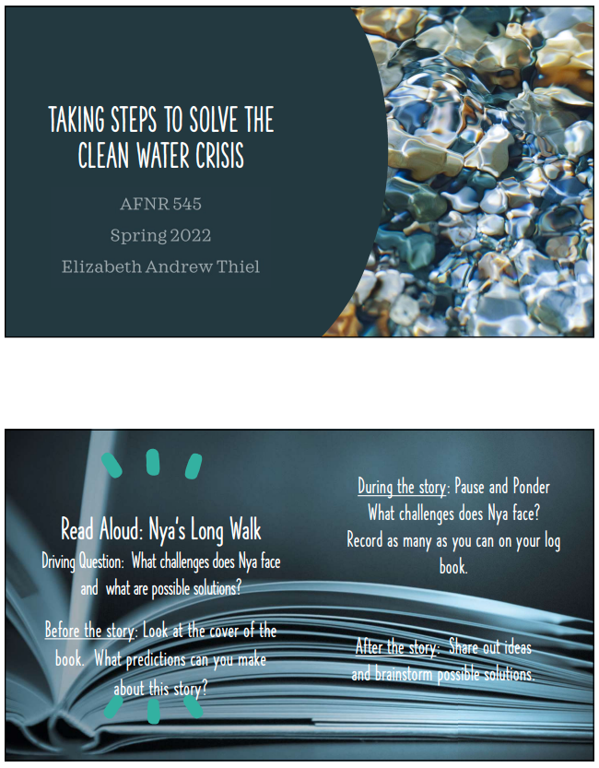
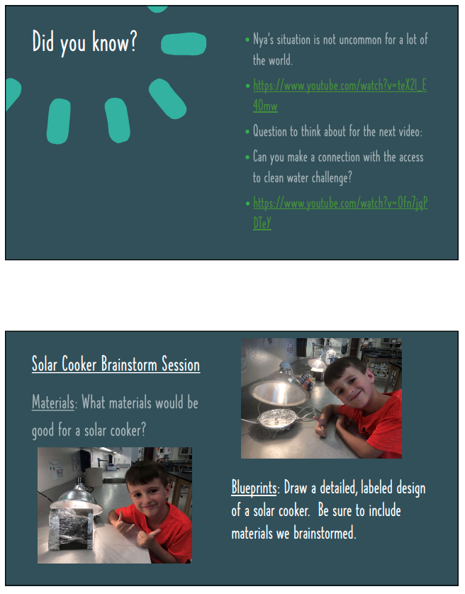
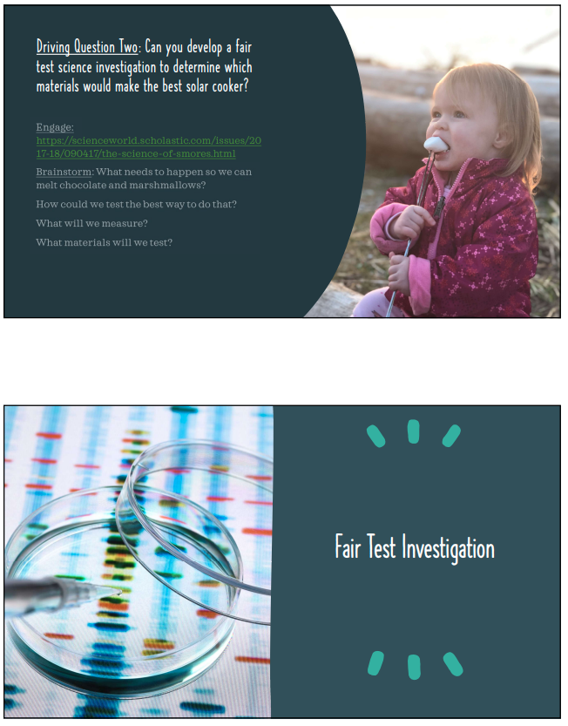
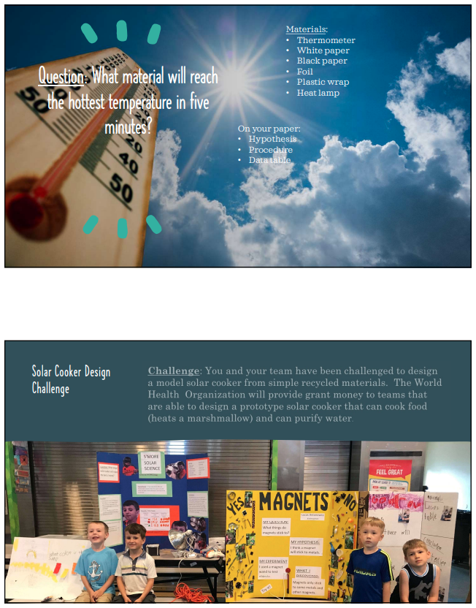
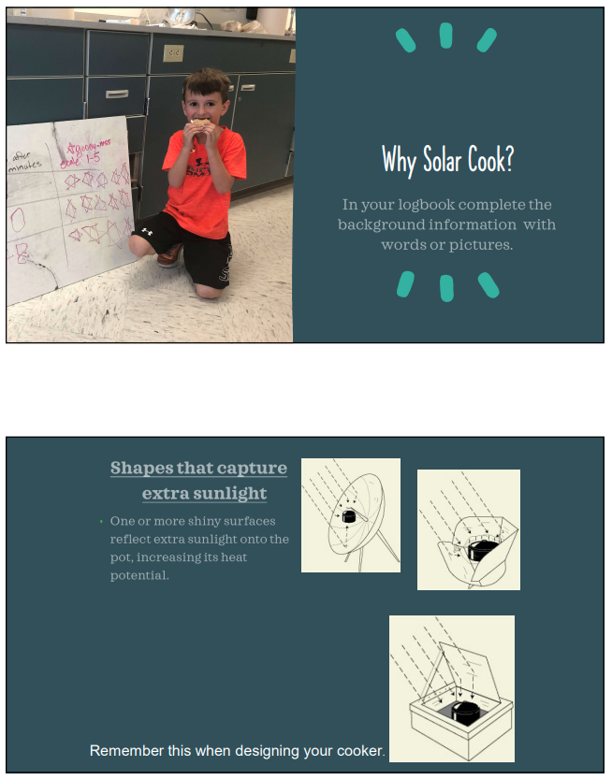
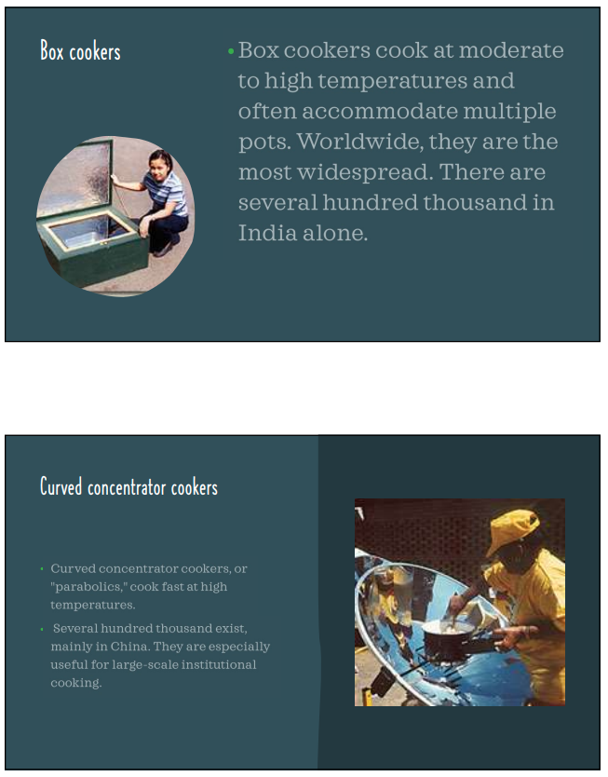
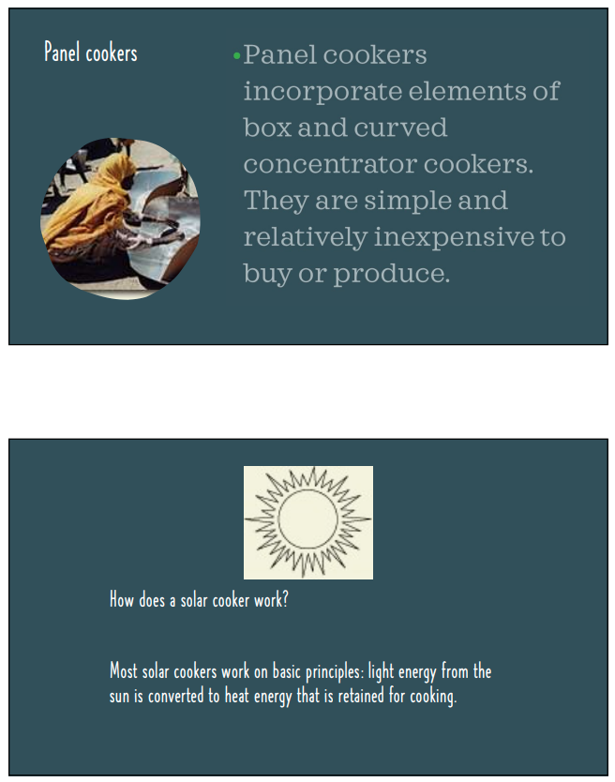
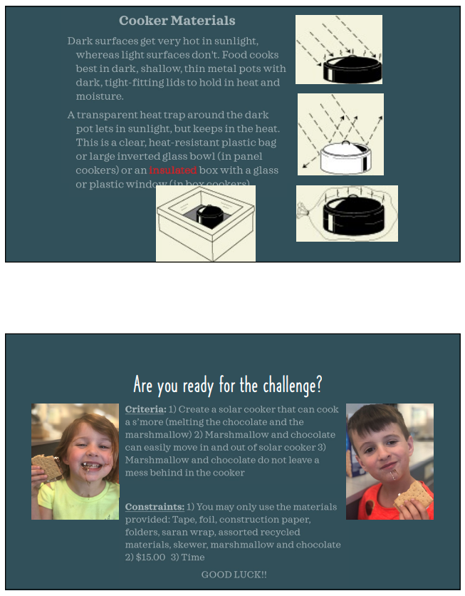
Rubric for Lesson 2: Fair Test Investigation

Criteria | Smoke Alarm (1) | Pretty Hot  (2) | On Fire!  (3) | Points Earned
Records and communicates observations and data | Student is unable to record of communicate observations | Student records of communicates observations, but they are unclear or incomplete | Student records and communicates observations in a clear and thorough manner using words, pictures, or both
Makes claims from evidence | Student is unable to make claims | Student makes claims that are unsupported by evidence | Students make claims about plans needed from observing patterns in data.
Demonstrates understanding of fair test | Students are unable to demonstrate understanding of a fair test. | Students recognize that the test needs to be fair but cannot identify factors to control. | Student identifies how to design a fair test and can identify controls
Total

Solar Cooker Materials Investigation
Name: ___________________________________
Question: What material will reach the hottest temperature in five minutes?
Materials:
· Thermometer  · White paper  · Black paper | · Aluminum Foil  · Plastic wrap  · Heat lamp

Hypothesis:
If we test four different materials then ________ will get hot the fastest because
____________________________________________________________.
Procedure:
1. Take white paper and fold in half. Place ________ inside.
2. Put paper and thermometer ________
3. Record temperature after ____ minutes.
4. Repeat with black paper, __________, ____________, and plastic wrap.
Data Table:
Material | Temperature after five minutes

Think about it (Analysis):
1. Which material had the hottest temperature? _____________
2. What temperature is needed to melt marshmallows? _________
Use the information above to write a CER (Claim, Evidence, Reasoning) Statement.
Question: What material will reach the hottest temperature in 5 minutes?
Claim: My hypothesis was (Correct/ Incorrect) because ________ reached the hottest temperature.
Evidence: I know this because _________was _______ degrees and that is (higher/ lower) than ___ of the other temperatures recorded. | Reasoning: This evidence supports my claim because

3. How can this information help us design and create a solar cooker?
Draw a picture below to show an idea of how the materials we tested could help someone stay cool outside on a hot day. (Think of clothing, hats, tents/shades, umbrellas)

Solar Cooker Feedback
Reviewer’s Name _____________________
Solar cooker team: _______________________
Problem: _______________________
List or draw one thing the Engineers did well | List one or more improvement the engineer could make

Does the solar cooker meet the criteria? | Yes | No
What was the budget for the cooker?

Make an inference about what rating the World Health Organization will give this play solar cooker (fill in the stars for rating)

