

Graduate Student Program RESOURCE MANUAL

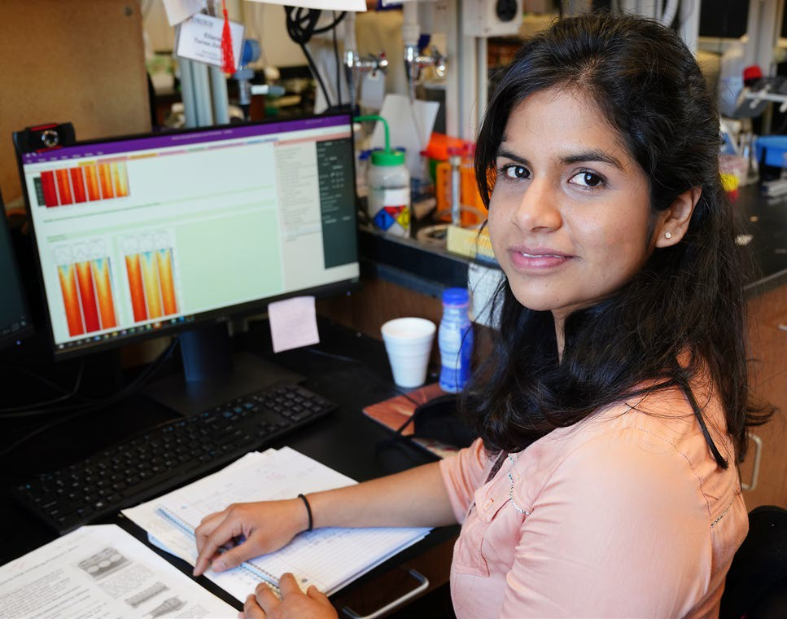
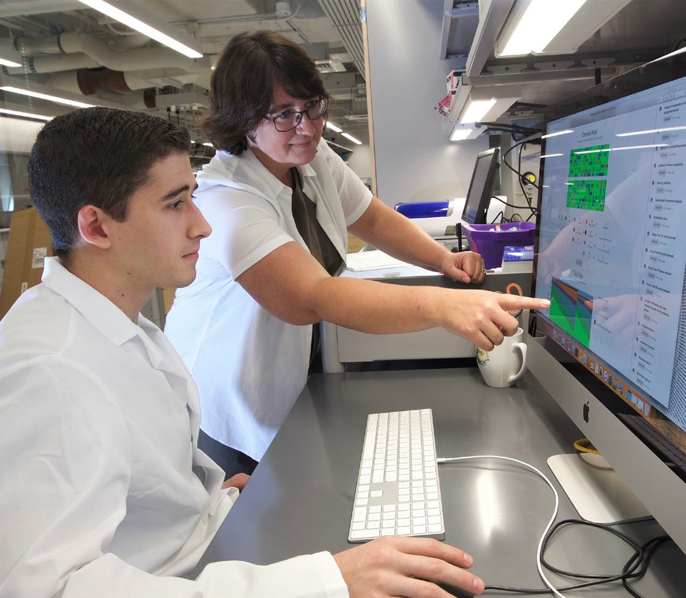
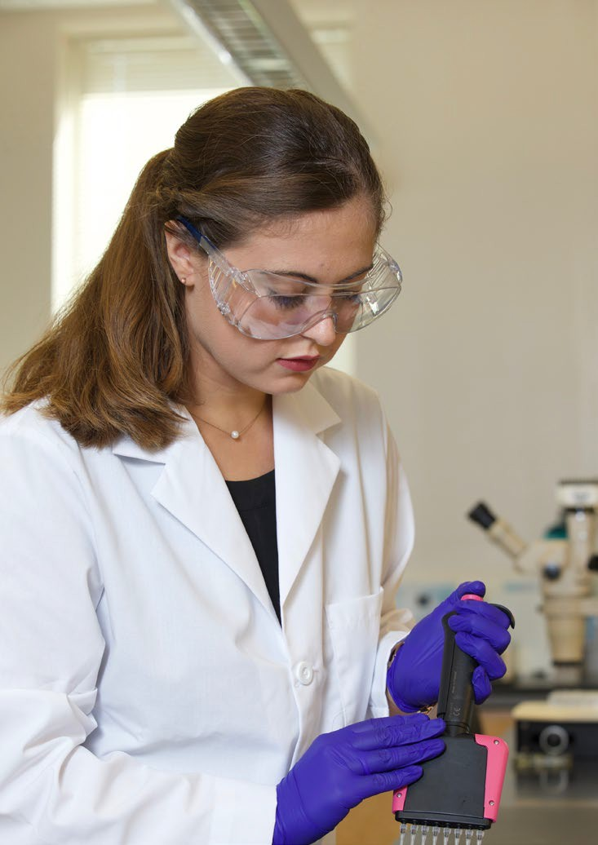
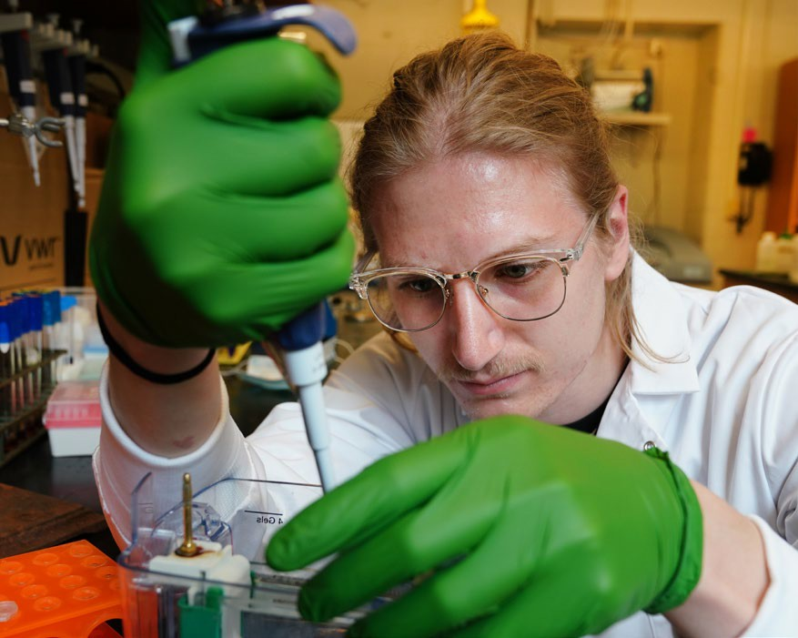

Revised June 2022

Table of Contents 1
Administration of Graduate Program 2
Staff and Resources 2
First Year Students 3
Expectations During First Year 4
Graduate Student Progress 5
Expectations after Permanent Lab Assignment 5
Registration 6
Plan of Study 7
Course, Grade and Elective Requirements 7-8
Publication Requirement 9
Seminar Series 9
Teaching Requirement 10
Ph.D. Thesis Advisory Committee 10
Guidelines for Preparation of the Annual Progress Report 11
Annual Progress Report Example 12
PRELIMINARY EXAM: Early Exam, Brief Overview 13
Steps 1-5 Prelim Exam Process 14-15
Content and Organization of Written Prelim Exam 16-17
Steps 6-9 Prelim Exam Process 17-18
iThenticate Screening and Avoiding Plagiarism 19
Plagiarism and Code of Research 19
Guidelines for Avoiding Plagiarism, Self-Plagiarism, and Questionable Writing Practices 20
Guidelines for Evaluation of Preiminary Exam Performance 22
Master's Degree 23
Thesis Defense 23
THESIS Preparation, Approval, and Distribution 24
Biochemistry Intranet 25
HR, Employment and Benefits Summary 26-27
Please refer to the Graduate School Employment manual for detailed information on benefits and employment. https://www.purdue.edu/gradschool/documents/gpo/graduate-student-employment-manual.pdf

Administration of Graduate Program
This information is a reference for Biochemistry graduate students to find program requirements/details. It supersedes prior editions of the Biochemistry Department Graduate Program Manual. Policies and procedures of Purdue University and the Biochemistry Department are subject to change periodically as a result of actions by federal and/or state government, trustees of Purdue University, and/or administrators of the Department of Biochemistry Graduate Program.

Staff and Resources
Graduate Program Coordinator/Assistant: Traci Jordan tljordan@purdue.edu
The program assistant works with Graduate Chairs, Major Professors, Dept. Head, and Graduate School to oversee the BCHM graduate program; providing guidance for Biochemistry PhD students as they navigate their graduate education in the Biochemistry graduate program.
First Year Graduate Chair: Dr. Scott Briggs sdbriggs@purdue.edu
Until a Major Professor is selected, the First Year Graduate Chair’s role is to help new students understand the academic requirements of the program; advise them and oversee their progress until they have a thesis advisor. He/she meets with students to determine rotation schedules and final lab placements. She/he is available to meet with graduate students about any problems or concerns.
Major Professor/Thesis Advisor: To be determined after lab rotations
The Major Professor has supervisory responsibility for a student’s research. She/he meets with students about their research and offers advice on problems or issues that may arise in their graduate career.
Preliminary Exam Graduate Chair: Dr. James Forney forney@purdue.edu
This faculty member serves dual roles. As Preliminary Exam Graduate Chair, he/she oversees prelim examinations, approves prelim examination proposal topics, assigns prelim exam committees, and meets with graduate students about issues that may arise regarding preliminary exams.
Department Head: Dr. Andrew Mesecar amesecar@purdue.edu
He/she is the head of the Biochemistry graduate program. She/he is available to meet with graduate students about any problems or issues that may arise throughout their graduate career.
Graduate Program Chair: Dr. Elizabeth Tran etran@purdue.edu
He/she oversees the graduate program; acts as mentor to BCHM GSO (Graduate Student Organization).
Biochemistry Grad Student Organization GSO: We have an active GSO who are involved in recruiting, social activities, professional development and more. New Officers for 2022 are listed below.
President – Ronard Kwizera Treasurer – Kedric Milholland
PGSG Senator for Biochemistry Department – Steven McKenzie Grad/Postdoc Seminar Co Chairs – Smriti Hoda / Isaiah Mensah Graduate Student Mentor Chair – Pallavi Joshi
Social Co Chairs – Bobby Cheng / Kendall Souder
Counseling & Psychological Services (CAPS) https://www.purdue.edu/caps/services/therapy/index.html Clinicians are available for mental health emergencies. Hours for walk in are 8 am to 5 pm Monday – Friday. To speak to a clinician, call (765) 494-6995 and press #1 for consultation and/or referral.
Biochemistry Intranet: Located under Resources on our home page. https://ag.purdue.edu/biochem/Pages/. The Graduate tab contains forms for meetings and exams, the Grad Program book and other resources.

First Year Students

Graduate school is quite different from undergraduate programs. Success in graduate school requires you to take ownership of your own learning and professional development. Being a graduate student involves much more than completing courses. Because there is less structure in a graduate program, you are and must be accountable for keeping your research focused and on track, taking initiative to read related literature, and making sure you are fulfilling degree requirements and meeting expectations of research progress. It is your responsibility to:
Attend ORIENTATION: First year graduate students must arrive on campus in time to attend Biochemistry orientation on Monday morning of the week before classes begin (mid-August). You are required to attend all scheduled orientation; complete all required safety training certifications; Grad School admitted student checklist items and be prepared to meet with faculty in the department to assist in choosing and ranking lab rotations.
Check your PURDUE.EDU EMAIL: Your purdue.edu email is the official communication method of the University, the department, and your advisor. You are responsible for the materials and information sent to your email, even if you choose not to read them. Please check your email regularly so you receive timely information and don’t miss important reminders, deadlines or opportunities.
Degree Requirements: It is your responsibility to read and understand this manual and the requirements within. If you have questions, please do not hesitate to ask.
Research Expectations: It is imperative that you meet with your major professor to define what is expected of you. Research and course expectations should be discussed every semester. A research acknowledgement form signed by you and your major professor is required each semester.
Take Action: You are required to take care of any academic or financial actions that are requested. Failure to do so can result in registration cancellation or a hold placed on your account. It is easier to remain in good standing than to try to correct oversights.
ORCID ID# https://orcid.org/ Please register for an ORCID ID number and send this number to the graduate program coordinator. This helps the department track student publications.
Official Transcripts: The Graduate School requires final official transcripts from each university on your transcript by the end of your first semester. An official copy shows the type of degree and date the degree was awarded.
Students are not allowed to register for subsequent semesters until this requirement is met. https://www.purdue.edu/gradschool/admissions/how-to-apply/apply-transcripts.html
Immunizations Required: Indiana state law requires all new, regularly-enrolled students attending residential campuses of Indiana public universities to meet all immunization requirements by the end of the first semester of residence. Please see the list of immunizations: https://www.purdue.edu/push/Immunization/ Students will not be allowed to register for subsequent semesters until this requirement is met.
Oral English Proficiency Test for International Students (OEPT): Graduate students are required to teach one semester (at half time) during the program. Students whose first language is not English must pass a test of spoken English unless their TOEFL speak score is 27 or more. If a student fails the OEPT test, the student may be certified by passing ENGL 620 course. Failure to complete the spoken English requirement before the end of the first year may result in the student not being permitted to register and continue in the program.
Plan of Study: Complete an electronic Draft Plan of Study electronically using myPurdue during the first few weeks of the fall semester. The first-year chair will serve as the advisory committee chair and members of the Postdoc-Graduate Program Committee (PGPC) serve as the additional members of the committee. The initial Plan of Study includes all required and related coursework. Only graded courses can be used on a Plan of Study.

Lab Rotations: First year students will participate in three lab rotations with the option of a fourth if it’s needed. Rotation periods will last approximately eight weeks. At the end of each rotation, students will prepare and present a presentation of their work. Students not placed in a permanent lab after the third rotation may have a fourth rotation within the Department of Biochemistry. Additional details are given during orientation week.
During orientation week, students are expected to interview as many professors as they can within the biochemistry department to facilitate their preferences/choices for lab rotations. Faculty web pages briefly describe the type of research and laboratory work of each professor. Students will also attend Faculty Research Talks during Orientation week. Please feel free to ask questions during these talks.
Selection of the Major Professor: The Major Professor is the primary thesis advisor and has supervisory responsibility for a student’s research. She/he will meet with students as needed and is available to guide them through their graduate education. Each student will have adequate opportunity to investigate various laboratories and to become acquainted with professors who have lab positions and funding available.
The selection of the Major Professor is based upon the student’s choice and the availability of openings in the various laboratories. The selection must be a mutually acceptable arrangement between student and professor. Selection and assignments occur after three (or optional four) rotations in the first year.

Expectations During First Year
Below are goals for your first year of the Biochemistry Graduate program to help you gauge your progress. The first year is different than subsequent years in that you will be rotating in different labs, learning about the department and completing course requirements. Once course and elective requirements are met, subsequent years are spent primarily on research and publication of research findings.

Year 1
- Handle course material efficiently and effectively; most required courses are taken during the first year
- Balance course work with commitments to laboratory research
- Attend all Tuesday Faculty Seminars (*clean up), attend all Friday Grad / Postdoc Seminars; and all relevant department seminars *new students help clean up after Tuesday seminars – instructions later.
- Work professionally with others in the laboratory
- Show initiative and effort in first-year laboratory rotations with regard to both experimental work and intellectual understanding of the project
- Assemble and present your research at the end of each lab rotation that demonstrating basic knowledge of research area and project data
- Understand that your reputation in the department will be based in part on productivity in the lab as shown by the generation of new data and publications
- Be sufficiently proficient at research that you have generated several completed figures for your own first manuscript, or a manuscript being prepared by someone else in the lab
- Realize that your position is a professional appointment with professional responsibilities, not a continuation of undergraduate studies
- Understand that stipends and research supplies are paid from grants awarded to faculty members by the federal government, private foundations, or other outside sources – as a recipient of such funds you are obligated to contribute to the scientific enterprise by publishing your research findings
- Select and be accepted into a permanent lab

Graduate Student Progress
Each year, reasonable progress should be made and is expected in order to stay in the program. All graduate assistants in the Biochemistry Department are expected to:
- Attend lab meetings as well as departmental and other relevant seminars
- Make contributions to lab meetings
- Demonstrate a strong commitment to research and gives scientific endeavors highest priority
- Show initiative and effort in both experimental work and intellectual understanding of project
- Make presentations at lab meetings that demonstrate an advancing knowledge of research area
- Work professionally with others in the laboratory and fulfil lab responsibilities
- Continue to read literature, increase knowledge of research related to your field of study, and seek professional development opportunities
- Conduct yourself in a professional and ethical manner
- Each semester, a research acknowledgment form is to be given to the Graduate coordinator before the deadline.
- Each semester, it is your responsibility to check your registration for accuracy and remove any holds from your registration; if you are not registered, contact the grad coordinator
Students who miss the registration deadline will incur a $200 late registration fee.

Expectations After Permanent Lab Assignment

Below are goals or expectations for subsequent years of the BCHM PhD program to help you gauge your progress. Successfully achieving these milestones will give you the tools to be competitive when seeking and securing a position after graduation. Recent graduates have accepted positions in data analytics, medical research, and drug discovery with biotechnology or Pharmaceutical companies or as post docs in higher education.

Year 2
- Completed core course work with a GPA greater than 3.5
- Scheduled and hold first advisory committee meeting
- Be acquainted with most literature in areas directly related to research topic.
- Presents research findings as a poster during the Biochemistry Research Retreat
- Design experiments and conduct research in consultation with advisor/s
- Have research for a first manuscript almost complete; most figures assembled & an outline of manuscript.

Year 3
- Taken and passed the preliminary examination
- Master prior literature in areas directly related to research topic ad demonstrate a good knowledge of research area
- Present research findings as a poster or oral presentation
- Perform research well enough to manage and benefit from the assistance of trained undergraduates
- Begin or continue to design and conduct experiments independently
- Have first manuscript in press
- Make a presentation at national meeting

When appropriate
- Fulfills Teaching Assistant responsibilities efficiently and effectively

Years 4-5
- Keep up with new literature directly and peripherally related to research topic

- Demonstrate a thorough knowledge of research area, setting an example for more junior students
- Present research findings orally during the Biochemistry Department Retreat
- Be a mentor to newer graduate students in all aspects of professional development and research integrity
- Takes initiative and provide leadership in dealing with the operation of the lab
- Train undergraduates to complete unfamiliar tasks and mentor undergraduate students in the theory and practice of specific laboratory experiments
- Design and conduct all experiments independently and give advice to newer graduate students on research techniques and experimental design
- Identifies new research opportunities that are based upon current experimental goals
- Can critically evaluate and review the manuscripts of others
- Begun to make inquiries concerning post-doctoral or industrial positions

Registration

Students are responsible for registering all non-research courses each semester, including summer through the myPurdue portal. A registration acknowledgment form must be completed with student and PI signature and given to the Graduate Program Coordinator each semester. The Graduate Coordinator registers all research credit hours. BUT, it is the student’s responsibility to check his or her registration for accuracy each semester.
Candidacy – Plan ahead: If a student expects a degree at the end of the semester for which he/she is registering, he/she must notify the graduate program coordinator as soon as possible. It’s best to check in the semester prior to the semester you plan to graduate. There are time constraints related to graduation that may cause a delay in your timeline and it’s best to know this in advance. If you register for candidacy and don’t graduate more than two times, you will incur a $200 late fee upon the third candidate registration.
Course Loads: Students are expected to make certain that the requested academic load is compatible with any appointment held under regulations and rules of the Graduate School.
If a student holds a half-time graduate assistantship in research or a graduate teaching appointment, they may register for up to 12 credit hours for coursework plus a minimum of six (6) hours of research ("698 or 699").
If a student holds a 1/4-time teaching appointment and a 1/4-time research appointment, they may register for up to 15 credit hours of coursework plus a minimum of three (3) hours of research ("698" or "699").
Degree Only: A student who has met all degree requirements except depositing the thesis and a positive Report of the Final Examination is received in the Graduate School prior to the first day of the academic session of graduation but was not awarded the degree may request registration for “Degree Only” at a reduced fee.
Exam Only: If all academic requirements are completed except the Final Examination and deposit of thesis prior to the first day of the academic session, a student can request to register for “Examination Only” at a reduced fee.
Transfer Credits: In general, transfer credits will be considered under the following conditions:
- The student has a minimum cumulative graduate index at Purdue of 3.00 or better.
- The student obtained approval from the Thesis Advisory Committee for the requested transfer of credits.
- The request from the student includes documentation about the content of the transfer course and the level at which it was taught (undergraduate or graduate). Transfer credits will be accepted only after one semester of satisfactory work in residence at Purdue.

Plan of Study

A draft Plan of Study is prepared by the student electronically using myPurdue in the first few weeks of the fall semester. The first-year chair serves as the advisory committee chair and members of the Postdoc-Graduate Program Committee (PGPC) are additional committee members. The initial Plan of Study includes all graded required courses. Courses taken with a pass/no pass option cannot be used on a Plan of Study.
The final Plan of study is to be drafted in consultation with the Major Professor and discussed at the student’s first Thesis Advisory Committee meeting (fall semester of second year). The final Plan of Study should be submitted by the end of that fall semester and approved by each committee member and the Department Head.
Additional elective choices should be made in consultation with the Major Professor. Any course(s) beyond program requirements but related to the field of study must be added to the Plan of Study. Courses not related to the field of study are not be included. All courses listed on the Plan of Study are included in the GPA calculation. Changes to the Plan of Study are submitted electronically using myPurdue.

Course, Grade and Elective Requirements
Year 1 | Course Title | Semester | Credits
BCHM 60100 | Critical Thinking & Communication in Biochem Research I | fall | 2
BCHM 60300 | Introduction to Grad Research in Biochemistry I | fall | 6
BCHM 60501 | Macromolecules | fall | 3
BIOL 66200 | SEM Methods Prof Dev I | fall | 1
BCHM 60400 | Introduction to Grad Research in Biochemistry II | spring (1st ½ semester) | 3
BCHM 61000 | Eukaryotic Gene Expression | spring | 3

*STAT 503 | Statistical Methods Biology | spring | 3
Year 2 | Course Title | Semester | Credits
BCHM 60200 | Critical Thinking & Communication in Biochem Research II | fall | 2
At least 2 credits in a course with a quantitative approach to biochemistry are required such as:

BIOL 60000 | Bioenergetics | fall | 2
BIOL 59500 | Xray Crystallography | spring | 3
*STAT 50300 | Statistical Methods Biology | fall/spring/summer | 3
STAT 51100 | Statistical Methods | fall/spring/summer | 3
STAT 51200 | Applied Regression Analysis | fall/spring/summer | 3

*Most students take STAT 503 as their elective. To take a quantitative course not listed above, send the course syllabus to your Major Professor for approval, then the post-graduate committee for their approval.
An additional graduate level elective of 2-3 credits is required and could include courses such as:
BCHM 61100 | Chromatin Biology | fall | 2
BCHM 61501 | Pathways | fall | 3
BCHM 62000 | Protein Mass Spectrometry & Proteomics | spring (alt. yrs.) | 2
BCHM/HORT 64000 | Metabolic Plant Physiology | fall (alt. yrs.) | 3
Note: For a Non-thesis MS degree, 30 credits are required; research credits are not eligible.

Computational Life Sciences (CLS) Program: https://www.purdue.edu/gradschool/cigp/ Biochemistry is a participating home department in the Computational Life Sciences program. CLS is an interdisciplinary area of specialization offered at MS and Ph.D. levels. Students enrolled in this program will perform Ph.D. thesis research in a laboratory in our department while simultaneously developing skills in the computational life sciences.
A student’s participation in the program is indicated on the transcript as a specialization in “Computational Life Sciences.” An approved CLS plan of study enables participants to become proficient in the use of computational tools and techniques employed in the life sciences, preparing them for the discovery and implementation of algorithms that facilitate the understanding of biological processes. The CLS Ph.D. plan of study requires a minimum of 12 credit hours with 6 of these credits obtained from CLS- relevant courses specified by Biochemistry. Remaining credits come from one of two CLS bridge courses, CLS core courses, and CLS relevant courses specified by the CLS graduate committee. Dr. Andy Tao is the Biochemistry representative to the CLS program.
Grade Requirements: In addition to the standards set by the Graduate School, the following requirements apply to students enrolled in the Biochemistry Program.
Students who finish their first year with a GPA below 3.0 in courses which are in their Plan of Study are required to hold a meeting of their rotation advisors and their chosen Major Professor (if one has accepted the student) or the head of the Department of Biochemistry if Major Professor has not been selected. The meeting must take place before the beginning of the third semester of the student’s studies. The professors will determine if the student shows sufficient indication of scientific understanding and growth in laboratory experience to warrant continued support in the program. If the answer is affirmative, there shall be assessments made by the Major Professor and the Thesis Advisory Committee within a month of the end of each semester thereafter until the student has surmounted the academic deficiencies. If the answer is negative, the student may pursue a Master’s thesis at the discretion of the Major Professor or may be asked to leave the program. A non-thesis Master’s degree requires 30 credits; research credits are not eligible.
Only grades of A, B, and C are acceptable on a Plan of Study. Incomplete(“I”) grades are not acceptable on the Plan of Study. Incomplete grades must be cleared during the following semester after the “I” grade was received. If the course is only offered once a year, the incomplete grade must be cleared during the next semester the course is offered. A Thesis Advisory Committee may require a higher grade than C in certain courses.
The Graduate School considers a GPA of below 3.00 as performance below that expected of a graduate student and grade reports will so indicate. Students with unsatisfactory academic records (scholastic index below 2.70) will be placed on probation within the Department of Biochemistry. Failure to remove probationary status can become the basis for terminating the training of a student.
Continuation in the graduate program also requires satisfactory effort in performing research. Any student receiving an unsatisfactory grade (“U”) will be placed on probation. When a student is assigned a grade of “U”, the Major Professor will provide the student with a written explanation on the Student Progress Feedback Form describing specific deficiencies that resulted in the unsatisfactory grade. Research credits for which a student receives a grade of “U” cannot count toward satisfaction of the residency requirement. When a student receives two consecutive “U” grades in research, the BCHM Program is mandated to inform the Graduate School of proposed action/s. The student will be required to: 1) leave the program or 2) remain in the program subject to certain conditions being met to allow the student to continue graduate study in Biochemistry.
BCHM 698 and 699 Syllabus - Goals and Objectives: Graduate research in biochemistry consists of an original experimental or theoretical investigation, beyond undergraduate level, conducted by graduate students in consultation with the Major Professor. Graduate research must acquire thorough knowledge of their field of inquiry based on scientific literature. Grad research students need to devote a majority of their time towards obtaining scientific data through experimentation. This data will form the basis of published manuscripts and the student’s dissertation. Students must use an organized, transparent record keeping system in collecting and recording data. Critical thinking skills are needed to: 1) design appropriately controlled experiments, 2) analyze the results and 3) reach conclusions supported by the evidence and existing knowledge in the field. Graduate students, in conjunction with faculty advisors, must exercise the highest integrity in collecting, analyzing, and reporting their scientific data, and will adhere to strict ethical standards in all aspects of their degree program.

Publication Requirement

At the time of thesis deposit, a Ph.D. candidate must show that at least one first author (or equivalent, i.e. co-first author) paper from his/her thesis research was accepted, or published in, a reputable scientific journal. It is preferred to have manuscript(s) covering all major results of thesis research published prior to the defense.
ORCID ID# https://orcid.org/ Please register for an ORCID ID number and send this number to the graduate program coordinator. This helps the department track student publications.
Guidelines for authorship (Purdue University): A commonly accepted standard states that all authors of a scholarly publication should satisfy three conditions:
- Each author should have made a significant contribution to the work described. (A significant contribution entails a substantial role in the conceptualization, design, execution, or interpretation of data, and a clear understanding of the goals and outcomes of the work.)
- Each author must be prepared to take responsibility for all aspects of their work described in the publication. They should be sufficiently familiar with the total project that they are comfortable with the description, methods, and conclusions and that they are willing to accept responsibility for the content of the publication.
- Each author will read and approved the final draft of the manuscript and explicitly consent to the submission of the manuscript to a publisher. Individuals who contributed to the project, but whose contributions do not rise to the level justifying authorship, should be recognized in an Acknowledgements section of the manuscript.

Seminar Series

The biochemistry program has a weekly Tuesday afternoon seminar series at 3 pm. Presentations are given by Purdue faculty as well as external-invited speakers. All graduate students are required to attend.
Graduate and Postdoctoral Seminar Series: The biochemistry program has a seminar series organized by graduate students and postdocs. The purpose is to allow the graduate/postdocs students to showcase their research and receive important scientific feedback from their peers. It is intended to help the presenters get constructive feedback, but also to prepare attending graduate students to think critically and ask insightful questions. Graduate students and postdocs will present their research and all graduate students are expected to attend. Graduate Postdoc seminars are held Fridays at 12:30 pm. Two faculty members will attend to serve as evaluators, providing feedback and distributing that feedback to the students’ committee members.
Talks are expected to last 20-25 minutes with 5-10 minutes of discussion. Presentations need an introduction that explains the research to BCHM students with very diverse research interests. Methods and rational for using the methods should be explained. Results should be presented and discussed in a way that is easy to read and interpret. The conclusion should have an overview of where the research fits into their respective scientific fields.
Third year graduate students may be expected to spend more time on introduction, precedence (in literature and from the lab) and rationale, whereas, fifth year students may focus more on results and discussion and telling a clear cohesive story. Methods-based presentations may include a different format.
First year students will present their research at the end of each eight-week rotation period. The Rotation presentations/talks will replace the Grad Postdoc Seminars on those three occasions.

Teaching Requirement

Teaching Requirement: Each Ph.D. graduate student is expected to fulfill a teaching requirement of one semester as a half-time teaching assistant or two semesters as a quarter-time teaching assistant. The teaching requirement may be fulfilled by serving as a teaching assistant in a course taught in another department on campus but the course topic should be in the natural sciences or applied life sciences. If a student gained equivalent teaching experience at the college level while a graduate student elsewhere, they may petition to have the experience fulfill the requirement. The petition must include a brief description of the course content and the name of the supervising professor. If a recommendation from the professor is not on file in the BCHM Graduate Office (as part of the application file for admission), one must be obtained and submitted with the petition.
Oral English Proficiency Program (OEPP) Students whose first language is not English must be certified by the Oral English Proficiency Program prior to being assigned duties involving direct instruction of students. The OEPT test certification is typically done in a student’s first year in the program.

PhD Thesis Advisory Committee

Until a Major Professor is chosen, a student’s progress is monitored by the First Year Graduate Chair. During the first summer in a Major Professor's laboratory, students will select a Thesis Advisory Committee in consultation with Major Professor. This committee includes the Major Professor as chairman and three additional professors. The committee must have *three biochemistry faculty members and a faculty member outside the Biochemistry Department. (*In special circumstances, committee may have two Biochemistry professors and two from other departments.) The Thesis Advisory Committee will counsel and review the student’s progress in both thesis research and course work during their graduate study. On the rare occasion that a student needs to choose an advisor outside of the Department of Biochemistry, the Thesis Advisory Committee shall consist of the Major Professor, at least two faculty members from the Department of Biochemistry, plus one additional member.
Meetings are held with the specific purpose of helping students upgrade the quality of research by critical discussion. It is required that students hold Thesis Advisory Committee meetings at least annually beginning their second year. Students are responsible for arranging each committee meeting and must schedule the meeting within their assigned time. You will be given a window of time (2-3 weeks) in which you must schedule your meeting. Once you schedule your Advisory meeting, send the date, time and location to the Graduate Program Coordinator.
A committee report is to be prepared and distributed to the Thesis Advisory Committee at least one week prior to each meeting. Students are to prepare their first committee report in the form of a proposal. This proposal is on their own research topic and should be hypothesis-driven where applicable and contain a series of aims that are justifiable with precedence, preliminary data, or prior publications. The committee report/proposal should follow the guidelines of the Content and Organization of the Written Preliminary Examination Document. Committee reports after a student has passed his/her preliminary exam should follow the format of a paper, emerging from the student’s research. An Annual Progress Report will be attached to the written summary as an appendix. This report will resemble a curriculum vitae and will document the student's major achievements as she/he progresses toward the Ph.D. degree. The Committee Report, the Annual Progress Report, a Thesis Advisory Committee Proposal, and Advisory Committee meeting forms, will be placed on file along with other material pertaining to progress toward the degree objective. Registration for subsequent semesters will be contingent upon compliance with this rule. In addition to these documents, students should also provide an overview of their IDP during their committee meeting presentation.
Individual Development Plan (IDP): The IDP provides a process that identifies annual progress, professional development needs, and career objectives for graduate students. The IDP serves as a communication tool between a student and their Major Professor and offers a platform for broader discussion. Identifying short-term goals gives students a better sense of expectations and helps identify milestones along the way to achieving specific objectives. The IDP is to be completed yearly about a month before their annual Thesis Advisory Committee meeting. Students

should take primary responsibility for completing this document; by doing so, you will have a process that assists in developing and achieving long-term career goals. Plan on scheduling time to review the document with Major Professor and for submitting to thesis committee members. Students should provide a brief (1-2 slides) overview at each committee meeting, and ask for assistance with areas of weakness.
Change to the Thesis Advisory Committee: If a student’s research changes substantially, and the Major Professor believes that the composition of the Thesis Advisory Committee must be changed, the student should submit an electronic Change of Advisory Committee in the Plan of Study using myPurdue. This also applies should a professor leave the university and is replaced on the committee. If a committee member is absent from campus only at the time of the final examination, please see the Graduate Program Coordinator for alternate options.

Guidelines for Preparation of the Annual Progress Report

Students will report major achievements and milestones that are crucial towards completion of thesis research and a successful scientific career. The Annual Progress Report is to be attached as an appendix to the written summary given to the Thesis Advisory Committee at the annual committee meeting. This will be placed on file along with all material pertaining to progress toward the Ph.D. degree objective.
Content and organization of this Progress Report is outlined below; example follows. It is organized by academic years in the program. For the purpose of this document, an academic year is September 1 to August 31 of the following year (e.g. Sept 01, 2007 to Aug 31, 2008). Students will list major academic, professional and scientific accomplishments for each academic year as described below.
The first section of the document will list the student’s name, thesis advisor’s name, the date in which they entered the program, and the date when they expect to complete their thesis research. For each academic year, a student should list the following information documenting major achievements and milestones:
- Give courses completed with grades earned.
- Include formal oral presentations of student’s research and the dates they were given. These may include rotation talks, formal presentations given at lab group meetings, talks given at the annual Biochemistry retreat, presentations given at journal clubs or other seminar series on campus, and presentations given at professional meetings.
- All poster presentations at local meetings on campus or at national or international meetings. Include the name of the event, location, and dates. Please list any special awards or recognition that your poster received.
- All peer-reviewed publications that you author or co-author. List publications that were submitted to a journal, are in press, or were published. Don’t list publications that are “in process”. You may list book chapters, published presentations from academic conferences, scientific publications on the internet or special technical reports, but they must be clearly distinguished from standard peer-reviewed articles.
- Any competitive fellowship applications submitted whether funded or not. Include the date submitted, the funding agency, and the outcome (pending, not funded, or funded).
- Special recognition or scientific related awards. List award name, organization giving the award, and date received.
- Include the date when the Preliminary Exam was completed.
- Service as a teaching assistant and include the course, semester, and instructor of the course.
- Serving as a mentor for an undergraduate or new graduate student in the lab can be included if student played a substantial role in guiding and instructing the mentored student that is acknowledged by their Major Professor.
- There may be other professional achievements that are suitable for inclusion. Please consult with the Major Professor to determine whether an activity or achievement is appropriate for this document.
Annual Report Example: Variations must have font at 10 pt or higher and organized by academic year in the program.

Annual Progress Report Example
Jane Doe (Student Name)
Major Professor: Boris Badenov
Date of Entry into Graduate Program: Fall 2003 Proposed Year of Graduation: Spring 2008 Year 1 Sept 2003 - August 2004
Courses Completed: BCHM 601; BCHM 602; BCHM 603; BCHM 604; BCHM 60501; STAT 503; BIOL 662; BCHM 610
Oral Presentations: 3 Rotation Presentations

Year 2 Sept 2004 - August 2005

Courses Completed: BCHM 664 A; BIOL 541 B; MCMP 625 A; ENTM 612 A; BCHM 690 (1) A
Oral Presentations: 1st Annual Thesis Committee Meeting
Lab Group Meetings (3): Oct 2004, Feb 2005, May 2005
Fellowship: NSF Pre-doctoral Fellowship, Nov 2004 - Not Funded

Year 3 Sept 2005 - August 2006

Courses Completed: BCHM 690 (2) A
Passed Preliminary Exam Nov 2005
Oral Presentations: 2nd Annual Thesis Committee Meeting Lab Group Meetings (4): Sept 2005, Dec 2005 Feb 2006, May 2006
Poster Presentations: Biochemistry Annual Retreat, October 2005 Characterization of the MP2 kinase, Doe, J., and Badenov, B.
ASBMB 2006 Annual Meeting, San Francisco, CA, April 2006 The MP2 kinase regulates the nuclear localization of the YFG protein. Doe, J., Jetson, G., and Badenov, B.
Publications: Spacely, A., Doe, J., Jetson, G., and Badenov, B. (2006) MP2 binds the Xxz activator in a hormone-dependent manner. J. Biol. Chem. 282: 1601-1606.
Fellowship: American Heart Association Predoctoral Fellowship, January 2006-Dec 2008
Mentoring: Supervised Maxwell Smart, undergraduate student, Summer 2006

Year 4 Sept 2006 - August 2007

Teaching Assistant: BCHM 561, Spring 2007, Dr. Kirchmaier
Oral Presentations: 3rd Annual Thesis Committee Meeting Lab Group Meetings (4): Sept 2006, Nov 2006 Feb 2007, April 2007 Biochemistry Annual Retreat, October 2006
Poster Presentations: Purdue Cancer Center Retreat; Sept 2006; Identification of Substrates for the MP2 kinase; Doe, J., and Badenov, B.
FASEB Summer Research Conference; Protein Phosphorylation; July 13- 18, 2007; Snowmass Village Conference Center Snowmass Village, CO; Mechanism of Regulation of the MP2 kinase. Doe, J., Smart, M., and Badenov, B.
Publications: Doe, J. and Badenov, B. (2007) The MP2 kinase is Regulated by the AMP kinase in Cardiac Myocytes.
Myocytes. EMBO J. 26: 2635-2640. Doe, J., Fatale, N., and Badenov, B. (2007) The Dynamic Subcellular Localization of the MP2 Protein Kinase Governs Its Access to Substrates. Mol. Cell Biol. manuscript submitted.
Mentoring: Helped Supervise Nell Fenwick, new graduate student, Fall 2006

PRELIMINARY EXAMINATION
Students are required to defend a hypothesis-driven research proposal for their preliminary examination. This proposal must be original and designed to advance the current state of knowledge in the chosen field. Prelim exam proposals cannot be directly based on student’s own research project or past or ongoing projects from the major advisor’s lab. The Prelim Examination is taken in the fall semester of the third year of study unless an early exam is requested. The general process/steps to prepare for the exam occur over a period of about six months.

Early Preliminary Exam (Spring 2nd year)
Students who request an early Prelim Exam need approval from the thesis advisor and thesis committee. They must schedule and hold their first thesis advisory committee meeting by October 31st in their 2nd year. The student is responsible for obtaining approvals, and conveying to the Preliminary Exam Chair and Graduate Program Coordinator via email immediately following the first committee meeting. The deadline for submitting the specific aims document and written proposal is determined by the Preliminary Exam Graduate Chair.

Brief Overview of Prelim Exam Process
- Topic Selection / Specific Aims – Student selects a topic, develops a hypothesis and creates a specific aims document.
- Certification of Specifics Aims Document by Thesis advisor – The student’s thesis advisor must certify that the specific aims do not overlap with the student’s thesis project or other work in the PI’s laboratory.
- Submission of Specific Aims to Program Coordinator – The Request for Preliminary Exam form is submitted to the Graduate Program Coordinator along with the specific aims document and the Advisor Certification of Preliminary Examination Topic form. The deadline for submission of these documents will be set by the Preliminary Exam Graduate Chair; it is usually late in the spring semester for exams scheduled in the fall semester.
- Assignment of Exam committee, feedback on specific aims, scheduling exam – Upon Specific Aims document approval, the Prelim Exam Chair assigns an examining committee. The student will send their Specific Aims document to their committee for comments after the committee is assigned. The student is responsible for scheduling the exam and location before the assigned deadline (typically several months in advance).
- Preparation of the Written Preliminary Proposal – The Preliminary Proposal document is to be submitted to the Grad Program Coordinator and examination committee at least 4 weeks before the exam date. After running the document through iThenticate, it is sent to the chair of the exam committee for evaluation.
- Submit GS Form 8 – At least three weeks before the exam, an electronic GS Form 8 Request for Appointment of Examining Committee via myPurdue is submitted by the student for approval of the exam committee and date.
- Feedback on Written Proposal – Two weeks after submitting the full proposal to their committee, the student will meet with the chair of his/her preliminary exam to receive written and verbal feedback on the proposal.
- Day of Preliminary Exam – Student will take their prelim exam which will last approximately 2 hours. Faculty will deliberate for a short time and may have questions. Students learn their outcome at the end of the exam.
- Exam Pass and Exam Fail – If the student passes, they have no further obligations. If they fail, they will be given a second attempt to pass the Preliminary Exam the following semester. A second exam failure results in automatic withdrawal from the PhD program. If student has 30 credits, they may leave with an MS Nonthesis degree.
Forms –Forms to be completed by student 1) Request for Preliminary Exam – Dept; 2) Advisor Certification of Preliminary Exam Topic – Dept; 3) GS Form 8 Request for Appointment of Examining Committee – electronic. All forms are on the Biochemistry Intranet under Resources on our home page. https://ag.purdue.edu/biochem/

Step by Step Prelim Exam Process

Selection of Topic and Specific Aims Document
The preliminary exam is based on a hypothesis-driven research proposal designed by the student to advance the current state of knowledge in the field. Although the prelim proposal may address a topic related to the thesis project, it must focus on a research problem that is clearly different from the student’s current or past research project(s). In addition, the proposal topic and aims cannot overlap with other current or past projects in the student’s home laboratory. Primarily descriptive or technology-based proposals are not generally acceptable.

Students who transfer to the Biochemistry Graduate Program are not permitted to defend a proposal based on a project developed as part of graduate studies conducted in a laboratory prior to their transfer. Similarly, any student who transfers between laboratories within the Biochemistry Graduate Program cannot select a project topic developed under a previous advisor. If a transfer student selects a research topic in an area similar to that of their previous project, they may be required to provide a brief summary of previous projects and/or have their previous advisor verify that their proposal topic and specific aims meet the criteria of an original proposal.

In addition, students cannot submit the same research proposal developed in a graduate course (e.g. BCHM 602), as it is no longer considered an original proposal since it has already received faculty feedback.

In summary, student proposals must satisfy the following criteria:
  - No specific aim/objective can be identical to or overlap with a student’s current or past research projects.
  - No specific aim/objective can be identical to or overlap with any goal(s) of ongoing research projects in the advisor’s lab conducted by the advisor, postdocs, graduate students, undergraduates, or technicians.
  - Specific aims/objectives are different from research groups actively collaborating with the advisor’s lab.
  - The specific aims/objectives must be different from those submitted as assignments in graduate courses.

Students should prepare proposals with a scope in line with a graduate student fellowship to the NIH. Typical proposals have three specific aims, but two to four may be appropriate depending on proposal topic and the hypotheses to be evaluated. Experiments should be designed so that all aims could be completed by a single graduate student within 4 years.

The specific aims document should be a concise summary of the research plan and rationale for the proposed project. It should begin with a short paragraph that gives a brief, concise description of key background information, states the hypotheses or model that underlies the proposal, explains what will be learned when the research is complete, and gives a rationale for experimental approaches and/or aims listed. It should contain a concise list of the specific objectives/aims of the proposed research.

The specific aims document must conform to all formatting guidelines. The complete document can be no longer than 3.5 pages with 1.5 line spacing, 11 pt Helvetica or Arial font, contain a title page (1 page), the specific aims (up to 1.5 pages) and references (no page restriction). The specific aims will become the first 1.5 pages of the full written proposal, but they may be modified after submission to the Preliminary Exam Graduate Chair. See #5 “Preparation of the Written Preliminary Proposal” for additional formatting details.

Certification of specific aims document by thesis advisor
Student will provide the thesis advisor with the specific aims document and the Advisor Certification of Preliminary Exam Topic form containing the required information so that he/she can verify that the topic and specific aims/objectives meet the criteria of being independent from research in the advisor’s lab (as described in section 1). To certify that topic and specific aims meet all criteria, the advisor will submit a signed Advisor Certification of Preliminary Exam Topic form directly to the Graduate Program Coordinator. If the advisor believes the proposal topic or specific aims cannot be certified, the student must select a new topic and/or set of specific aims/objectives.

The advisor can explain why the certification wasn’t approved, but he/she can’t help the student select a new topic or help modify the aims. It is the student’s responsibility to make the necessary revisions.

Submission of “Request for Preliminary Examination” form and documents
After the thesis advisor certifies the specific aims, the student will submit their specific aims document and BCHM Request for Preliminary Examination Form, to the Graduate Program Coordinator. These documents are sent to the Preliminary Exam Graduate Chair (PE-Chair) who will review the specific aims proposal, the Advisor Certification form and the BCHM Request for Preliminary Exam form to verify that the advisor certification was obtained and determine if the proposal is hypothesis-driven and suitable for the preliminary examination.

If the proposal is approved, the Prelim Exam Graduate Chair will assign a preliminary examining committee and set a deadline for holding the exam. If the proposal is not approved, the student may meet with the Preliminary Exam Graduate Chair to discuss why the specific aims document was rejected. The Prelim Exam Graduate Chair will explain the general reasons for rejection but will not provide specific advice on selecting a new topic.

The approved specific aims document may be revised prior to submission of the final written proposal. However, a change in topic or major alterations in the aims/objectives requires re-certification by the thesis advisor and Preliminary Exam Graduate Chair that the topic does not overlap research in the student’s home laboratory.

Assignment of exam committee, feedback on specific aims and scheduling the exam
The Preliminary Exam Graduate Chair will assign members of the examination committee and the chair after approval of the specific aims document. The committee consists of four graduate faculty from the Department of Biochemistry or other departments and usually includes members of the thesis committee with the exception of the Major Professor. A copy of the specific aims document will be sent to the exam committee chair and distributed to the committee members for comments. The committee will provide limited feedback to the student through the exam committee chair within two weeks of the distribution of the document. The goal is to provide some early feedback that the student can incorporate into the full proposal. There is no official “failing” grade for the specific aims document and resubmission after feedback is not required.

It is the student’s responsibility to schedule the exam by their assigned deadline. Contact Committee members 3-4 months in advance to get their travel and teaching schedule, then send them a Doodle poll with two weeks of exam options to identify a specific date and time for the exam. Student must also find and schedule a conference room for the exam and inform the committee and graduate coordinator of the date, time and location. In special circumstances, deadlines can be postponed, but only with the approval of the Preliminary Exam Graduate Chair.
Students and prelim exam committees do not have the authority to independently change deadlines.

- Preparation of the written preliminary proposal (Send to committee at least 4 weeks before exam date)
The prelim exam is primarily an oral defense of the proposal. However, students should know that the written proposal is very important to the committee as they will use it to prepare for the exam. This document is a “first impression” of the scientific quality and merit of the proposal. Please note that evaluation of the prelim exam performance includes rating the ability to communicate scientific ideas in writing. A poorly prepared document may lead the committee to have an initial negative view of the proposal and could adversely affect the overall evaluation of the exam.

Proposals should be prepared with a scope in line with a graduate student fellowship to the NIH or NSF. Typical proposals have three specific aims, but two to four may be appropriate depending on the proposal topic and the hypotheses to be evaluated. Experiments should be designed so all aims could be completed by one graduate student within 4 years. The written proposal must be sent to the committee at least 4 weeks before the date of the preliminary exam.

Content and Organization of the Written Preliminary Examination Document
Guidelines for preparing the written prelim document are outlined below. The Chair of the Preliminary Examination Committee may refuse any document exceeding page limitations or does not meet the guidelines. The specific aims through the research plan sections of the proposal can be no longer than 12.5 pages. There is no page restriction on references or figures and tables.

- Cover/Title Page (1 page) This page should include: student name, proposal title, list of Exam Committee Members, the date, time and location of the exam, and a section where the student can sign to verify iThenticate screening (Example Cover Page below).

COVER PAGE EXAMPLE
TITLE

Student Name Preliminary Exam Committee
Dr. XXX, Dr. YYY, Dr. ZZZ, Dr. CCC

Preliminary Exam November 15, 2019
2:30 PM
BCHM 101

This document has been submitted for screening by iThenticate and a PDF report generated from this screen will be sent to the prelim examining committee chair.

(Student Signature)

- Specific Aims (1.5 page) See Section #1 “Selection of topic and specific aims page” for content of this section.

- Significance and Innovation (3 pages) Explain the importance of the topic/problem and how scientific knowledge will be improved as a result of the project. Include an introduction to key background information (prior knowledge) that is required to understand the proposal and formulate the hypothesis. Describe any controversial issues or inconsistent findings in the area of study. Identify innovations that challenge current paradigms or have potential to shift research directions. Clearly explain the impact that the results of the proposed research will have on the field. Explain where there are gaps in fully understanding the field or problem and how the proposed work will overcome this lack of knowledge.

- Experimental Approach (8 pages) Concisely describe the experiments that were performed to achieve the goals of each aim a listed on the specific aims page. This section should be organized so that research plans are presented for each aim. Give the rationale for selecting the methods and analyses that will be utilized to achieve the specific aims. Several major experimental approaches may be used for each aim. For each approach, outline the experiments to be performed. Briefly explain how data will be collected, analyzed, and interpreted. Student should list potential caveats, pitfalls and alternatives. It is crucial to understand that a student will not be able to provide detailed procedures in the written report.

Although they can’t be included in the written proposal, details are likely to be important in the oral exam where a student will be expected to understand the mechanics of experiments, underlying physical and chemical principles, and the basic operation of any instrumentation required. They will also be expected to understand and evaluate the strengths and limitations of the methods selected.

- References: (no page limit) In the text of the proposal, a student should cite references for important work in the field. This is essential for the committee to obtain supplemental information as well as to evaluate whether the proposal is novel or derivative. References must be formatted according to the style used for the journal Molecular and Cellular Biology. Most personal bibliography programs (e.g. Endnote) have this style set up. See example shown below.

18. Clute, P., and J. Pines. 1999. Temporal and spatial control of cyclin B1 destruction in metaphase. Nat. Cell Biol. 1:82–87.

- Tables and Figures (no page limit) Figures and tables, if used properly, can greatly enhance the document by making it easier for the committee to follow and understand the proposal. Figures can contain models and diagrams that enhance presentation of background material. Figures and/or tables may also be employed to illustrate the data and results the student expects to obtain from the proposed experiments.

Figures and tables must be legible and of publication quality. Each figure or table must have a title and should be accompanied by a suitable legend. Place the text for the legend on the same page as the figure. As long as the figures are legible, more than one figure and accompanying legends can be on a single page. If data is plotted, all axes must be properly labeled. If figures are taken from the literature, they must be appropriately acknowledged and the source cited. Make sure that all figures and tables print properly. We recommend using the Journal of Biological Chemistry as a source of examples illustrating high quality figures and tables.

Formatting
Font - Use only 11 pt Arial or Helvetica for the text. Arial or Helvetica 10 pt fonts can only be used for legends to go with tables or figures. Other fonts may only be used for Greek characters, symbols, or other special characters.
Margins - Use 1-inch margins at the top and bottom of pages; 0.8 to 1” margins are fine on the left and/or right. Line Spacing - 1.5 line spacing
Page Numbers - Number all pages including those containing figures and tables.

Submission of Graduate School Electronic Request for Appointment of Examining Committee (GS Form 8)

At least three weeks before the Examination date, you must submit a GS Form 8 Request for Appointment of Examining Committee (this electronic form is in myPurdue.) This form is routed to all committee members for approval and then approved by the Graduate School. It must be fully approved 2 weeks before your exam.

Feedback on Written Proposal

Two weeks after submitting the full proposal to their committee, the student will meet with the chair of his/her preliminary exam to receive written and verbal feedback on the proposal. This will include an assessment of the significance of the proposed project, the clarity of the presentation, the justification of the experimental aims, experimental approach, controls and analysis of data. The goal is to provide the student with an indication of strengths and weaknesses before the exam. Nevertheless, a strong written proposal does not guarantee success in the preliminary exam and correspondingly a weak written document does not predetermine failure. If the student strengthens the proposal and provides a solid intellectual defense, then a weak written document can result in a successful preliminary exam.

- Preliminary Exam – Day of Exam Purdue Graduate School states the Prelim Exam should not last over 2 hours. The exam meeting should be scheduled for 2.5 hours to allow for committee discussion and paperwork.

The exam begins with a short student presentation of the background, hypothesis or model to be tested and a brief description of each aim and the experiments proposed. This presentation should not last more than 20 minutes (12-15 slides). The student may bring additional slides to clarify information or details later in the exam. The committee may interrupt with questions for clarification, thus the talk may last longer than 20 minutes. Nevertheless, the student should prepare a talk that can be delivered in 20 minutes.

After the presentation, there will be a period of general questioning by the examination committee. There are no restrictions on what committee members may ask. Questions may pertain to details of the experimental approach(es), the measurements that were made, data interpretation, significance of the results, justification for the proposed study or fundamental principles of biochemistry that relate to the proposed project. General knowledge expected may consist of mastery of the content of any major upper-level biochemistry text book (e.g. Stryer, Lehninger, etc.) and Lewin’s GENES XII. Accordingly, many questions may probe basic knowledge of biochemistry, molecular biology or other relevant topics even if they are not directly mentioned in the proposal.

If a committee member is not able to attend the exam, the examination can proceed if three of the four committee members are present (Note: passing requires approval from three members). The student may request to postpone/reschedule the exam so all four committee members can be present. In this case, the Prelim Exam Graduate Chair is to be notified and the examination must be rescheduled within three weeks.

Three of the four committee members must judge the overall performance in defense of the original proposal as satisfactory to pass the examination. The student’s performance in five major categories is assessed using the Outcomes Rating of the Preliminary Exam form. The ratings form represents a consensus opinion of the committee. It will be completed by the committee chair and sent to the Grad Program Coordinator along with a report with the result of the exam and written comments from each committee member. A copy of the Outcomes Rating of Preliminary Exam Form and the Student Feedback Form for Preliminary Examination will be sent to the student and Major Professor, and a copy of each will be kept in the student file.

The best preparation for the Oral Preliminary exam is a “pre-prelim” practice session with senior graduate students and/or postdoctoral scientists. The most useful pre-prelims are scheduled well in advance of the exam and before the submission of the written proposal. Students need to use their own judgement to decide which, if any, suggestions to incorporate into their proposal. More than one pre-prelim may be helpful.

Exam Pass and Exam Fail

If a student fails the Prelim Exam on the first attempt, one reexamination is permitted within six months or by a deadline from the Prelim Exam Graduate Chair. Graduate School policy requires a semester between exams unless a student requests the exam sooner. But the second exam can’t be taken in the same semester as the first.

For the second preliminary exam, a new GS Form 8 must be submitted – see step 6. Student will have the same Prelim Examination Committee for the second exam unless a change in composition of the committee for their second exam is granted by the Prelim Exam Graduate Chair. The Preliminary Exam Chair has the option to replace some or all initial members of the original Preliminary Examination Committee. The student may change the topic of the second exam. This will require certification of the new topic by the Major Professor and approval by the Preliminary Exam Graduate Chair using procedures described above. If there is a substantial change in topic for the second exam, the Preliminary Exam Graduate Chair may elect to change the committee membership to better match the expertise of the committee to the topic.

Written documents submitted for a second attempt are due to the committee no later than 2 weeks before the exam date. Additional feedback on the written proposal is not given on the second attempt.

iThenticate Screening and Avoiding Plagiarism
Before submission to the Preliminary Examination Committee, written proposals must be screened using the iThenticate system to detect potential plagiarism. Students will submit their written proposals to the Graduate Program Coordinator, who runs the iThenticate screen. A summary report (PDF format) is sent to the chair of the Preliminary Examination Committee and the student. Students will sign the cover page of the written proposal to verify it has been screened and contains no significant evidence of plagiarism. The iThenticate report must be generated using the final version of the written prelim proposal that is submitted to the prelim committee. After reviewing the iThenticate report, the chair of the examination committee will determine whether the proposal contains substantial evidence of plagiarism and communicate their findings by email to the Graduate Program Coordinator, other members of the exam committee, and the student. Other prelim examining committee members may request a copy of the iThenticate report by contacting the Biochemistry office.

If the chair finds no evidence of potential plagiarism, no further action will be necessary by the student.

If the document contains substantial segments of text that have clearly been inappropriately duplicated from the work of others, the chair may conclude that the proposal contains evidence of potential plagiarism. Upon notification by the chair, the student must arrange a meeting with the chair of the examining committee to discuss the problem(s) found in the iThenticate report at the earliest mutually agreeable date.

If a limited number of sentences or phrases have been improperly copied from other sources, the chair will request that the student modify the problematic text and provide a revised proposal to the committee no later than one week prior to the exam. The revised proposal must be rescreened by iThenticate as described above.

If the chair finds evidence of flagrant plagiarism in the iThenticate report generated from the screen of a revised proposal, the student will fail the scheduled preliminary exam.

Plagiarism and Code of Research

Responsible Conduct of Research / Ethics Training: All graduate students in the Biochemistry Program are expected to follow the guidelines set forth by the Graduate School regarding Responsible Conduct of Research. All students are required to take GRAD 612 or BIOL 662, which provides an overview of values, professional standards, and regulations that define responsible conduct in research. Typically, this course is taken in fall of a student’s first year. University policy on Research Misconduct: https://www.purdue.edu/policies/ethics.html
Plagiarism: Purdue University is committed to the highest standards of ethical behavior with respect to writing and reporting. Plagiarism is considered to be a form of academic dishonesty at Purdue and is not permitted as stated in the Student Code of Conduct. Moreover, plagiarism is not tolerated in the scientific community and attempts to publish plagiarized material can have severe consequences.
The Graduate School and Office of the Vice President for Research contracted iThenticate to provide electronic document screening services for Purdue students as a safeguard to avoid plagiarism. iThenticate reports for all preliminary exams will be reviewed by the chair of the preliminary exam committee as required by the department. The Graduate School requires that iThenticate reports for all theses be reviewed and approved by the chair of the thesis committee. Please contact the Graduate Program Coordinator a few days in advance to run the iThenticate screening. See guidelines for Avoiding Plagiarism below.

Guidelines for Avoiding Plagiarism, Self-Plagiarism, and Questionable Writing Practices
(The following guidelines are taken directly from “Avoiding plagiarism, self-plagiarism, and other questionable writing practices: A guide to ethical writing: by Miquel Roig St. John’s University 3/12/09

1: An ethical writer ALWAYS acknowledges the contributions of others and source of ideas.
2: Any verbatim text taken from another author must be enclosed in quotation marks.
3: We must always acknowledge every source that we use in our writing; whether we paraphrase it, summarize it, or enclose it quotations.
4: When we summarize, we condense, in our own words, a substantial amount of material into a short paragraph or perhaps even into a sentence.
5: Whether we are paraphrasing or summarizing we must always identify the source of the information.
6: When paraphrasing and/or summarizing others’ work we must reproduce the exact meaning of the other author’s ideas or facts using our words and sentence structure.
7: To make substantial modifications to the original text resulting in a proper paraphrase, an author must have a thorough understanding of the ideas and terminology being used.
8: A writer has an ethical responsibility to readers, and author/s from whom s/he is borrowing, to respect others’ ideas and words, to credit those from whom we borrow, and whenever possible, to use one’s own words when paraphrasing.
9: When in doubt as to whether a concept or fact is common knowledge, provide a citation.
10: Authors who submit a manuscript for publication containing data, reviews, conclusions, etc., that have already been disseminated in some significant manner (e.g., published as an article in another journal, presented at a conference, posted on the internet) must clearly indicate to the editors and readers the nature of the previous dissemination.
11: Authors of complex studies should heed the advice by Angell & Relman (1989). If the results of a single complex study are best cited as a ‘cohesive’ single whole, they should not be partitioned into individual papers. If there is any doubt as to whether a paper submitted for publication presents fragmented data, authors should enclose other papers (published or unpublished) that might be part of the paper under consideration (Kassirer & Angell, 1995). Similarly, old data that is merely augmented with additional data points and that is then presented as a new study can be an equally serious ethical breach.
12: Because some instances of plagiarism, self-plagiarism, and even some writing practices that might otherwise be acceptable (e.g., extensive paraphrasing or quoting of key elements of a book) can constitute copyright infringement, authors are strongly encouraged to become familiar with basic elements of copyright law.
13: While there are some situations where text recycling is an acceptable practice, it may not be so in other situations. Authors are urged to adhere to the spirit of ethical writing and void reusing their own previously published text, unless it is done in a manner consistent with standard scholarly conventions (e.g., by using of quotations and proper paraphrasing).
14: Authors are strongly urged to double-check their citations. Authors should always ensure that each reference noted in the body of the manuscript corresponds to the correct citation listed in the reference section and vice versa. Each source listed in the reference section must be cited at some point in the manuscript.
Authors should only use the original paper’s citation (e.g., spelling of authors’ names, volume number of journal,

pagination) rather than a citation that appears on a secondary source to be certain it’s correct. Finally, you should ensure that you credit those authors who first reported the topic or phenomenon being studied.
15: The references used in a paper should only be those that are directly related to its contents. The intentional inclusion of references of questionable relevance for purposes of manipulating a journal’s or a paper’s impact factor or a paper’s chances of acceptance is an unacceptable practice.
16: Authors should follow a simple rule: Strive to obtain the actual published paper. When the published paper cannot be obtained, cite the specific version of the material being used, whether it is conference presentation, abstract, or an unpublished manuscript.
17: Generally, when describing others’ work, do not rely on a secondary summary of that work. It is a deceptive practice, reflects poor scholarly standards, and can lead to a flawed description of the work described. Always consult the primary literature.
18: If an author must rely on a secondary source (e.g., textbook) to describe the contents of a primary source (e.g., an empirical journal article), s/he should consult writing manuals used in her discipline to follow the proper convention to do so. Above all, always indicate the actual source of the information being reported.
19: When borrowing heavily from a source, authors should always craft their writing in a way that makes clear to readers, which ideas are their own and which are derived from the source being consulted.
20: When appropriate, authors have an ethical responsibility to report evidence that runs contrary to their point of view. In addition, evidence that we use in support of our position must be methodologically sound. When citing supporting studies that suffer from methodological, statistical, or other types of shortcomings, such flaws must be pointed out to the reader.
21: Authors have an ethical obligation to report all aspects of the study that may impact the independent replicability of their research.
22: Researchers have an ethical responsibility to report the results of their studies according to their a priori plans. Any post hoc manipulations that may alter the results initially obtained, such as the elimination of outliers or the use of alternative statistical techniques must be clearly described along with an acceptable rationale for using such techniques.
23: Authorship determination should be discussed prior to commencing research collaboration and should be based on established guidelines, such as those of the International Committee of Medical Journal Editors.
24: Only those individuals who have made substantive contributions to a project merit authorship in a paper.
25: Faculty-student collaborations should follow the same criteria to establish authorship. Mentors must exercise great care to neither award authorship to students whose contributions do not merit it, nor to deny authorship and due credit to the work of students.
26: Academic or professional ghost authorship in the sciences is ethically unacceptable

Guidelines for Evaluation of Preliminary Exam Performance

Criteria listed below are given as a guide to assist in evaluating a student’s overall performance on the preliminary examination. Committee members may use their own discretion in assigning a weight to each of these criteria.
Knowledge and Scholarship
- Student exhibits knowledge of pertinent literature and underlying theoretical concepts
- Student understands and can discuss data supporting the major concepts/models in the field
- Student understands principles and/or theory underlying proposed experimental techniques
- She/he is able to synthesize knowledge from multiple fields or disciplines
Communication Skills – Written and Oral
- Document is organized in a concise, logical manner and writing is of adequate quality to publish
- There are few errors in grammar, punctuation, spelling and word use
- Literature is adequately cited
- Figures have properly labeled axes; figures and tables contain clear and concise legends
- Background information is presented in a logical, clear and coherent manner
- Slides/overheads are clear, properly labeled, not crowded with text or data, and well organized
- Responses adequately address the questions/issues posed by committee members
- Responses to questions are clear and reveal depth of knowledge and command of subject
- Student exhibits confidence, is comfortable fielding questions and performs well on her/his feet
- Student is able to draw models, flow charts, etc. on the board when requested
- Provides detailed background information, experimental strategies and alternative strategies

Critical Thinking
- The student independently developed at least one aim/objective
- Understands the scientific method and has critical thinking skills expected of a Ph.D. candidate
- Questions the validity of scientific conclusions, hypotheses, and models based on experimental results and recognizes and identifies invalid assumptions, inconsistencies, or alternative explanations
Ethical and Responsible Research
- Student has demonstrated the ability to conduct research, scholarly and/or creative endeavors in an ethical and responsible manner that aligns with best practices in their field of study.
Professionalism
- Student demonstrates professionalism consistent with expectations/norms in their field of study.
Originality and Significance of the Proposal
- Proposal is original and addresses important issues in the field where there may be a gap in understanding or a reason to challenge existing hypotheses or dogma
- Student articulates significance of anticipated findings to explain how they may advance the field.
- Does not simply involve the application of standard, established experimental paradigm to a new system or organism; creative and innovative ideas and approaches are viewed favorably
Experimental Design
- Student formulates testable hypotheses or models
- Explains how and why proposed experiments provide an adequate test of hypotheses or models
- The rationale for experimental approaches for each aim/objective is strong and clearly articulated
- Explains how expected results will be interpreted, which conditions will either support or contradict the hypothesis. Understands limitations of proposed experiments and includes alternative methods

Master’s Degree

The Biochemistry Graduate Program currently accepts PhD students to its graduate program. If a graduate student wishes to leave the program early for whatever reason, the program has a non-thesis master’s degree option. A non-thesis MS in Biochemistry requires 30 credits of 500-600 level coursework, at least a
3.0 GPA on the Plan of Study courses, and no grade less than a C. Please ask the graduate coordinator for the Non-thesis Master’s Degree Policy which details all requirements.
M.S. Thesis Advisory Committee: This committee will consist of the Major Professor as chair and two additional members. It is no longer required to include a member from another department. No grade lower than a C is allowed for a course on the Plan of Study. A student must maintain at least a 2.7 grade point average on courses included in the Plan of Study. Deficiencies must be removed prior to graduation.

Thesis Defense

At least two sessions (including summer), but no more than five years, must elapse and be devoted to research between Preliminary Examination and the Thesis Defense.

Including Publications and Collaborative Work in a M.S. or Ph.D. Thesis:
Unpublished work: If all the figures, legends or tables within thesis chapters are not the student’s sole effort, please describe the student’s own contribution and acknowledge other researchers that contributed to the generation of data. If significant data or findings from collaborators are described in the thesis but not shown in figures or tables, text to acknowledge their contribution/s) should be included in a footnote of the chapter.
Published work: Text, figures and tables prepared for publication often have significant contributions from co-authors, including thesis advisors. If the thesis contains previously published materials where multiple authors contributed to the text, experimental design, figures, or analysis, a “declaration of collaborative work” page should be included that clearly indicates the contributions of the candidate and others to the publication (e.g. figures contributed, analysis, writing and editing).
Students must be prepared to defend all of the data, results and conclusions included in their thesis, whether or not they were the primary data gatherer. That is why it is important to carefully consider whether or not to include publications to which they made relatively minor contributions. Copyright permission may be required if journal-formatted publications are used as thesis chapters.
Final Examination: The Final Examination must be held before the last week of classes of the semester. A Ph.D. candidate has to meet the publication requirement. Once the Ph.D. thesis is written, the Ph.D. candidate will present their thesis research in an open seminar of no longer than forty minutes.
Immediately after, the candidate is examined on the material in the thesis and on related topics by members of their Thesis Advisory Committee. If the thesis is acceptable and they pass examination, the candidate is recommended to the Graduate School for a Doctor of Philosophy degree. The Report of the Final Examination form must be fully approved at least a week before the last day of classes of the semester in which the degree is expected. The electronic deposit copy, incorporating all changes/modifications requested by the examining committee, and complying with all University and departmental format requirements, is to be deposited in the Thesis/Dissertation Office before the last day of classes of the semester and a Thesis Receipt must be sent to the Graduate School by the same deadline. Two bound hard copies are to be submitted to the Graduate Coordinator and the Major Professor.
Important Notes: A GS Form 8, Request for Final Exam, (through myPurdue) must be submitted online AT LEAST two weeks prior to the exam. The Form 8 must be approved by all members of the thesis examining

committee and Graduate School before the final exam date; this is why we allow at least 2 weeks for needed approvals.
A first draft of the thesis should be in the hands of the Major Professor at least six weeks before the final exam deadline of the session in which conferral of the degree is expected.
Your thesis should be submitted to the Major Professor at least three weeks before the end of the session in which the degree is to be conferred. The thesis must be approved by the professor who has directed the research before it is submitted to the final examining committee. Each member of the examining committee must receive a copy of the thesis at least two weeks before the date of the final oral examination. Please ask your committee if an electronic version via email is acceptable. Failure to meet this two-week deadline may result in a member refusing to honor the defense date, which could affect the student’s graduation date and financial support.
Ph.D. Completion Policy: A graduate student must defend their Ph.D. thesis within six years of entering graduate school at Purdue University. The student may request an extension of the time limit through their Thesis Advisory Committee that must be approved by the Head of the Department. The student will meet yearly with the Thesis Advisory Committee. At meetings starting one year after passing preliminary examinations the committee will discuss with the student and Major Professor the time table for completion of the thesis. The committee's report will include a statement as to when it can be expected that the student will be ready to write a thesis.

THESIS Preparation, Approval, and Distribution

All candidates must meet certain requirements in thesis preparation. Thesis format requirements have been separated into two categories:
- departmental format requirements that will be reviewed by the student's department, covering such matters as how figures are prepared and numbered; style of references; placement of notes; headings; chapter headings; etc., and
- University format requirements that will be reviewed by the Thesis/Dissertation Office, covering paper requirements; typeface and quality; spacing; margins, page numbering; title page; and abstract.
  - When ready to begin writing, plan to attend the next thesis format/deposit workshop offered.
Workshops are scheduled once a semester and may be attended as often as needed.
  - Register as a Candidate the session the degree is expected with the Graduate Program Coordinator.
  - Visit the Thesis/Dissertation Office website: https://www.purdue.edu/gradschool/research/thesis/
  - Review the Deposit Steps: https://www.purdue.edu/gradschool/research/thesis/requirements.html/
  - Submit a first draft of the thesis to the Major Professor six weeks prior to the end of the session in which conferral of degree is expected.
  - At least three weeks before the Final Examination date, submit an electronic request for approval of the Final Examination G.S. Form 8 located in myPurdue portal. Final examinations must be held before the last week of classes.
  - Prepare a final copy of the thesis. This Deposit Copy will incorporate all editorial changes and modifications requested by the members of the Examining Committee and will comply with both University and departmental format requirements. Once a committee member has signed the Thesis Acceptance, the document is approved by that individual.
  - All manuscripts are submitted electronically. Deadlines for deposition are established by the Graduate School for each term and are normally the last day of classes prior to final examination week. Formatting

compliance will be checked at that time. No changes may be made to the thesis after it has been deposited.
  - Complete all requirements of the Dissertation office- signed forms, exit survey, and fees paid.

Students should provide a bound copy of the thesis to their Major Professor and the Graduate Program Coordinator to keep on file.

Biochemistry Intranet

Located under Resources on our home page. https://ag.purdue.edu/biochem/Pages/. The Graduate tab contains the current Grad program book and other resources. You can find the current version of this document, committee forms and other information in the Graduate Students section at the top of the page.

Forms for Exams and Committee meetings are located in the Graduate Students section of the Intranet. Click on Graduate Students at the top of the page, then choose the appropriate folder for the forms you need.

HR, Employment and Benefits Summary

The Graduate School Staff Employment Manual contains detailed information on all aspects of employment including payroll, insurance, leave time and other benefits. Please refer to it for the most updated and complete information. https://www.purdue.edu/gradschool/documents/gpo/graduate-student-employment-manual.pdf
Below is a brief summary of this information for quick reference.

Parking Permits: https://www.purdue.edu/parking/permits/students/index.html
Printing: Graduate students get an $80 annual print/copy quota (= 2,000 BW copies) for academic use at any ITaP printer locations on campus. See: https://www.itap.purdue.edu/facilities/instructionallabs/printing/faq.html#quota
Keys: Keys are issued to you for the outside door of the laboratory/building you are assigned. Some buildings require you to swipe your PU ID for entrance to the building.
Mail: After assignment to a Major Professor, mail will be delivered to that lab mailbox. Mailboxes are located in BCHM 17.
Pay: You will be paid every other Wednesday; a Biweekly Calendar of Pay Dates can be found at: https://www.purdue.edu/hr/paytimepractices/paycontractdates/fycontractbi.php Employees are paid via direct deposit. A detailed earning statement and direct deposit notice of net pay, indicating applicable deductions, is available through Employee Launchpad - SuccessFactors. See One Purdue - https://one.purdue.edu/.
One Purdue https://one.purdue.edu/ Employee Launchpad – SuccessFactors, myPurdue, and many other links to employee and student information are located here.
Leaves: All leaves/time off must be requested using the SuccessFactors system. Boiler Key login required. All leaves lasting up to and including 22 days must be approved by the supervisor and department head.
Vacation: Fiscal year graduate staff paid vacation begins to accrue from their employment start date. Four hours are accrued in the months of September and March and 8 hours in all remaining months for half time students. Vacation leave must be requested through the SuccessFactors system. Vacation in excess of 22 days is forfeited.
Holidays: Fiscal-year, Benefits-Eligible Graduate Student Staff receive paid leave for all official University holidays.

Please see Purdue Holiday schedule: https://www.purdue.edu/hr/Benefits/LTD/holidays.php
Class Breaks: When classes are not in session, fiscal year paid graduate students are in work status unless they take vacation leave.

Questions regarding leaves of absence should be directed to Human Resources – Employee Benefits at 765.494.2222 or e-mail hr@purdue.edu.
Sick Leave: Graduate student staff are eligible for ten working days per year of paid sick leave for illness. “Illness” is defined as a staff member’s own illness, disabling injury, or pregnancy.
Illness in Family: Graduate student staff are eligible for three working days per fiscal year paid leave for immediate family illness. (Spouse, same-sex domestic partner, parents, children, grandparents, grandchildren, sisters, brothers, and corresponding in-laws and step-relatives.
Bereavement Leave: Graduate student staff are eligible for up to five (5) working days per occurrence of paid bereavement leave for a death in the immediate family. One work day is allowed for other relatives or fellow employee. Refer to the Graduate School Student Manual for more detail, or check with the business office.
Jury and Witness Duty: Graduate student staff are eligible for paid leave of absence as a juror or court witness if a subpoena is issued by a court.
Military Leave: Graduate student staff who are members of the Indiana National Guard, or members of the reserve components or retiree personnel of the US naval, air, or ground forces, and are required to report for up to 15 day,

may take a leave for military duty without loss of benefits, time, or pay. Refer to the Graduate School Student Manual. For questions contact HR Employee Benefits at 765-494-2222 or e-mail hr@purdue.edu.
Paid Parental Leave Policy: Purdue University has Paid Parental Leave to benefits eligible employees, including graduate student employees. To qualify, graduate staff must have been employed by the University for at least one continuous year (12 months), half-time or more, in a benefits-eligible position. An Eligible Employee must give their supervisor at least 30 calendar days advance notice of this leave or as soon as is practicable. Questions regarding Paid Parental Leave Policy may be directed to HR – Employee Benefits at 765-494-2222 or e-mail at hr@purdue.edu.
Insurance: Graduate research and teaching assistants with appointments of 50% or greater are covered under Purdue’s insurance program for graduate student staff. Each graduate staff member pays an annual premium via payroll deduction and the University covers the remaining cost.
A graduate staff member has the option of insuring his or her spouse and dependents under the same plan. The graduate staff member is responsible for 100% of these premiums. Eligible graduate staff who have medical coverage through other sources can “opt out” of the coverage.
International students are required to obtain health insurance. Information is provided by the Bursar's Office at registration time.
Worker's compensation covers accidents occurring while on the job in the lab.

Fringe Benefits & Privileges of Graduate Research Assistants, Teaching Assistants and Instructors:
Accident Insurance Worker's compensation
Group Medical Insurance Graduate staff are covered by Purdue’s insurance program for graduate
student staff if graduate appointment or fellowship is 50% or more.
Fee Reduction Tuition is waived. Current graduate fees are $298 per semester. Summer session fees are $149. Student’s employment is certified each semester with the Registrar’s Office by the Graduate Program Coordinator
Staff Dependent Fee Reduction Yes, staff spouse/staff child reduction Purdue Village Student rate
Parking Privileges Yes, C permit, A/B permit if employed 75% or more
City Bus Free with ID
Co-Rec Gymnasium Included in fees
Athletic Tickets At staff rate
Purdue University Hospital Included in fees

Please refer to the Graduate School Employment Manual for the most updated and complete information on benefits and employment: https://www.purdue.edu/gradschool/documents/gpo/graduate-student-employment-manual.pdf

