Managing Candidates
Candidates are viewed through the Job Requisition listing. Under the Candidates column, click the Number to view candidate information.
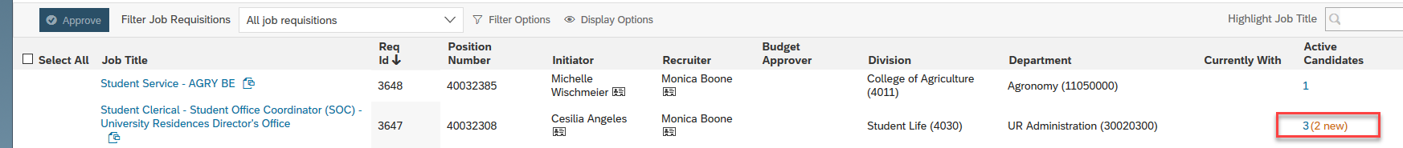
The Talent Pipeline is across the top of the page. It is your tool in managing candidate process. Since this is a quick hire process, those tiles that make the most sense to use should be. It is not required to use all the tiles.
All candidates start under ‘New Application.’  To view candidate details, click candidate Name. | 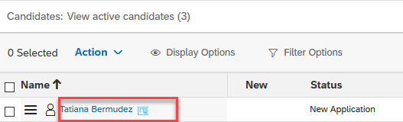
Candidate details are displayed, including the Application and/or Resume.
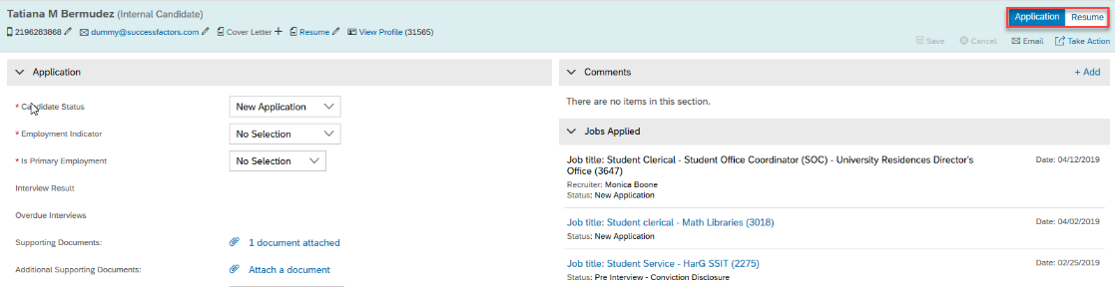
Click Take Action, to move a candidate from the current status, to a different status along the Talent Pipeline.  Select Move Candidate. | 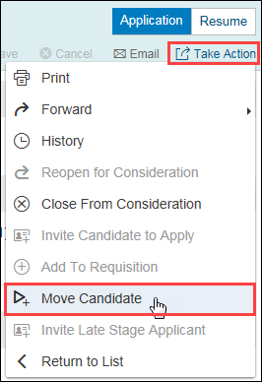
Select the appropriate Status from the drop-down menu. | 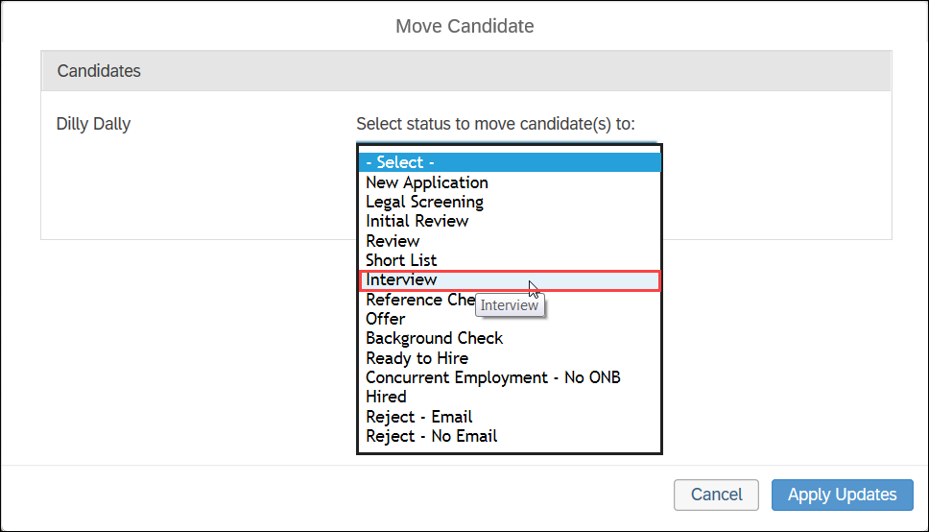
Enter Comments, if necessary.  Click Apply Updates. | 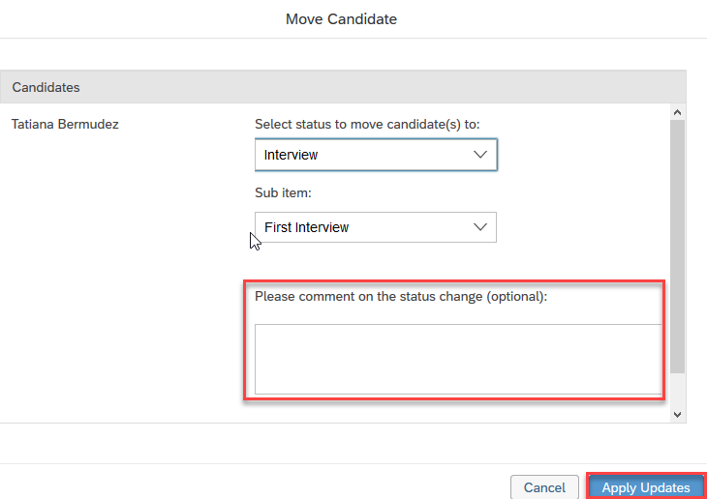
Candidates can also be moved within the Talent Pipeline by:  - Selecting the icon next to the candidate name,  - Dragging it across the pipeline, and  - Dropping it into the respective bucket. | 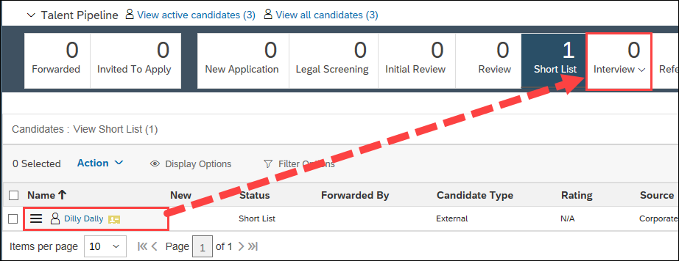

Move Candidate Offer
Click candidate Name and drag and drop candidate into the Offer status of the Talent Pipeline  Or, Select Candidate and use Action to move to Offer. | 