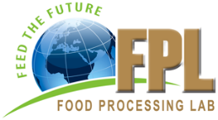  Property of  Food Processing Innovation Lab  United States/Kenya/Senegal |  | Property of  Food Processing Innovation Lab  United States/Kenya/Senegal
Property of  Food Processing Innovation Lab  United States/Kenya/Senegal |  | Property of  Food Processing Innovation Lab  United States/Kenya/Senegal
Property of  Food Processing Innovation Lab  United States/Kenya/Senegal |  | Property of  Food Processing Innovation Lab  United States/Kenya/Senegal

