Understanding Soil Science and Its Impact on Daily Life
Author: Mariah K. Stollar Awan
Unit Overview
Target Audience: grades 9-12 | Est. Time: 48 minutes per lesson | Content Area(s): Soil Science, Environmental Science, Agricultural  Literacy
Abstract: Why is soil important? What are its properties? How does soil affect our environment? What causes soil to become polluted or contaminated? Students will investigate the answers to these questions through this mini-unit on soil science. Students will be introduced to soil science through hands-on activities. Students will learn about soil properties, ideal soil conditions, fertilizers, contamination, and pollution. Examples of educational activities include soil sample identification, ribbon method to identify soil types, soil pH level testing, examining online soil data, and calculating safe fertilizer levels. Students will also learn agricultural literacy concepts, as they can explain how soil impacts our food supply after completing the unit. The unit also connects to public health concepts, as they will discuss how improper
fertilizer application and soil contamination (pollution) can affect the health of humans.
Unit Goals/Objectives:
Students will be able to:
- identify different soil textures using Inquiry-based Learning.
- describe ideal soil conditions for crop production.
- explain the effect of fertilizer on soil pH and soil health.
- calculate appropriate fertilizer application quantities.
- test soil pH using Inquiry-based Learning and evidence-based reasoning.
- explain how to locate and use online soil data to learn more about soil properties in a selected location in the U.S.
- explain how soil quality impacts crop production and food.
- identify potential sources of soil contamination.
- explain how soil contamination affects public health.
- apply inquiry-based Learning and Problem-based/Project-based Learning to design a solution to address pollution from a real-world case study

Lesson Summaries:
Lesson 1 – Exploring Soil Properties:
- Students will be introduced to soil science.
- They will learn about soil properties and ideal soil conditions.
- Students will analyze soil texture kits to learn the different types of soil.
- We will discuss other ways to measure soil health.
- We will talk about ideal soil conditions for crop production.
- In this lesson, we will also explore soil properties in Indiana using USDA soil data.
- Students will be able to practice inquiry-based learning by making observations to help them identify each soil type.
Lesson 2 – Investigating the Effects of Fertilizer on Soil:
- In this lesson, students will learn about soil pH and fertilizer application.
- After learning about soil pH and how fertilizer can affect soil, students will complete a hands-on activity.
- They will be presented with 2 soil samples (one with fertilizer applied and one without).
- They will be asked to predict which is which and use Inquiry-based Learning to complete the experiment and evidence-based reasoning to explain their answers.
- Students will also be given a scenario where they will need to calculate how much fertilizer should be applied to the soil.
Lesson 3 –Understanding How Soil Contamination Affects the Environment:
- Students will learn how mismanaged production practices can negatively impact soil.
- Students will learn about soil contamination.
- Students will be able to learn and identify accidental and intentional sources of soil contamination. We will discuss how contamination impacts the quality of soil and crops (food).
- We will also discuss how soil contamination can affect our health.
- Students will be able to apply problem-solving skills by working through a real-world case study of a soil-contamination scenario.
- Students will synthesize their knowledge of soil science to construct and present their solution using evidence from their research to present a solution to the soil contamination case study, engaging in evidence-based reasoning.
- By solving a real-world problem, students will also be able to engage in Inquiry-based Learning and Problem-based/Project-based learning.

Lesson Timeline:
Lesson 1: Exploring Soil Properties
- Introduction (5 minutes Soil)
- texture activity (7 minutes)
- Activity debriefs (5 minutes)
- Discuss other ways to assess soil quality and nutrients needed for plant development (10 minutes)
- Show students how to access USDA soil data, and get them started on the website (5 minutes)
Let students work on soil data worksheet questions and report (they can choose their research question, and work on preparing the online report)
- walk around and discuss progress with students, and troubleshoot (12 minutes)
- Wrap up (4 minutes)
Lesson 2: Investigating the Effect of Fertilizers on Soil
- Introduction (5 minutes)
- Overview (7 minutes)
- Fertilizers (7 minutes)
- Soil pH evidence-based reasoning activity (15 minutes)
- Fertilizer calculation activity (10 minutes)
- Wrap up (4 minutes)
Lesson 3: Understanding How Soil Contamination Affects the Environment
- Introduction (5 minutes)
- Soil contamination overview (5 minutes)
- Soil contamination & food supply (5 minutes)
- Soil contamination & health (5 minutes)
- Discussion about personal experiences with pollution/current events (5 minutes)
- Case study work time (10 minutes)
- Case study solution group 1-min presentations/discussion (9 minutes)
- Wrap up (4 minutes)
Standards:
- Indiana Dept. of Education: Advanced Life Science Plants and Soils Framework (High School Elective Course)
- Indiana Department of Education: Plant and Soil Science Framework (High School Elective Course)
- Indiana Academic Standards: High School Science (Environmental Science)
- Indiana Academic Standards: High School Science (Earth & Space Science)
- AFNR (Plant Systems Career Pathway)
- AFNR (Natural Resource Career Pathway)
- AFNR (Environmental Service Systems Career Pathway)
- Common Core Math Standards
STEM Integration within the Unit:
Science and Technology: USDA interactive soil survey data activity Science and Math: Fertilizer calculation activity
Science and Engineering: Soil contamination case study (engineering a solution)

Lesson 1: Exploring Soil Properties
Est. Time: 48 minutes
Lesson Learning Goals/Objectives:  Students will be able to:  - identify different soil textures using Inquiry-based Learning.  - explain different ways to measure soil quality.  - explain ideal soil conditions for crop production.  - locate and use online soil data to learn more about soil properties in a selected location in the U.S. |  | Indiana State Standards:  PSS-3.1 Describe the effects air, temperature, and water have on plant metabolism and growth  ALSPS-6.6 Describe the physical and chemical structures and functions of soil components including sand, silt, clay, and organic matter  National:  ESS.03.02.01B. Use a soil survey to determine the land capability classes for different parcels of land in an area. PS.01.03.01A. Identify the essential nutrients for plant growth and development and their major functions (e.g., nitrogen,  phosphorous, potassium, etc.).
Assessments:
Pre-Assessment: Ask the class: Who has had experience growing plants? (can be on a farm, gardening, in a class, etc.). Raise your hand if yes. Who has ever taken a class or after-school program where they learned about soil? Raise your hand if yes.
Formative: Exit card
Summative: End of unit test
Vocabulary: soil, soil texture, soil horizons, organic matter, soil respiration, macronutrients, micronutrients
Materials & Technology Needed: computer and projector for instructor, slides, soil texture kits, soil texture worksheet, soil triangle worksheet, USDA worksheet, 1 computer per group to complete soil data activity (if not
an option can do as a whole class on the main computer projected)
Lesson Component | Instructions |  | Materials
Introduction  5 minutes | Pre-assessment  - Let a couple of students share their previous experiences with soil from pre-assessment. Transition into the lesson.  - Give an overview of what we will be learning about soil.  - Ask students to predict: What do you think soil texture will tell us about the soil’s health? Discuss for a couple of minutes. |  | Supplementary slides
Instructional Activities  - minutes | - Define soil texture – explain it is the size of the particles. Use the analogy of beach ball, golf ball, and marble to explain the sizes of sand silt, and clay. Explain that soil quality is what helps plants grow fast and well.  - Explain soil texture activity and worksheets, and form students into groups. Pass out soil-type worksheets.  - Explain the main components of soil: sand, silt, clay, and organic matter.  - Show students how to do the “ribbon test” as a way to identify the soil type. (Tell them soil with higher clay content will be able to form a ribbon.)  - Groups will predict each soil type by matching them with the description on the worksheet.  - If students are done early, they can work on the soil triangle worksheet.  After activity:  - Call on student groups for answers. Have them explain their reasoning before giving the correct answer.  - Explain that soil texture is one way to examine soil quality.  Ask students:  - Do you think soil texture is a precise measure of soil quality? Why or why not.  - Soil texture can tell us a lot. It can tell us water holding capacity, nutrient capacity, and how easily the soil can be used to grow crops (tilling, planting). Loam is the best soil for plants.  Present other measures of soil quality.  - soil horizons –the layers of the soil, help us identify the topsoil, which is needed to grow crops  - Soil color – tells us how much organic matter there is, and how well soil drains.  - Soil structure (what you did!) – how the soil clumps or doesn’t clump; how much air and water movement air in the soil  - organic matter content – may indicate better structure, improved ability to hold nutrients, suppression of diseases/pests/runoff  - soil respiration – or carbon mineralization. how much CO₂ is released from the soil surface, tells us the amount of biological activity or decomposition in the soil  Have students say which qualities they think are more effective and why.  Ask students: What do you know is needed for plant growth?  (Here can start with the basics, light, and water, then guide them to start thinking of nutrients that plants need.). |  | Soil texture sample, soil texture worksheet (Appendix A), soil triangle worksheet (Appendix B)
 | Present remaining answers and their functions:  - Macronutrients: plants use these the most - nitrogen, phosphorous, potassium, calcium, manganese, and sulfur.  - Nitrogen – makes proteins for plants, phosphorus – helps plants start growing and forming roots, potassium – helps the plant use water, larger plant size, & better quality, calcium – helps roots and stems grow, Manganese – helps the plant to make its food, sulfur – also needed to make plant proteins  - Micronutrients: iron, boron, zinc, copper, manganese, molybdenum, nickel, chlorine – most important is iron, which is needed for photosynthesis and respiration  Transition into soil survey data activity.  - Show students how to access USDA soil data, and get them started on the website.  - Explain that they should choose one location to examine (create an Area of Interest (AOI). Then, click on Soil Data Explorer> Soil Health.  - Then, students should choose a category to explore under the Soil Health tab. Students will be asked to read the description (“View Rating) and come up with a research question. Once their question is approved by the instructor, they can move forward and click View Rating to see map results.  Students can share some of their research questions. Group discussion on other ways we could use soil data. |  | Computer(s), USDA soil survey website, USDA worksheet (Appendix C)
Wrap Up/Closure  4 minutes | Will recap that we discussed different properties of soil, and conditions ideal for crop production, and learned how to access this information from USDA.  Assessment: Exit card.  Before they leave, students should 1. write at least two ways to  measure soil quality and 2. explain how they would tell someone to access the soil survey data on a notecard. |  | Notecards, questions written on the board
Resources:
Purdue Extension Master Gardener: Soils & Plant Nutrition Presentation (John Orick, 2021). Topsoil Characteristics and Ribbon Test for Estimating Soil Texture (Government of Cedar Falls, Iowa, and., https://www.cedarfalls.com/DocumentCenter/View/9851/Topsoil-Soil-Ribbon-Test).
Soil Organic Matter, Fact Sheet (Cornell University Cooperative Extension, 2008, https://www.cedarfalls.com/DocumentCenter/View/9851/Topsoil-Soil-Ribbon-Test).
Soil Quality Indicators, Fact Sheet (USDA Natural Resources Conservation Service, 2022 https://www.nrcs.usda.gov/sites/default/files/2022-10/soil_respiration.pdf). http://websoilsurvey.nrcs.usda.gov/app/HomePage.htm https://www.ddtwo.org/site/handlers/filedownload.ashx?moduleinstanceid=23187&dataid=40314&FileName
=Soil%20Texture%20Triangle%20Worksheet.pdf.

Lesson 2: Investigating the Effects of Fertilizers on Soil
Est. Time: 48 minutes
Lesson Learning Goals/Objectives:  Students will be able to:  - explain the purpose of a soil pH test.  - explain how fertilizer helps plants grow.  - explain the effect of fertilizer on soil pH and soil health.  - conduct a pH test and analyze a pH soil sample using Inquiry-based learning and Evidence-Based Reasoning.  - calculate appropriate fertilizer application quantities |  | Standards:  State:  ALSPS-6.9 Discuss the effects of soil pH on mineral availability and toxicity and apply necessary changes for maximum fertility  ALSPS-6.10 Interpret laboratory analyses of soil and tissue samples and prescribe applications based on the results.  ALSPS-6.11 Identify, calculate, and calibrate appropriate fertilizer applications to meet plant nutrient needs.  National:  Quantities N-Q. Reason quantitatively and use units to solve problems.
Assessments:
Pre-Assessment: Ask the class: Has anyone ever done a pH test? Raise your hand if yes. Has anyone ever applied fertilizer to help a plant grow? Raise your hand if yes. What about doing a pH test before applying fertilizer? Raise your hand if yes.
Formative: Exit card
Summative: end of unit test
Vocabulary: pH, fertilizer
Materials & Technology Needed: computer and projector for instructor, slides, soil samples, Nitrogen-
based fertilizer, pH test kits, worksheets for pH and fertilizer activities
Lesson Component | Instructions |  | Materials
Introduction  5 minutes | Review of formative assessment. Tell students they did a great job. Go over any issues.  Tell students we will be learning about soil pH and how fertilizer affects soil today.  Pre-assessment. After discussion, transition into the lesson.
Instructional Activities  39 minutes | What is pH? It is a measure that tells us how acidic or basic a soil is. A pH of 5 means the soil is very acidic. A pH of 9 means it is very basic. Ideally, we want the soil pH level to be between 6-7 for ideal growing conditions for plants and crops.  Different things can affect soil pH. The chemical makeup of the soil, the age of the soil, and gardening and farming activity can change soil pH.  - Ask: In Indiana, most of our soil has limestone. Do you think that makes the soil more basic or acidic? Answer: Acidic. This is because lime affects the soil chemistry by transforming hydrogen ions into water and CO_{2.}  - Ask: Do you think if the soil is older or younger, the pH is higher?  Answer: Older soils have fewer minerals and are more likely to be acidic, or have a lower pH. |  | Supplementary slides
 | - Ask: How do you think gardeners and farmers fertilizing soil affects the pH? Let students predict and discuss, then transition to soil pH test activity.  Instead of giving you the answer, we are going to do an activity to test ourselves on how fertilizer affects the pH of soil. But first, we will discuss why we would want to apply fertilizer and how it encourages plant growth.  - Ask: Some of you mentioned earlier that you have fertilized plants before; can you share more about your experience? Discuss students’ experiences.  - Fertilizer helps improve soil fertility, or the ability to grow plants.  - There are two main types: processed and organic.  - Processed (Inorganic): Derived and processed from natural ingredients, like rock phosphate. This form can be absorbed by plant roots more easily. Nitrogen, phosphorus, potassium, sulfur, and sometimes micronutrients. However, they can be lost from the soil quickly and may need to be applied multiple times a year. Can cause a crust on the soil. If too much is applied, it can damage plants. If overused, it can also deplete essential nutrients/chemicals and good bacteria.  - Organic fertilizer: Made from decomposed plants or animals. Usually contains nitrogen, phosphorus, and potassium. Warmer temperatures are needed for the fertilizer to break down. Has lower concentrations of plant nutrients, so is more expensive. But can improve soil structure and water movement.  - We should always test soil before applying a fertilizer, to make sure it needs it.  Tell students to form into groups of 4. Have each group get a sample of each soil and pH test strips. They will also describe where the soil was collected from. They will be asked to predict which sample has the fertilizer applied and which does now and to provide evidence to explain their reasoning.  Label the one with the Nitrogen-based fertilizer sample A, and the other sample B. After letting them do the activity, they should be able to tell sample A was fertilized because it should have a more basic reading  - Debrief: The answer is, in general, it depends. Most fertilizers can increase pH, but some can lower it. We looked at one of the more common fertilizers, Nitrogen-based. These fertilizers usually lower pH, causing soil to become more acidic. Again, we should always be checking if fertilizer is needed by testing pH because we want soil pH to be in that 6-7 range, which is ideal growing conditions for crops and plants.  - This happens for a couple of reasons. First, Nitrogen fertilizers usually contain ammonium-N. When nitrification, or the bacterial conversion from ammonium to nitrate, occurs in the soil, hydrogen is released. This  can increase the acidity of the soil. Second, when plants absorb ammonium-N, they release hydrogen. Both of these processes are positive charges to the soil. These positive charges cause the soil pH to decrease. Then, this causes the soil levels of aluminum and manganese to increase, which can damage crops and plants.  To help you learn how to properly apply fertilizer if you ever want to have house plants or a home garden in the future, we are going to do some fertilizer calculations.  Transition into fertilizer calculator activity. Pass out student worksheets.  - Explain the activity. We will be using a fertilizer label to calculate how much fertilizer we want to apply to our garden.  Allow students to try the calculations themselves. Walk around to answer questions. |  | Soil samples (one with fertilizer already applied), pH test strips, pH lab worksheet (Appendix D)  Fertilizer calculation worksheet (Appendix E)
Wrap Up,  Synthesis/Closure  4 minutes | Help students wrap up. Remind them key concepts were pH and fertilizer application.  Assessment: Exit card.  Before they leave, students should answer the following on a notecard:  - If a soil sample has a pH level, of 4, is it acidic or basic?  Should we apply a Nitrogen-based fertilizer to the plants growing in this soil? Why or why not? |  | Notecards, questions written on the board
Resources:
“Here's the scoop on chemical and organic fertilizers”, (Oregon State University Extension, n.d. https://extension.oregonstate.edu/news/heres-scoop-chemical-organic-fertilizers)
Purdue Extension Master Gardener: Soils & Plant Nutrition Presentation (John Orick, 2021).
“The Role of Nitrogen Fertilizer on Soil pH”, (Brookside Laborites, n.d.). https://www.blinc.com/role- nitrogen-fertilizer-soil-ph
“Understanding Soil pH”, (Alabama Cooperative Extension System, 2018). https://www.aces.edu/blog/topics/farming/soil- ph/#:~:text=A%20Ca2%2B%20ion%20from,occur%2C%20forming%20an%20acid%20soil “Why It’s Time to Stop Punishing Our Soils with Fertilizers” (Schiffman, 2017)
https://e360.yale.edu/features/why-its-time-to-stop-punishing-our-soils-with-fertilizers-and-chemicals https://www.amazon.com/Dewilde-Trading-Co-Paper- Testing/dp/B08TJ4RWZ8/ref=sr_1_3_sspa?crid=1MKSTM6A12FGD&keywords=soil+ph+test+strips&qid= 1682082364&sprefix=soil+ph+test+strips%2Caps%2C101&sr=8-3- spons&psc=1&spLa=ZW5jcnlwdGVkUXVhbGlmaWVyPUEzRlVFV1lNR0tIM1Q3JmVuY3J5cHRlZElkP UEwMjE0Nzk5MTlPME1RSzU1VzFXViZlbmNyeXB0ZWRBZElkPUEwMjQ2MTY3Q0E5Tkg5VE9TV0
0wJndpZGdldE5hbWU9c3BfYXRmJmFjdGlvbj1jbGlja1JlZGlyZWN0JmRvTm90TG9nQ2xpY2s9dHJ1ZQ
==

Lesson 3: Understanding How Soil Contamination Affects the Environment
Est. Time: 48 minutes
Lesson Learning Goals/Objectives:  Students will be able to:  - explain how soil quality impacts crop production and food  - identify potential sources of soil contamination.  - explain how soil texture can impact soil contamination.  - explain how soil contamination affects public health.  - apply evidence-based reasoning to design a solution to address pollution from a real-world case study. |  | Standards:  State:  HS-ESS3-1. Construct an explanation based on evidence for  how the availability of natural resources, occurrence of natural hazards, and climate changes have influenced human activity.  HS-ENV2-6. Evaluate competing design solutions for developing, managing, and utilizing energy and mineral resources based on cost-benefit ratios.  National:  PS.01.03.05B. Assess and describe the short-and long-term  effects production methods have on soil  PS.01.03.06. A. Summarize the impact of environmental factors on nutrient availability (e.g., moisture, temperature, pH, etc.) PS.01.03.06. B. Assess and describe the impact environmental factors have on a crop
Assessments:
Pre-Assessment: Ask class: Have you ever thought about soil contamination, or soil pollution? Raise your hand if yes. Have you ever been concerned about the quality of your food due to soil or water contamination, or heard others share concerns about this? Raise your hand if yes.
Formative: Exit card
Summative: end of unit test
Concept Prerequisites or Background Knowledge Needed: N/A

Vocabulary:
Vocabulary: soil contamination
Materials & Technology Needed:
Materials & Technology Needed: computer and projector for instructor, slides, hand out for soil health
issues, case study work sheet
Lesson Component | Instructions |  | Materials
Introduction  5 minutes | Review of formative assessment. Tell students they did a great job. Go over any issues.  Tell students we will be learning about soil contamination. We will also get think about solutions to soil contamination using a real-life case study.  Pre-assessment. After discussion, transition into lesson.
Instructional Activities  - minutes | - What is soil contamination? Ask students first, then explain: it is when a chemical or substance in the soil is above what occurs naturally is identified that may cause negative impacts on humans’ health.  - How does soil contamination affect the environment?  - Remind students in last lesson we discussed ways that too much fertilizer can impact the soil. Recall: Ask them if they  remember any of these.
 | - Discuss: What are other sources of Soil contamination? Ask students to share their thoughts first. Common sources are: manufacturing, industrial dumping, land development, local waste disposal, car and truck traffic (oil), and again, over fertilizing.  - Sandy soil can cause more adverse effects when contaminated than clay soil; ask students to recall soil type activity, then explain: the contaminants can more easily flow to ground water sources in soil that has more sand than clay.  - How do humans come in contact with soil contamination? May be by 1. Ingesting contaminated soil, 2. Breathing contaminated soil dust, 3. Absorbing the contaminant through the skin, 4. Eating food grown in contaminated soil  - If a garden or farmland was used before for industrial purposes or is near a contaminated site, it is more likely to be contaminated.  - Explain that sometimes coil contamination occurs by accident, but sometimes it is purposeful.  - When large companies are accused of willfully contaminating areas or lying about it, this can launch a criminal investigation. Explain DuPont example.  - What health problems can arise from soil contamination? Endocrine (hormone) disruptors, cancer, accelerated ageing, immune disorders, heart and neurodegenerative diseases, infertility problems, and more  - These conditions are usually caused by low-level exposure overtime, and it is hard to determine whether or not soil contamination caused them. Scientists are doing more studies to learn more about this.  - Ask the students – does anyone have experiences or have heard about people who have had their health harmed through environmental pollution?  - Share with students about Dupont Case (you can read more here if you are not familiar=>https://www.sciencefriday.com/articles/dupont- bilott-book-exposure/). You could also print and have them read the article as homework the night before.  - Discuss their reactions to the Dupont Case.  - You are now going to be the engineers trying to design a solution to fix a real soil contamination problem.  We are going to do a case study that explores a potentially contaminated school site. You will identify the source of contamination and design a solution to lower soil contamination levels to what is safe for humans.  Provide general Case Study Description: Beard Elementary School is in need of a new school building. However, the site that has been chosen has soil contamination. Community members want the pollution to be addressed for the safety of  the teachers and children that will attend the school.  - Pass out worksheets with more thorough description of the case study. In their groups, students will imagine that they are environmental engineers from the Michigan Department of Environmental Quality (MDEQ), who are tasked with finding a solution to make the soil and site safe for humans.  - Students will be provided descriptions of possible solutions. They may pick Replacement of contaminated soil, Soil removal and soil isolation, Electrokinetic remediation, Soil leaching, or Adsorption. They will need to research on school computers or smart phones what materials and the amount of time that will be needed for each solution (guided worksheet will ask them to fill in needed information). They will also need to consider the costs of the solutions. Then, they will choose the solution they think is best, citing evidence from their research.  - Students will present solutions. Class will discuss pros and cons of each solution. |  | Give students hand out for soil health issues (Appendix F)  Pass out case study worksheets (Appendix G)
Wrap Up,  Synthesis/Closure  4 minutes | Assessment: Exit card.  Before they leave, students should answer the following on a notecard:  - 1. Please list 3 causes of soil contamination. 2. List 2 ways that soil contamination can negatively affect our health.  - Summative assessment reminder: next class, students will have a test over the unit |  | Notecards, questions written on board
Resources:
What are soil contaminants? (Soil Science Society of America (SSA), n.d.). https://www.soils.org/about- soils/contaminants/#:~:text=Some%20examples%20are%20manufacturing%2C%20industrial,excessive%20p esticide%20or%20fertilizer%20use.
Environmental, health and socio-economic impacts of soil pollution (Food and Agriculture Organization of the United Nations, n.d.) https://www.fao.org/3/cb4894en/online/src/html/chapter-04- 3.html#:~:text=Dermal%20exposure%20to%20soil%20contaminants,spread%20through%20the%20circulato ry%20system.
https://websites.umich.edu/~snre492/Jones/beard.htm
https://www.futurelearn.com/info/courses/sustainable-agriculture-in-a-changing-environment/0/steps/55195 https://www.fao.org/3/cb4894en/online/src/html/chapter-04-3.html https://www.sciencefriday.com/articles/dupont-bilott-book-exposure/

Summative Assessment Additional Explanation: This assessment will be used for 9-12 grade students who have completed the Why does soil matter? Understanding Soil Science and Its Impact on Daily Life integrated STEM mini unit. The following objectives will be measured on this assessment:
- identify different soil textures.
- explain different ways to measure soil quality.
- explain how to locate and use online soil data to learn more about soil properties in a selected location in the U.S.
- identify potential sources of soil contamination
- explain how soil texture can impact soil contamination
- calculate appropriate fertilizer application quantities
- explain how soil quality impacts crop production and food
- explain the purpose of a soil pH test.

===============================================================================
Why does soil matter? Understanding Soil Science and Its Impact on Daily Life
End of Unit Summative Assessment

Name Date Score /20

Directions: Please answer the following questions using the soil samples.
- Which sample has more clay in the soil? Please explain how you know. (2 pts)

- How does the amount of sand vs. clay in the soil impact contamination? (Hint: remember how it affects ground water contamination) (2 pts)

Directions: Please answer the following questions in complete sentences.
- You friend is a farmer wanting to learn more about the properties of her soil using survey data. She asks you for help finding the information. Please explain how you would explain to her how to access this information online. (2 pts).
- Your friend tells you she would also like to learn more about soil quality. Please list two ways they could learn more about the soil’s quality. (Hint: remember the first lesson) (2 pts)
- The same friend tells you her soil has a pH level of 8. She wants to use a Nitrogen fertilizer. Would this be a good practice? Why or why not? (2 pts)
- Use the fertilizer label to answer the following questions. (5 pts)

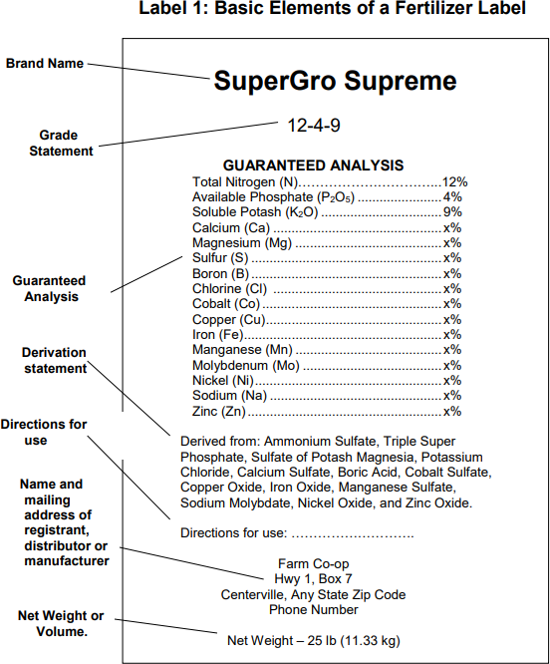

  - How much Nitrogen is in the fertilizer (in lbs.?) lbs. (1 pt)
  - How much P2O5 in the fertilizer (in lbs.?) lbs. (1 pt)
  - How much K2O is in the fertilizer (in lbs.?) lbs. (1 pt)
  - If you want to apply ½ lb. of Nitrogen to your 1000 sq ft lawn using this fertilizer, how much fertilizer should you apply? (Show your work below) (2 pts)

- Please list 3 possible sources of soil contamination. (3 pts)

- Please 2 ways soil contamination can affect human health. (2 pts)
Why does soil matter?: Understanding Soil Science and Its Impact on Daily Life
End of Unit Summative Assessment RUBRIC

Question 1
0 pts | 1 pt | 2 pts
Student does not correctly identify  soil sample and does not correctly explain rational. | Student either correctly identifies  the sample or explains the rational, but both parts are not correct. | Student both correctly identifies  the sample and explains the rational.

Question 2
0 pts | 1 pt | 2 pts
Student does not correctly identify sandy soil as more adverse and does not explain that the ease of flow to groundwater is the rational. | Student either correctly identifies sandy soil as more adverse or explains that the ease of flow to groundwater is the rational, but  both parts are not correct. | Student both correctly identifies sandy soil as more adverse and explains that the ease of flow to groundwater is the rational.

Question 3
0 pts | 1 pt | 2 pts
Student does not explain that the farmer should go to the USDA website and that the farmer should use the soil survey data from the web soil survey. | Student either explains that the farmer should go to the USDA website or that the farmer should use the soil survey data from the web soil survey, but does not  explain both. | Student both explains that the farmer should go to the USDA website and that the farmer should use the soil survey data from the web soil survey.

Question 4
0 pts | 1 pt | 2 pts
Student does not list 2 correct sources of soil contamination. | Student lists 1 correct source of  soil contamination. | Student lists 2 correct sources of  soil contamination.

Question 5
0 pts | 1 pt | 2 pts
Student does not explain if it is a good practice and does not give an explanation. | Student either answers the question correctly or gives a correct explanation, but does not  achieve both. | Student both answers the question correctly and gives a correct explanation.

Question 6 (for a – c)
0 pts | 1 pt
Student does not give the correct amount of fertilizer to apply. | Student does give the correct  amount of fertilizer to apply.

Question 6d
0 pts | 1 pt | 2 pts
Student does not correctly convert the % of the nutrient to a decimal and divide the target application rate by the decimal value to get the correct answer. | Student either correctly converts the % of the nutrient to a decimal or divides the target application rate by the decimal value, but does  not achieve both. | Student both correctly converts the % of the nutrient to a decimal and divides the target application  rate by the decimal value to get the  correct answer.

Question 7
0 pts | 1 pt | 2 pts | 3 pts
Student lists no correct sources of soil contamination. | Student lists 1 correct source of soil  contamination. | Student lists 2 correct sources of soil  contamination. | Student lists 3 correct sources of soil  contamination.

Question 8
0 pts | 1 pt | 2 pts
Students lists no ways soil contamination can affect human health. | Students lists 1 correct way soil contamination  can affect human health. | Students lists 2 correct ways soil contamination  can affect human health.

Score /20

Appendix A – Soil ID Activity Worksheet
Name Date
Soil Identification Activity

Directions: Choose the correct soil type from the word back to match the labeled soil samples on the table. Then, explain the reason for each of your answers in 1-2 sentences.
Word Bank
Silt Loam Sand Clay

- Sample A:

- Sample B:

- Sample C:

Solutions:
A – Texture Silt Loam
B – Moab Sand
C – Textural Clay

Appendix B – Soil Triangle Worksheet
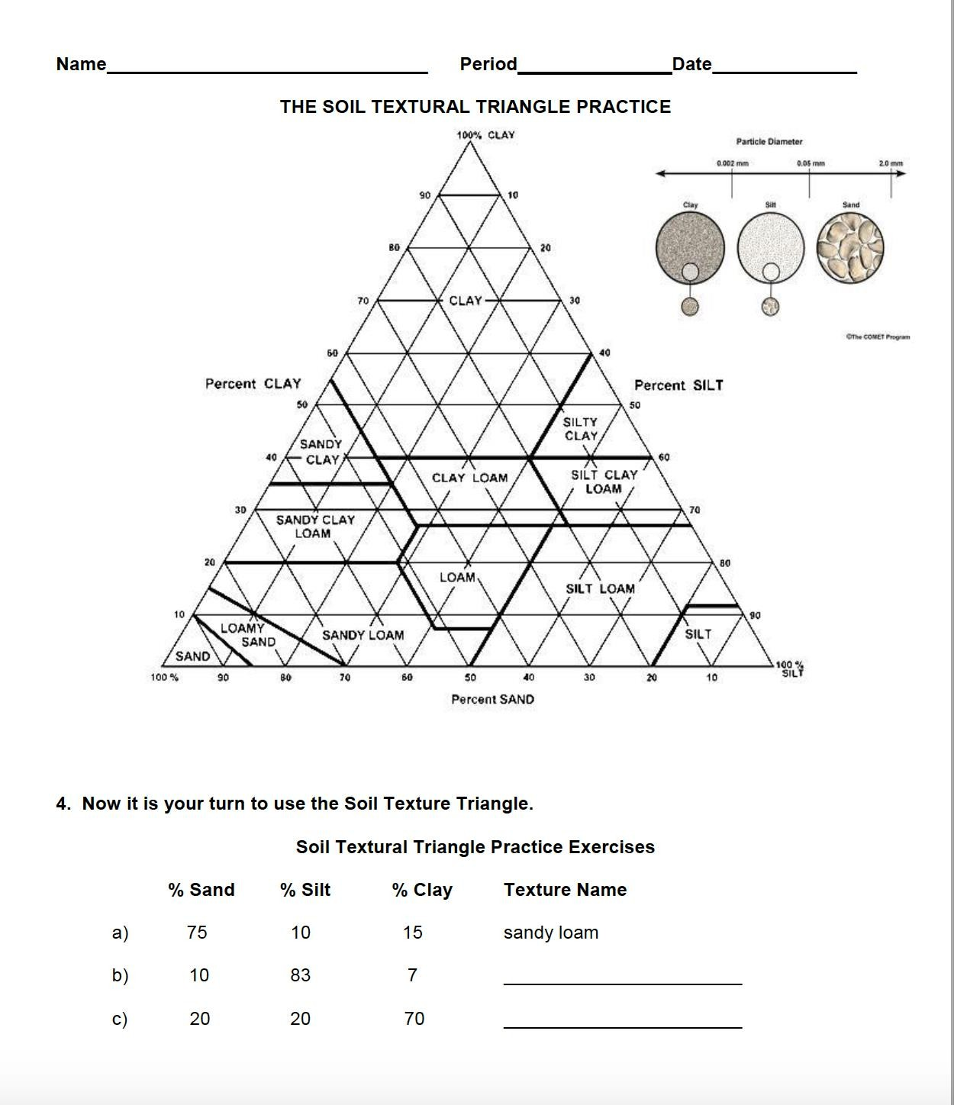

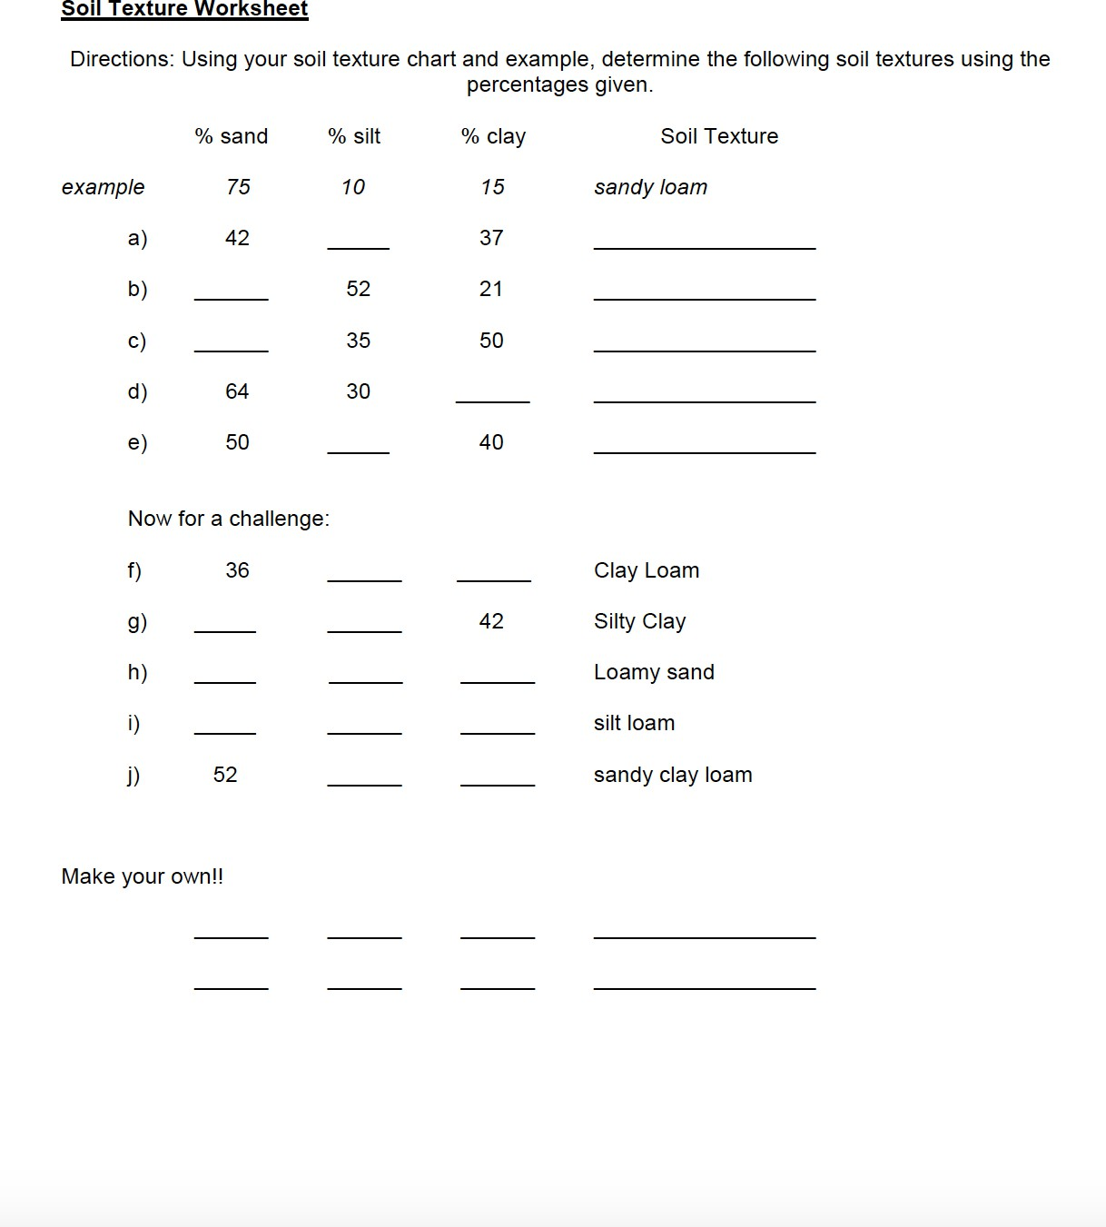

Solutions:

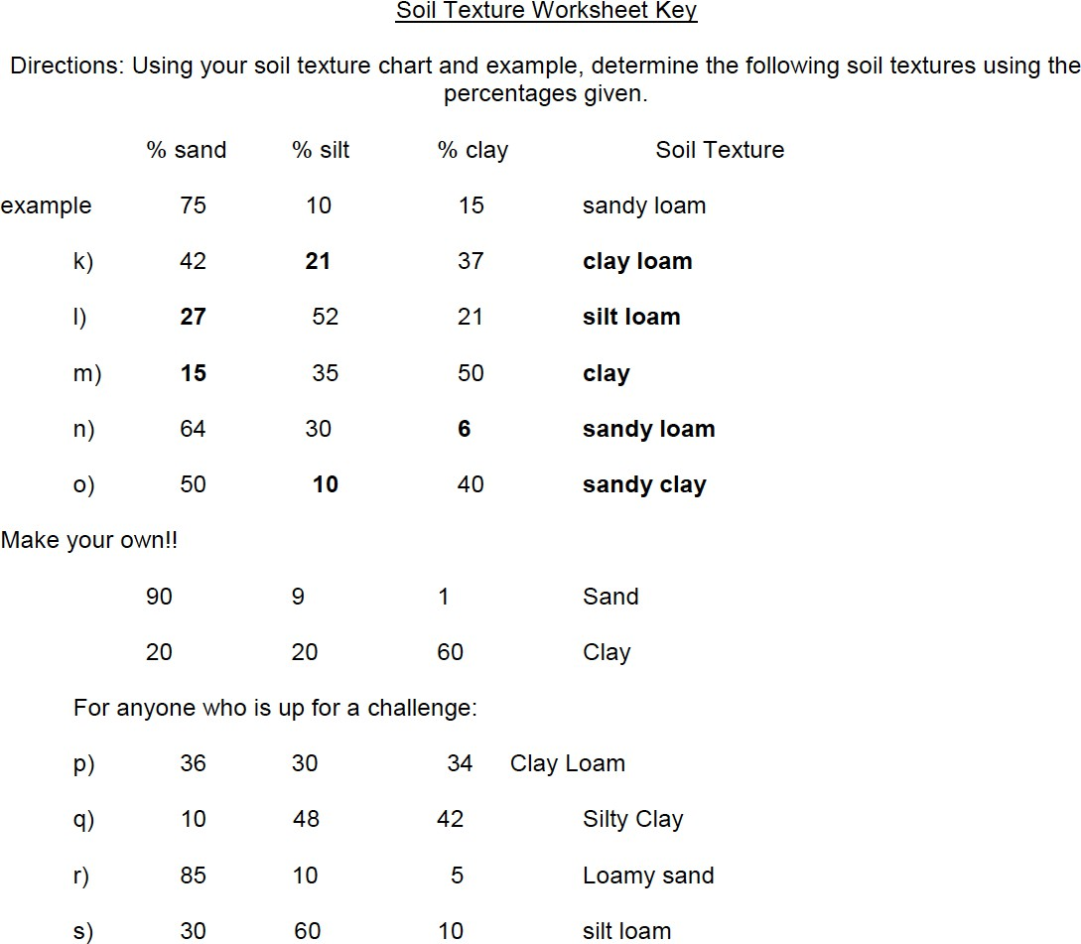

Worksheet source/link: https://www.ddtwo.org/site/handlers/filedownload.ashx?moduleinstanceid=23187&dataid=40314&FileName=Soil%20Texture%20T riangle%20Worksheet.pdf

Appendix C – USDA Soil Survey Data Activity Worksheet

USDA Soil Survey Data Activity
Name Date

USDA Soil Survey Data Introduction
🠶 Go to link: https://websoilsurvey.sc.egov.usda.gov/App/WebSoilSurvey.aspx
🠶 Find area of interest (AOI)
🠶 We will use Wea Creek Orchard in Lafayette
🠶 5618 S 200 E, Lafayette, IN 47909
🠶 Click soil map.
🠶 Click soil data explorer > Suitabilities and Limitations for Use
🠶 Vegetative Productivity > Yields of Non-Irrigated Crops (Component)> View Description
> View Rating > Add to Shopping Cart
🠶 Click Shopping Cart > Check Out > Get Now
🠶 PDF Report will be created
What is a research question (RQ)?
🠶 It is a tool that guides the aim of a research study, or the purpose.
🠶 It should be Focused, Specific, Feasible, Researchable, and Relevant
🠶 A purpose of research can be to describe (descriptive)
🠶 not looking at relationships
🠶 answering the question “What is going on here?”
Write and explore your own RQ – Instructions and Example
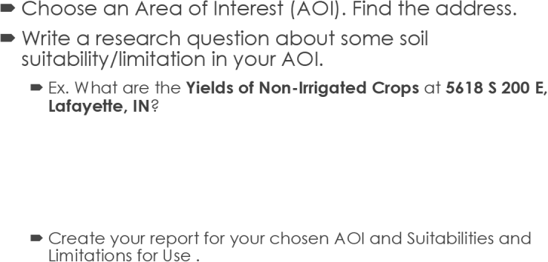

Category you chose:

Area of interest (AOI) you chose:
Your RQ:

Appendix D-Soil pH Lab Directions & Observation Worksheet

Soil pH Lab

Name Date

Materials: 2 soil samples, 2 cups, beaker, measuring cup, pH test trips, pH chart

Directions: Follow the steps below to test the 2 soil samples. Record your observations in the observation boxes below. Answer the question at the bottom of the page.

- Mix the soil with water. Mix (1/2 c) of each soil sample with (120 mL) water and let the solution sit for 30 minutes before testing.
Observations: Describe what each solution looks like. Can you tell any differences between each sample?
- Dip the test strip in the solution. Dip one strip into solution for 3 seconds and remove the strip, then hold the strip horizontally for 60 seconds.

- Compare the color of the strip to the color on the chart. Compare against the color chart and read immediately to get accurate results. Repeat steps 2 and 3 for the second strip.
Observations: Describe the color of each pH test strip. What are the readings?

Based on your results, which sample do you think has been fertilized? Please explain your answer.

Solution: Sample A; has a more basic reading than Sample B.

Source and where to purchase strips: https://www.amazon.com/Dewilde-Trading-Co-Paper- Testing/dp/B08TJ4RWZ8/ref=sr_1_3_sspa?crid=1MKSTM6A12FGD&keywords=soil+ph+test+strips&qid=1682082364&sprefix=s oil+ph+test+strips%2Caps%2C101&sr=8-3- spons&psc=1&spLa=ZW5jcnlwdGVkUXVhbGlmaWVyPUEzRlVFV1lNR0tIM1Q3JmVuY3J5cHRlZElkPUEwMjE0Nzk5MTlPME1RSz U1VzFXViZlbmNyeXB0ZWRBZElkPUEwMjQ2MTY3Q0E5Tkg5VE9TV00wJndpZGdldE5hbWU9c3BfYXRmJmFjdGlvbj1jbGlja1JlZG lyZWN0JmRvTm90TG9nQ2xpY2s9dHJ1ZQ==

Appendix E – Fertilizer Calculation Worksheet

Fertilizer Calculation Activity

Name Date

Directions: Solve the problem below by showing your work for each step to practice calculating the proper amount of fertilizer to apply.

A home owner wants to apply 1/2 lb. of N on their 1000 sq. ft.. lawn using a 18-0-10 fertilizer. How much fertilizer should be applied apply (for N needed)?

Solution:

- Convert the % of the nutrient to a decimal
  - The 18-0-10 contains 18% N or .18
  - Divide the target application rate (.5 lb.) by the decimal value
    - .5 / .18 N = 2.78 lbs. of actual fertilizer product per 1,000 sq feet

Activity Source: Purdue Extension Master Gardener: Soils & Plant Nutrition Presentation (John Orick, 2021).

Appendix F

Soil Contamination Health Issues Handout

Main effects of soil contaminants on human health, indicating the organs or systems affected and the pollutants causing them.
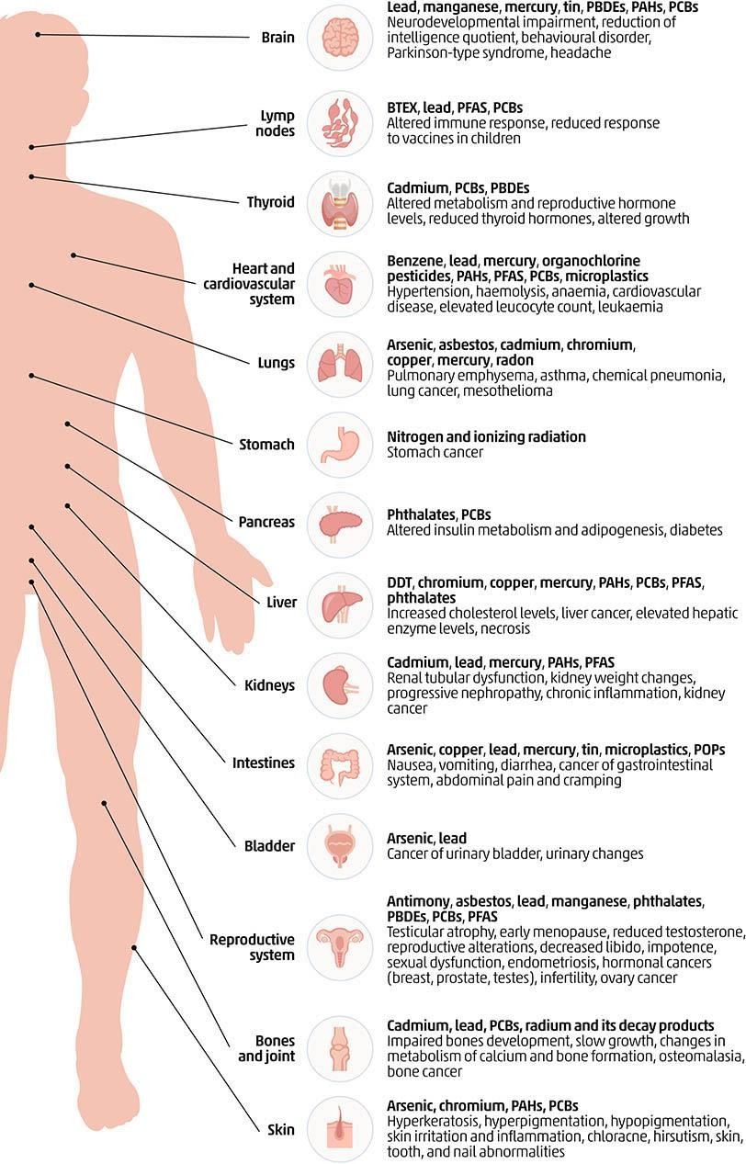
Source: https://www.fao.org/3/cb4894en/online/src/html/chapter-04-3.html

Appendix G

Case Study Activity Materials

Case Study Activity

Name Date

Directions: You are now going to be the engineers trying to design a solution to fix a real soil contamination problem. We are going to do a case study that explores a potentially contaminated school site. You will identify the source of contamination and design a solution to lower soil contamination levels to what is safe for humans.

Case Study Description: “Beard Elementary School in Michigan is in need of a new school building. However, the site that has been chosen has soil contamination. Community members want the pollution to be addressed for the safety of the teachers and children that will attend the school. Imagine you are environmental engineers from the Michigan Department of Environmental Quality (MDEQ), who are tasked with finding a solution to make the soil and site safe for humans.”

- Review the case study materials provided.

- Research possible solutions. Research the following for each potential solution: definition (what is the process), cost estimate (how much will it cost the school district to do this?), time (how long will the project take?) and record them below.
Replacement of contaminated soil Definition:
Cost:
Time:
Soil removal and soil isolation Definition:
Cost:
Time:
Electrokinetic remediation Definition:
Cost:
Time:
Soil leaching Definition: Cost:
Time:
Adsorption Definition: Cost: Time:

Other (use if you find another solution that you think is better suited to address the problem-must find at least 2 credible sources to support)
Definition:
Cost:
Time:

- Choose and design your solution. Answer the following questions.
Which solution do you believe is best? Please explain, citing at least two credible sources you found during your research.

Draw a rough sketch of what your solution would look like. List any 1) materials that would be needed to implement the solution, and the 2) estimated cost of and 3) time to complete the project.

Sketch:

Materials needed:

Cost:

Time:

Problem

Case Study Materials
Beard Elementary School Sitting on Contaminated Property
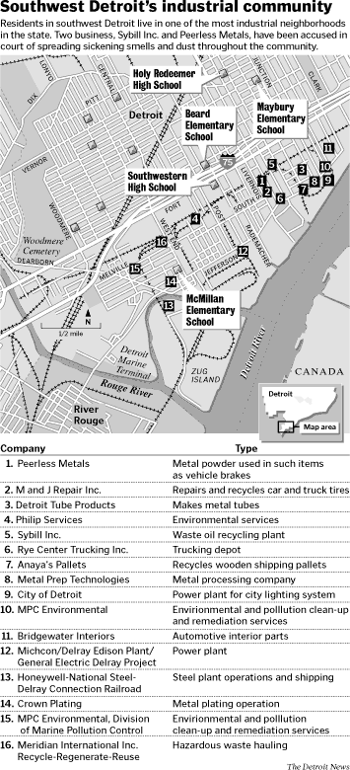

“The view out of the car window as one heads toward Beard Elementary School in Detroit can hardly be called scenic. From Chrysler Freeway, one can see heavy industrial plants stretch into southwest Detroit. Within all of this ugliness sits a little elementary school. Like something out of a storybook, Beard Elementary school, built

in 1886, is a picturesque little red schoolhouse. When inside, the first impression is quite romantic, but after a quick tour, the building’s limitations become clear. The school has no cafeteria, a minuscule gym, and is extremely overcrowded with 563 students. However, construction for a new and better school was started in July of 2000 at 7036 Chatfield Street (Thornton, 2000). The new school is necessary because of the poor
conditions in the current school. Unfortunately, the Detroit Public Schools have decided to build the new school on property contaminated with lead, arsenic, polychlorinated biphenyls (PCBs), benzo(a)pyrene, and trichloroethylene (Thornton, 2000).

Background

The construction site of the new Beard Elementary/Preschool has a long history of heavy industrial uses. Located on the intersection of Chatfield, Beard, and Green Streets, the 6.4 acre triangle of vacant land is in the heart of Southwest Detroit. The site is surrounded by an elevated railroad to the North and a partially vacant industrial facility to the East and is only 1/4 of a mile northwest of Chrysler Freeway, I-75. Primary occupation of the site began in 1909 by a brass foundry. The brass foundry was closed in 1918 and a variety of industrial activities sponsored by Ireland & Mathews Mfg., Aetna Steel Company, the Ohio Automobile Radiator Company, and the Wolverine Aluminum Company have taken place on the site. Each company occupied different buildings on the site in 1929. During the period between 1937 to 1950, the International Detrola Corporation operated on the property. From 1950 to1964, the U.S. Army owned and operated a tank ordinance center at the site, before donating the land to the City Board of Education, who then ran a vocational skills center and repair garage on the property from 1965 to 1981. In 1981, all of the buildings on the site were demolished. For seventeen years, the site remained vacant (Thornton, 2000; MDEQ 2002).

The Beard Elementary school neighborhood is overburdened by polluting facilities. In the two-mile radius around the school, there are a total of 58 polluting facilities (See map above). Of those 58 facilities, the majority handle hazardous waste. In the two-mile radius, there are 40 facilities handling hazardous waste, 3 facilities with toxic releases, 6 with air releases, and 9 facilities that deal with multiple types of pollutants (U.S. Environmental Protection Agency, 2000). With the disproportionate amount of pollution in the neighborhood already, further exposure to the children as a result of the sitting of the new elementary school on contaminated soil compounds already dangerous health risks.

Beard Elementary School Site Environmental Testing

An environmental consultant hired by SDEV completed a review of the site history in March of 1999 and concluded that the site was contaminated with toxic compounds (Milberg, 2000b).

SDEV representatives Kathy Milberg and Juan Jose Martinez met with the DPS soon after the contamination was discovered and provided them with the site report. The DPS then gave permission to conduct Phase I and Phase II Environmental Assessments of the area for commercial reuse (Milberg, 2000a). In July and August of 1999 the Phase I and II assessments were finished for Wayne County (Thornton, 2000). After the initial Phase I and II assessments were completed for commercial reuse, the DPS decided to build the new Beard Elementary/Preschool on the site. Construction of the new school commenced in July of 2000 (Thornton, 2000). The Michigan Department of Environmental Quality (MDEQ), requested additional testing on the site because of the previous discovery of contaminants like lead, benzo(a)pyrene, polychlorinated biphenyls (PCBs), PNAs, trichloroethylene, and arsenic (Thornton, 2000).”

Activity Sources: https://websites.umich.edu/~snre492/Jones/beard.htm#Problem https://www.futurelearn.com/info/courses/sustainable-agriculture-in-a-changing-environment/0/steps/55195

Assessment Plan
Why does soil matter?: Understanding Soil Science and Its Impact on Daily Life Formative Assessment Plan

Target Audience: High School Students (grades 9-12) who have completed the unit in a formal classroom setting.

Objectives Assessed:
- explain different ways to measure soil quality.
- locate and use online soil data to learn more about soil properties in a selected location in the U.S.
- explain the effect of fertilizer on soil pH and soil health.
- conduct a pH test and analyze a pH soil sample using Inquiry-based learning and Evidence Based Reasoning.

Instructions:
- Students will answer pre-assessment questions as a class at the beginning of the lessons as directed by the teacher.
- Students will complete the exit ticket notecards at the end of all three lessons as directed by the teacher.

Total Points: Not graded, part of participation points

Formative Assessments Overview
- Pre-assessment questions: The teacher will ask the class the following questions, using the following scripts, before lessons to gauge their prior knowledge of soil science
  - Lesson 1: Who has had experience growing plants? (can be on a farm, gardening, in a class, etc.). Raise your hand if yes. Who has ever taken a class or after school program where they learned about soil? Raise your hand if yes.
  - Lesson 2: Has anyone ever done a pH test? Raise your hand if yes. Has anyone ever applied fertilizer to help a plant grow? Raise your hand if yes. What about doing a pH test before applying fertilizer? Raise your hand if yes.
  - Lesson 3: Have you ever thought about soil contamination, or soil pollution? Raise your hand if yes. Have you ever been concerned about the quality of your food due to soil or water contamination, or heard others share concerns about this? Raise your hand if yes.
- Exit Tickets: The teacher will pass out notecards at the end of each lesson. Students will answer the following questions for each lesson:
  - Lesson 1: 1. Write at least two ways to measure soil quality. 2. Explain how you would tell someone to access the soil survey data on a notecard.
  - Lesson 2: 1. If a soil sample has a pH level, of 4, is it acidic or basic? 2. Should we apply a Nitrogen-based fertilizer to the plants growing in this soil? Why or why not?
  - Lesson 3: 1. Please list 3 causes of soil contamination. 2. List 2 ways that soil contamination can negatively affect our health.

Why does soil matter?: Understanding Soil Science and Its Impact on Daily Life Summative Assessment Plan

Target Audience: High School Students (grades 9-12) who have completed the unit in a formal classroom setting.

Objectives Assessed:
  - identify different soil textures.
  - explain different ways to measure soil quality.
  - explain how to locate and use online soil data to learn more about soil properties in a selected location in the U.S.
  - identify potential sources of soil contamination
  - explain how soil texture can impact soil contamination
  - calculate appropriate fertilizer application quantities
  - explain how soil quality impacts crop production and food
  - explain the purpose of a soil pH test.

Instructions for Students: Follow the directions for each section to complete the paper-pencil test.

Example Test Questions: See p. 12 for assessment.

Rubric for Instructor: See p. 14 for rubric to grade.

